LAB1: Creating a Kali VM and Importing it into GNS3

Exercise 1. Creating a Kali VM in VMware
1.1 For WINDOWS OS

To create a Kali VM in VMware, please follow the process outlined in the LINK below. NOTE the process is for Windows ONLY. Also, when you follow these steps, PLEASE Use name “Kali” for the step where is asks you Name the Virtual machine. Do not name the machine “Kali_x64”. That applies too for the Location: field too, please just use “Kali”

https://www.nakivo.com/blog/install-kali-linux-vmware/

Continue with the Creation process and then follow the steps for “Deploying Kali Linux on VMware VM”. STOP after Deploying section.
Do not install VMware Tools on Kali. You are now done.

After the installation process is completed, turn off Kali inside the VMware.

Now you need to import Kali into the GNS3 as outlined in Exercise 2.

1.2 For MAC OS

- Start VMware Fusion. Under the File menu, click on “New” as shown below.
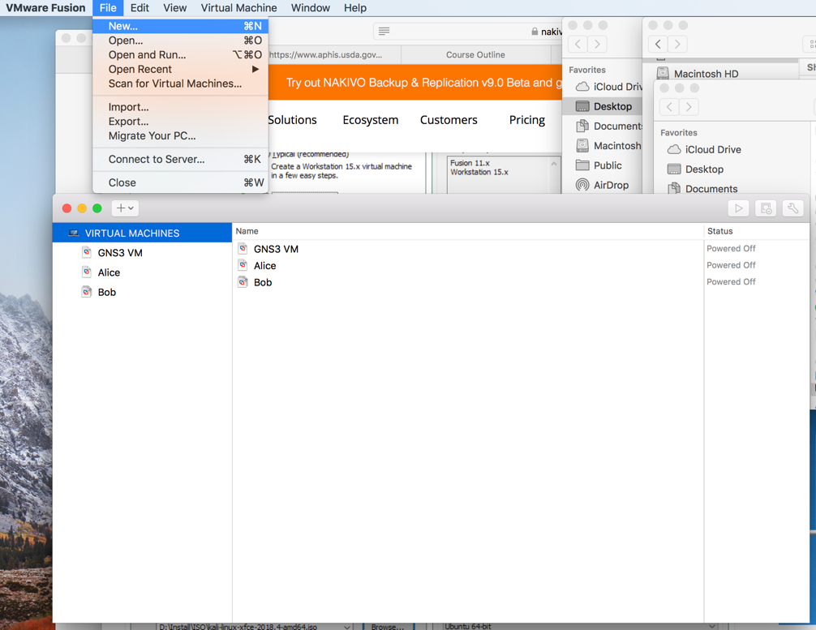

- You will be required to select an OS. Choose Linux, then pick Ubuntu 64-bit as shown below.
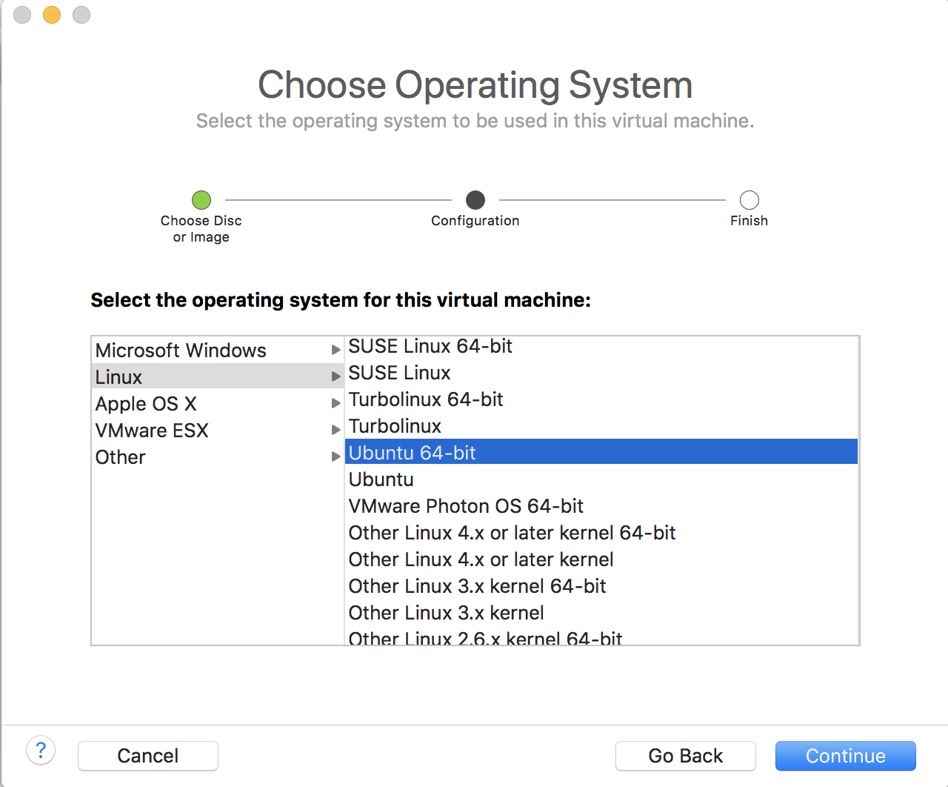

- You will then select the boot firmware as shown below.
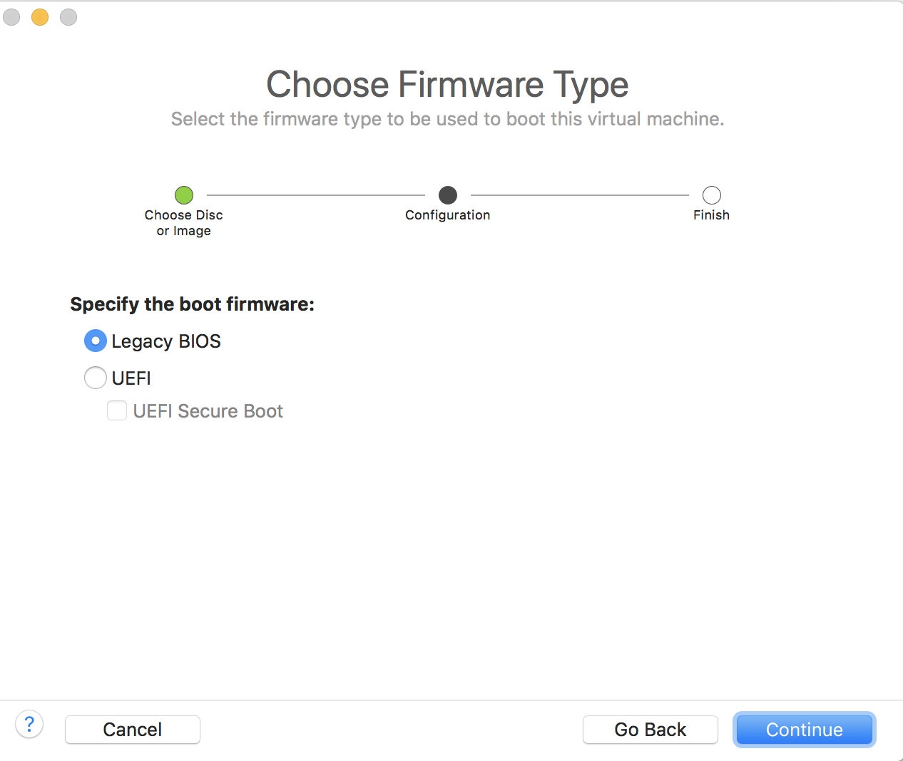
- When it is done, click “Finish”.
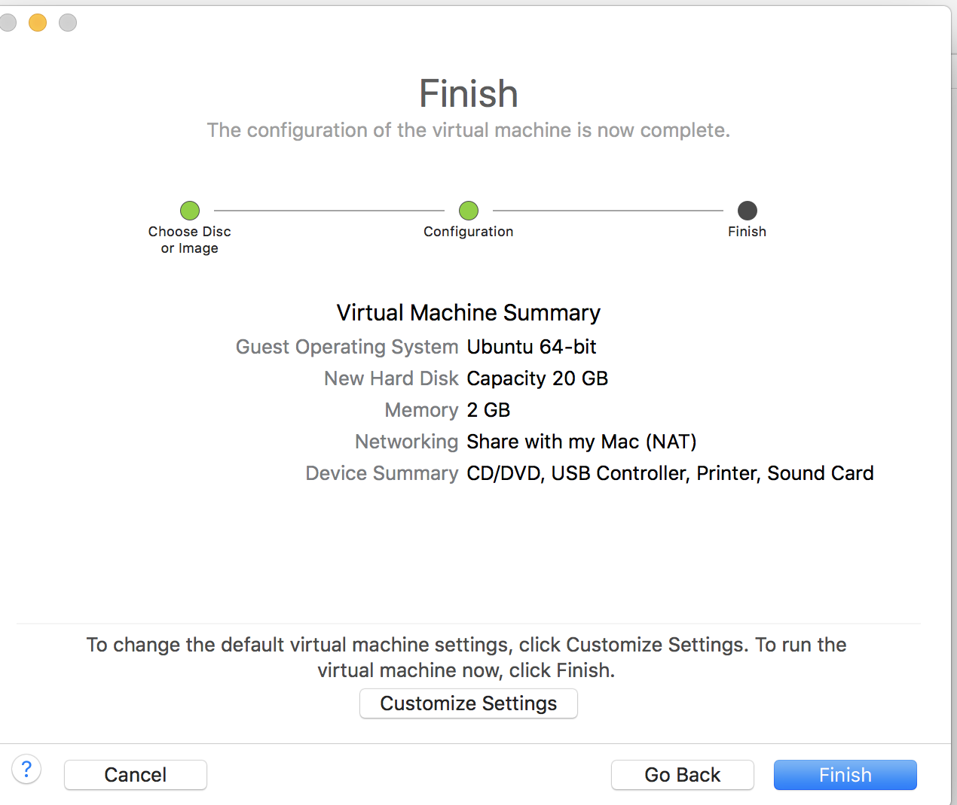

- Save as Kali. Then click “Save”.

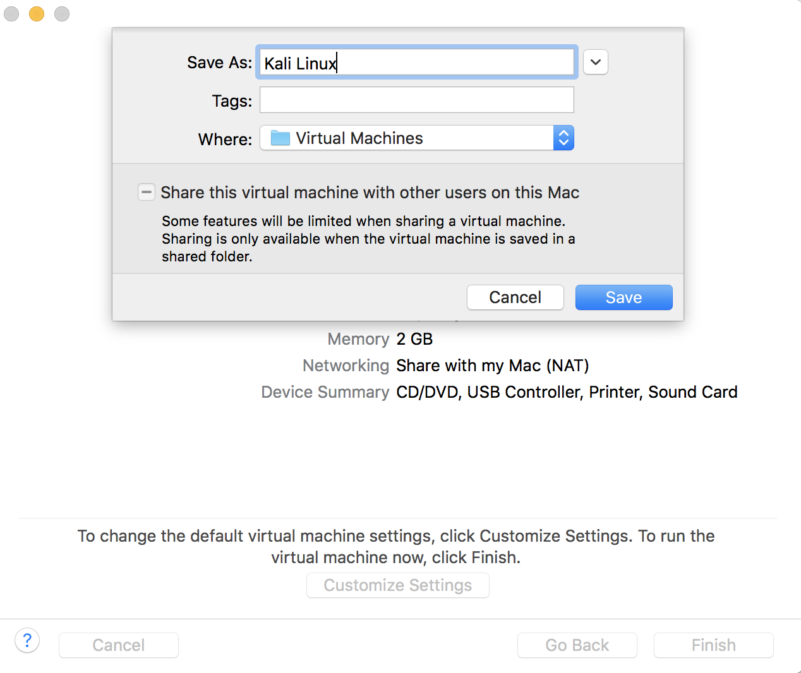

- You will then see the following screen.

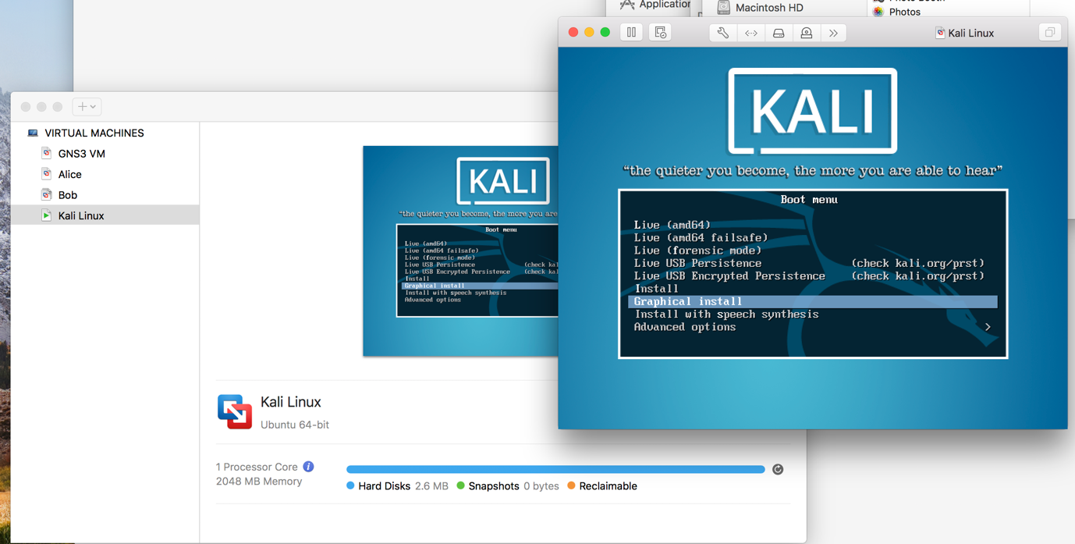

- This is the point at which you go to this link (same link as used for Windows OS installation):

https://www.nakivo.com/blog/install-kali-linux-vmware/

- You SKIP the section on “Creating a New VMware VM” and jump to “Deploying Kali Linux on VMware VM”.

STOP after the Deploying section.

Do not install VMware Tools on Kali. You are now done. Continue to exercise 2 for importing into GNS3.

- After last screen in “Deploying” section you will see:

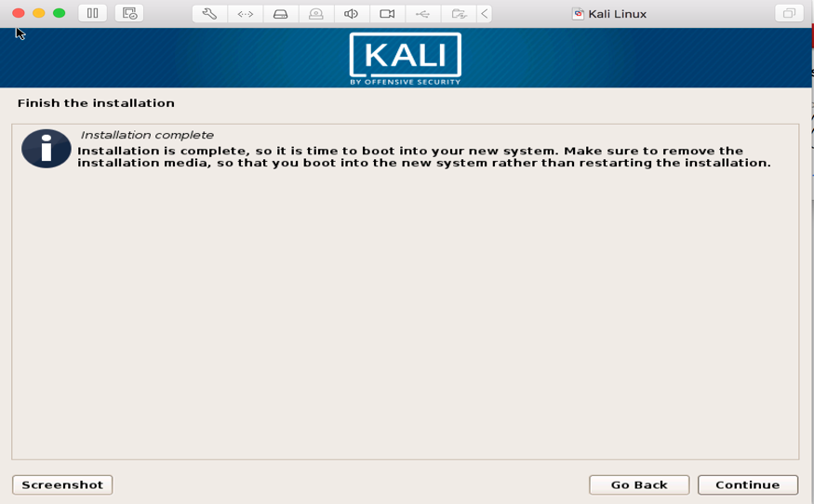

- Click Continue. You will see the Kali VM login screens. Login as root and use the password you assigned for root.

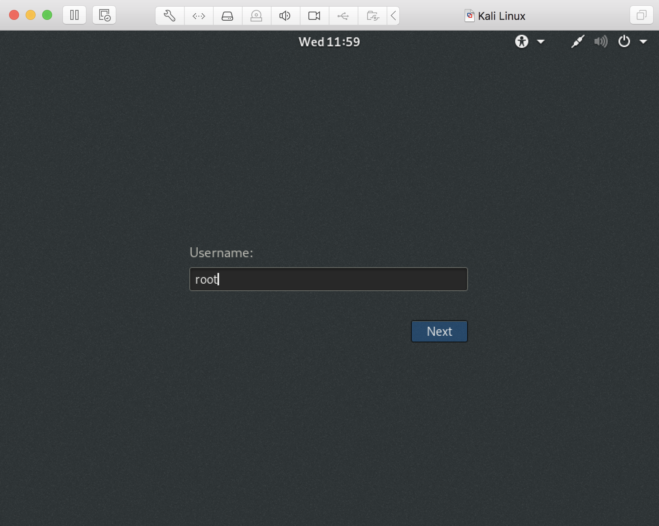

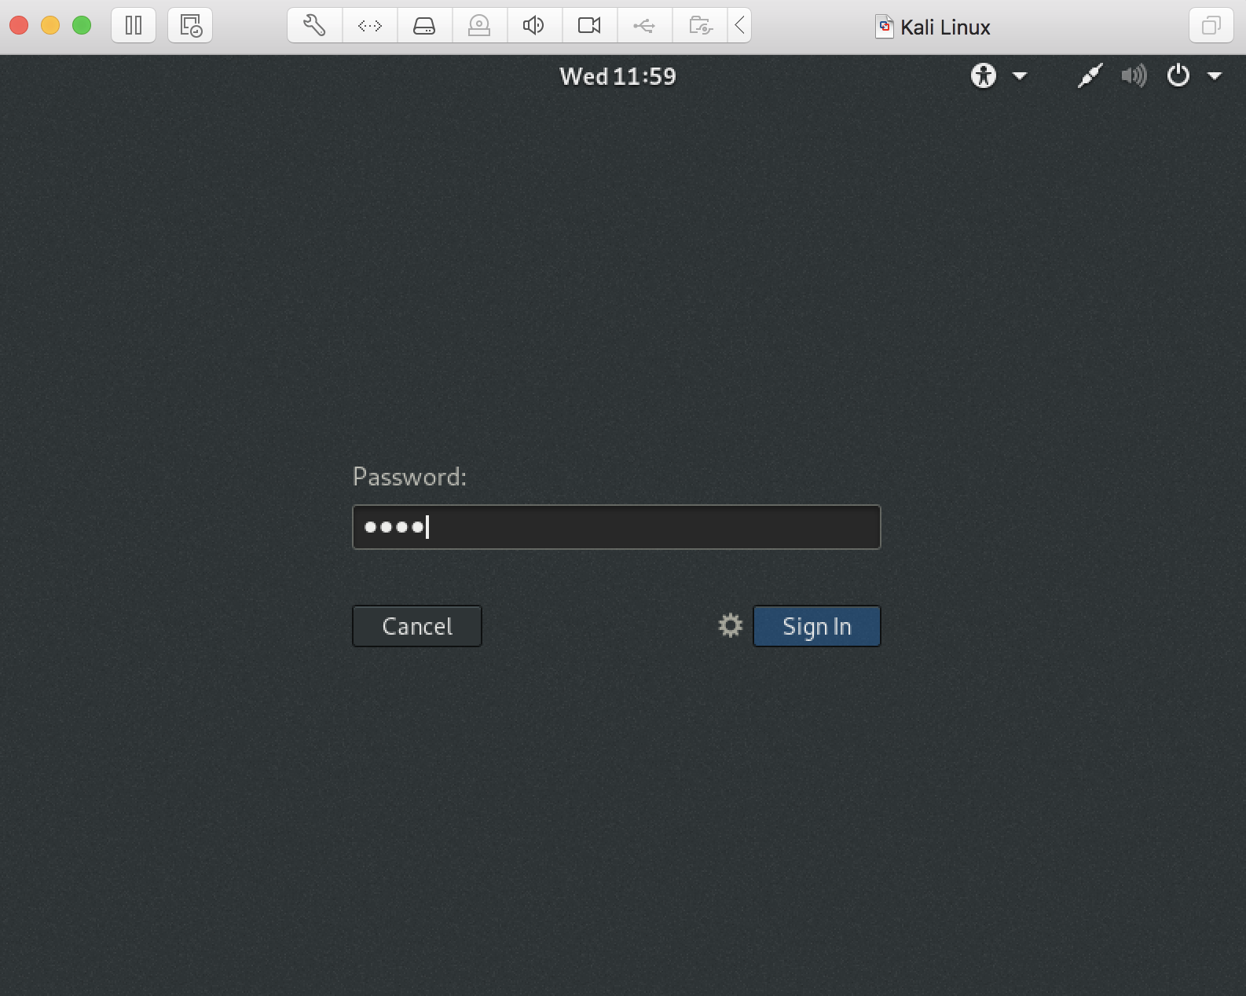

- You are now logged into Kali. You will see screen below. Power off as shown in next screenshot.
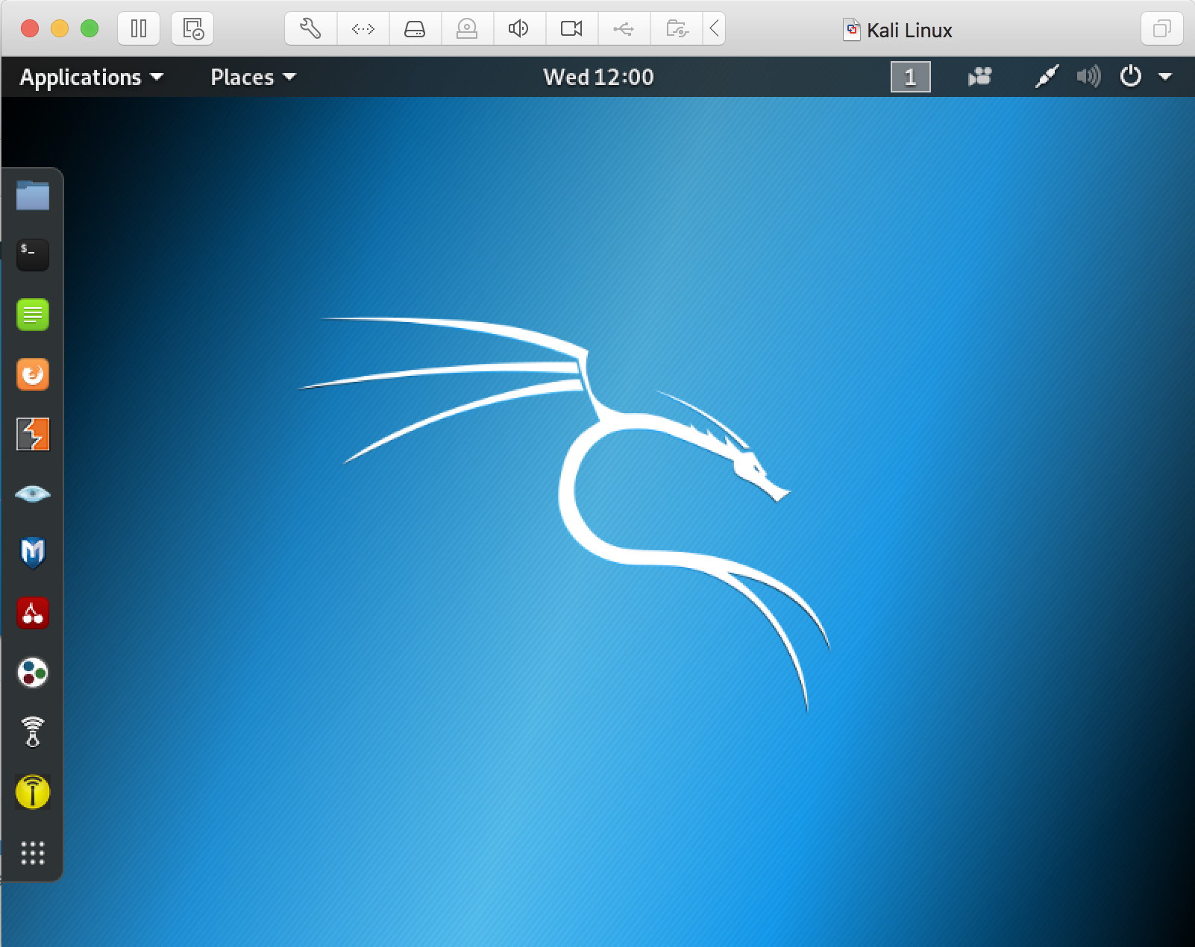

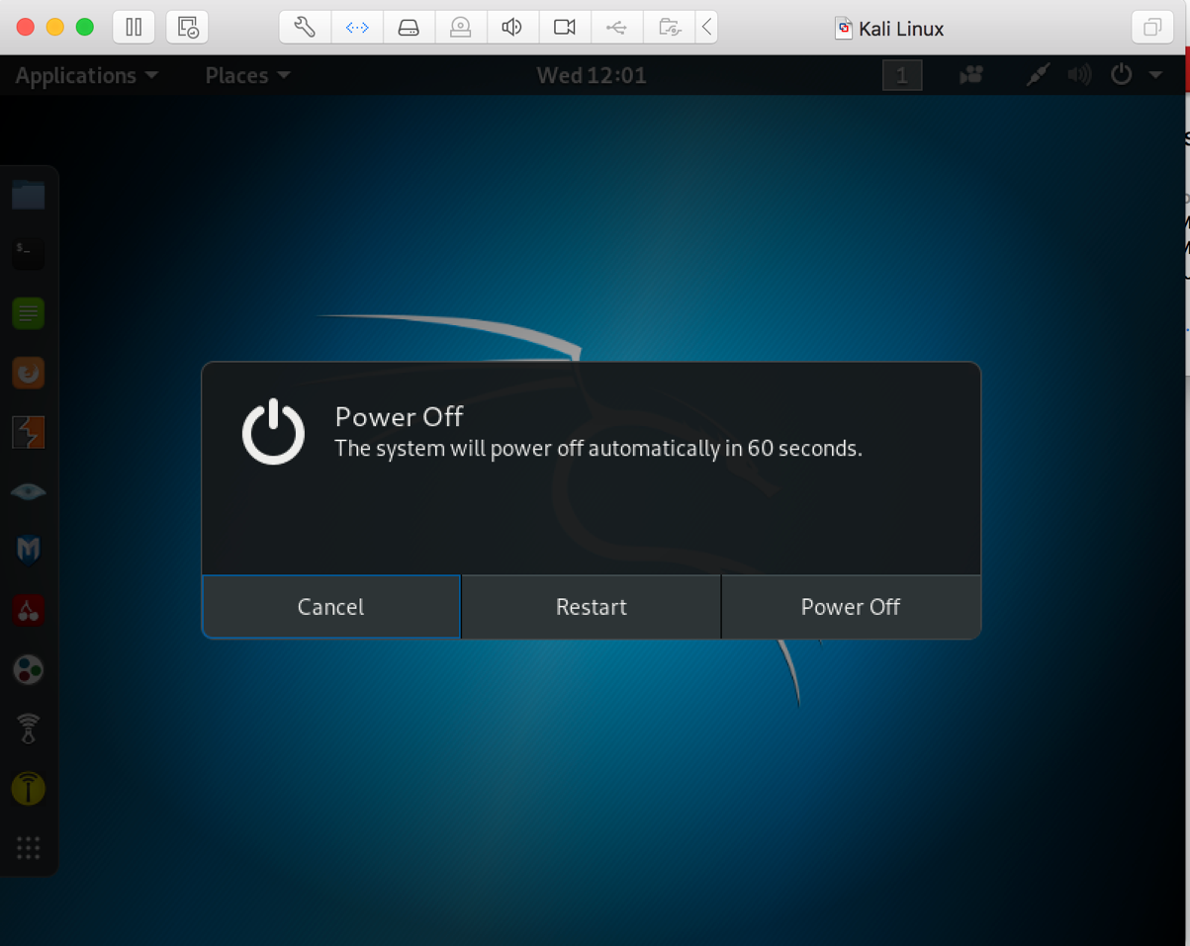

- Now we need to set the correct network settings for Kali as we did for Ubuntu. Still in VMwareFusion you will choose “Settings” under Virtual Machine

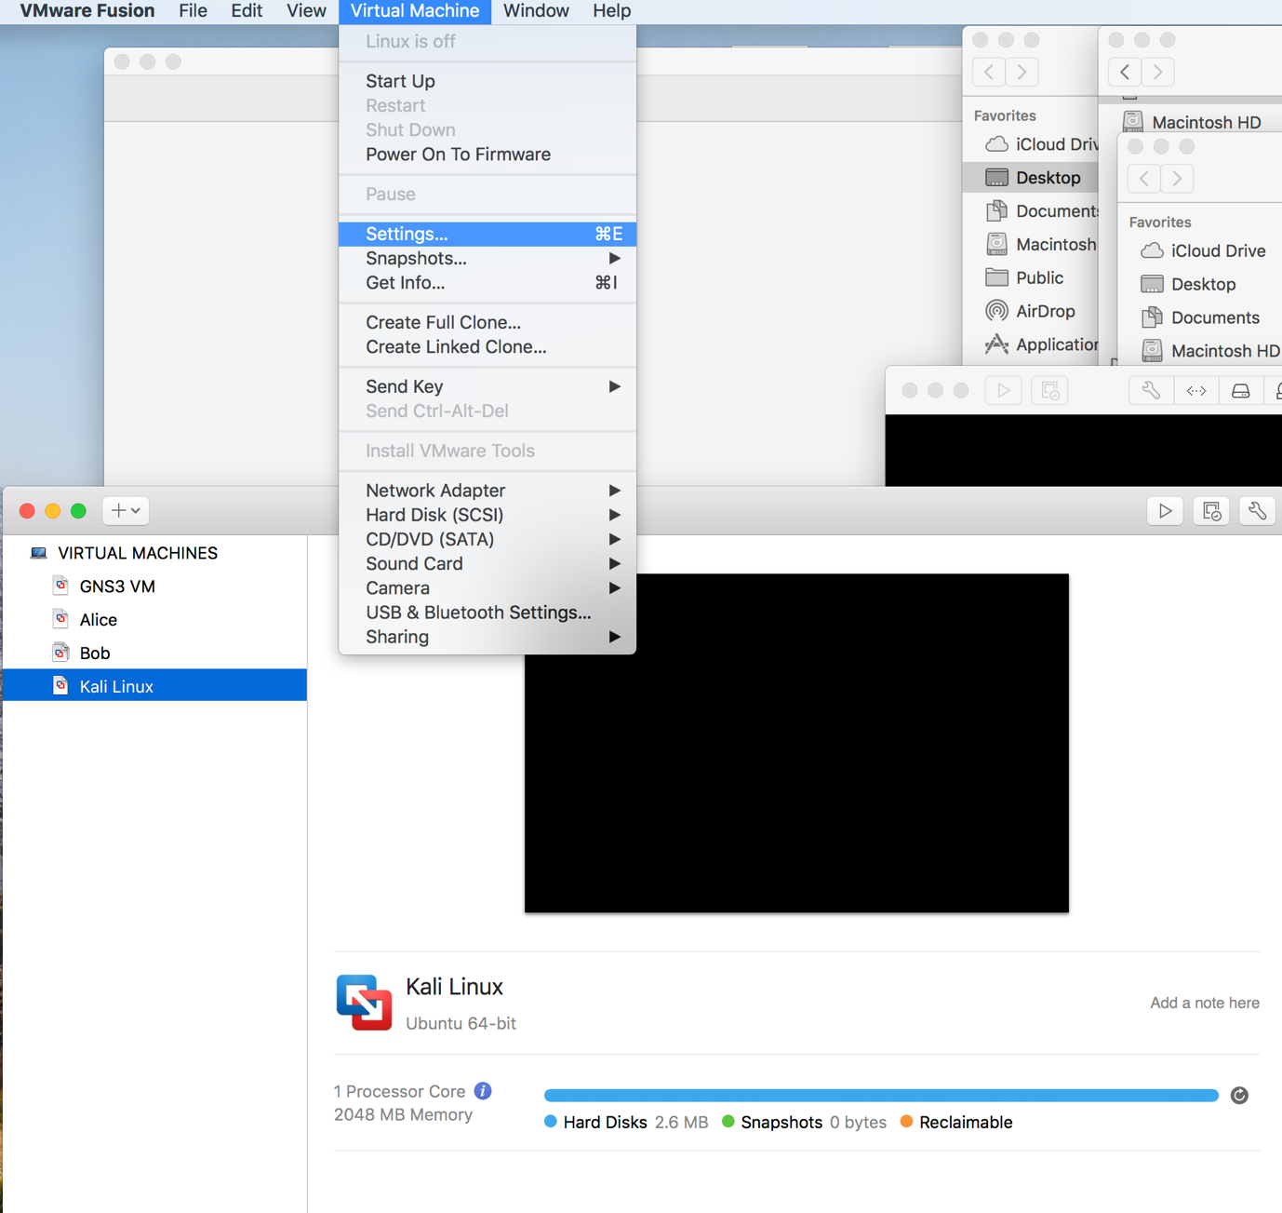

- Choose “Network Adapter” under Systems Settings.

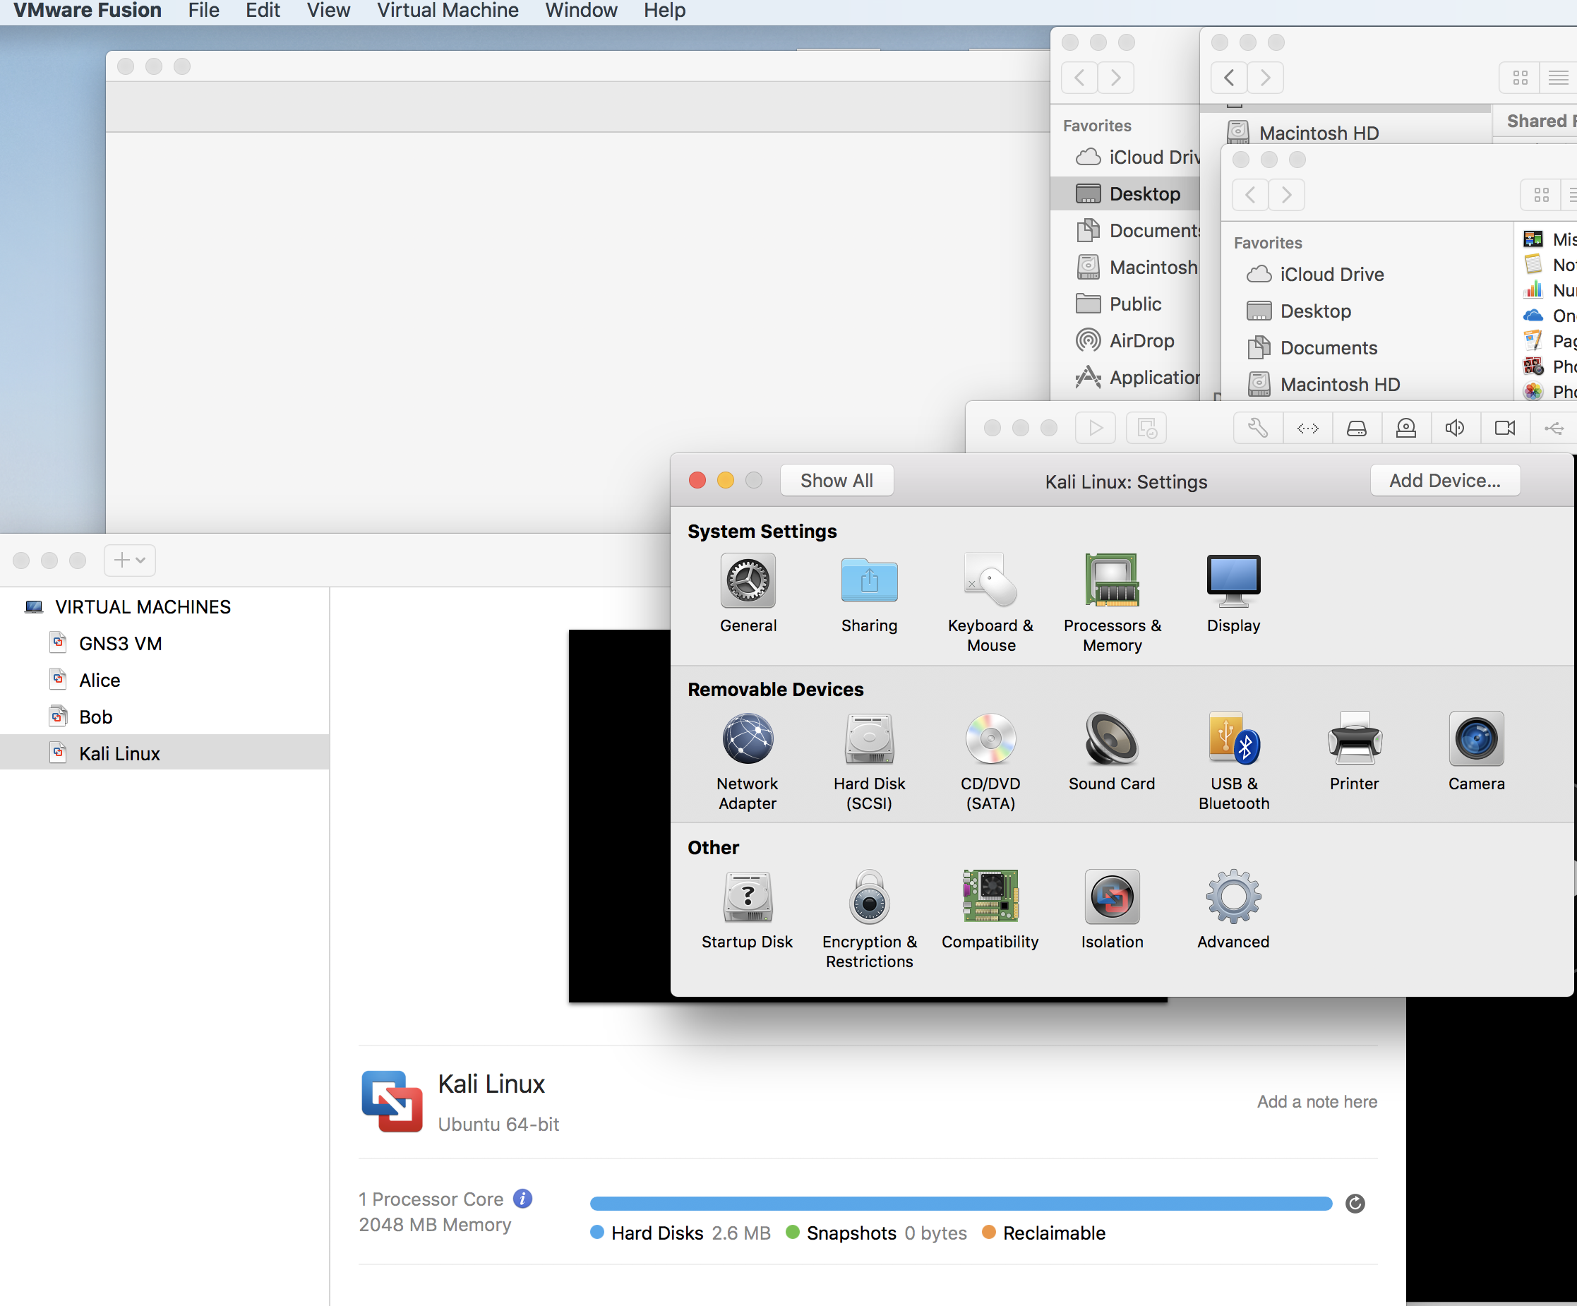

- You will see this screen, choose vmnet2 as shown. Close Systems settings

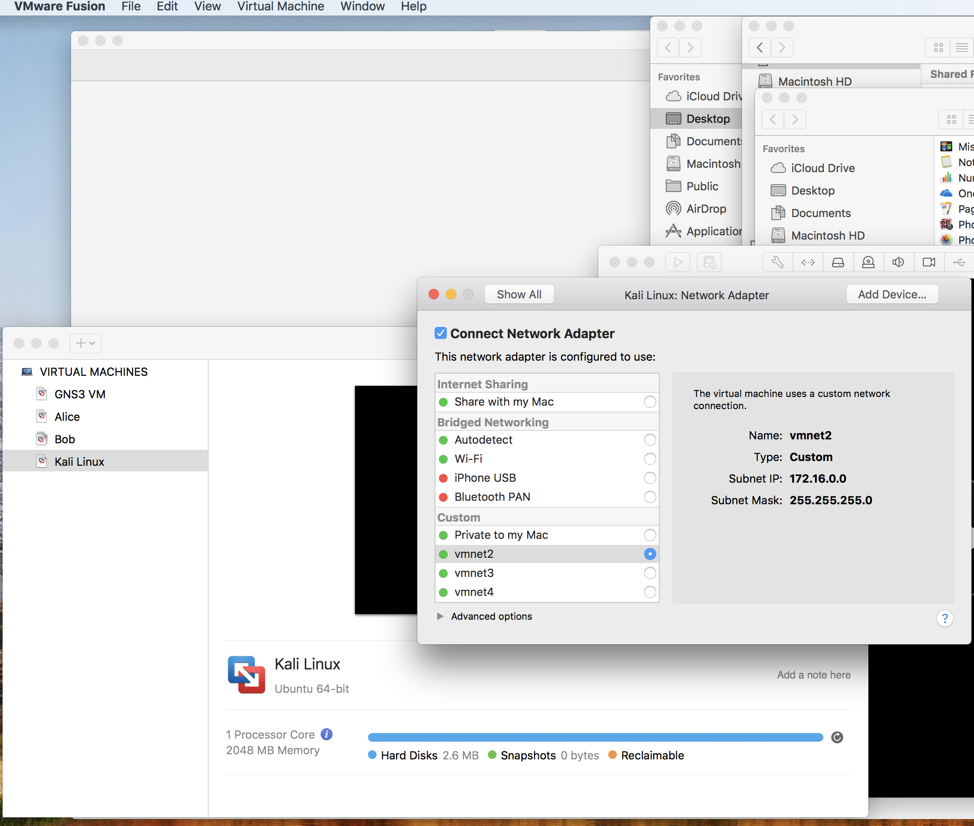

- After the installation process is completed, poweroff Kali inside the VMware. Now you need to import Kali into GNS3 as outlined in Exercise 2. below.
Exercise 2. Importing Kali into GNS3

- Go to GNS3 preference and click on the VMware VMs under VMware.
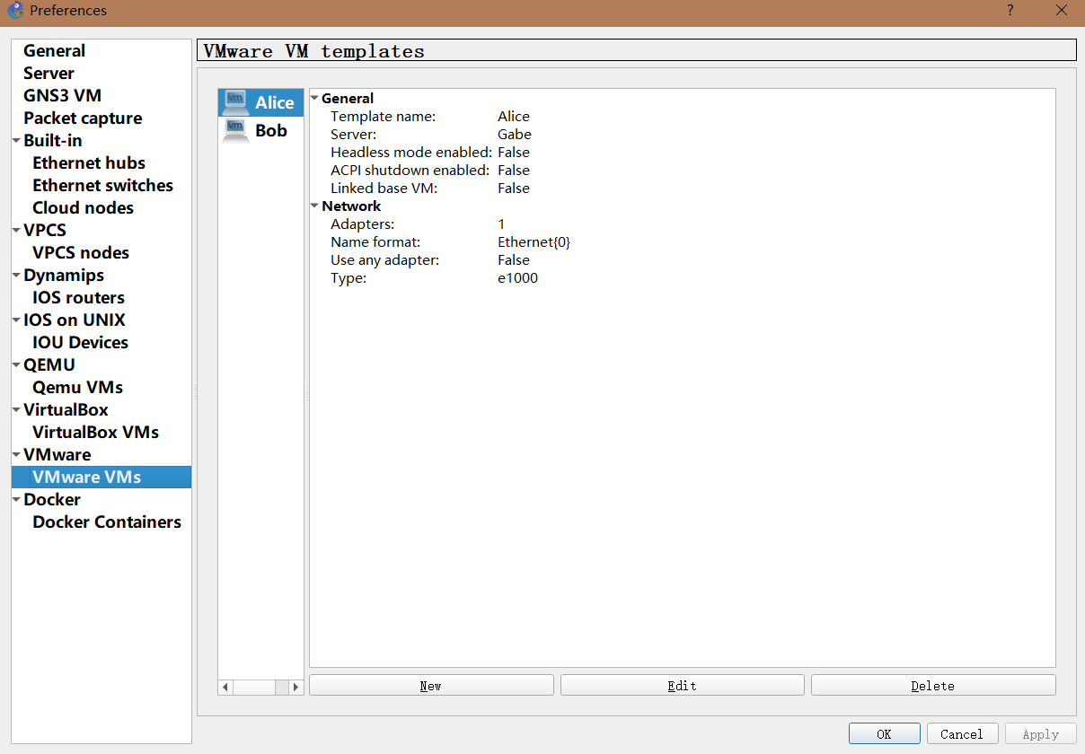

- Click the “New” option.
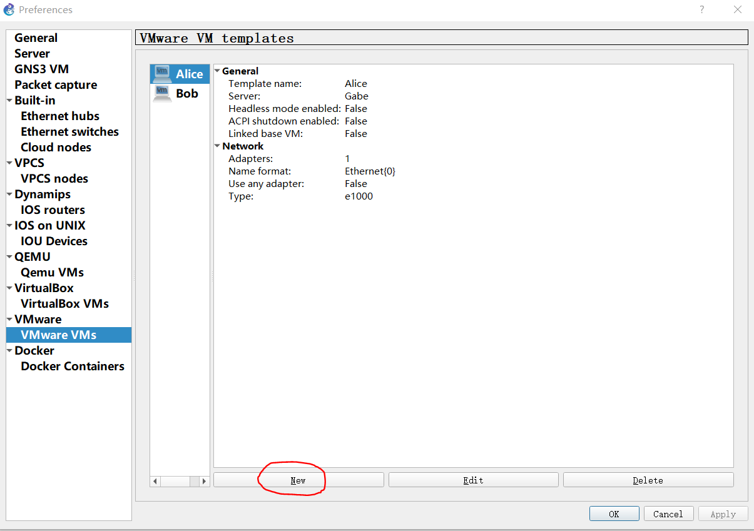
- Choose “Run this VMware VM on my local computer”
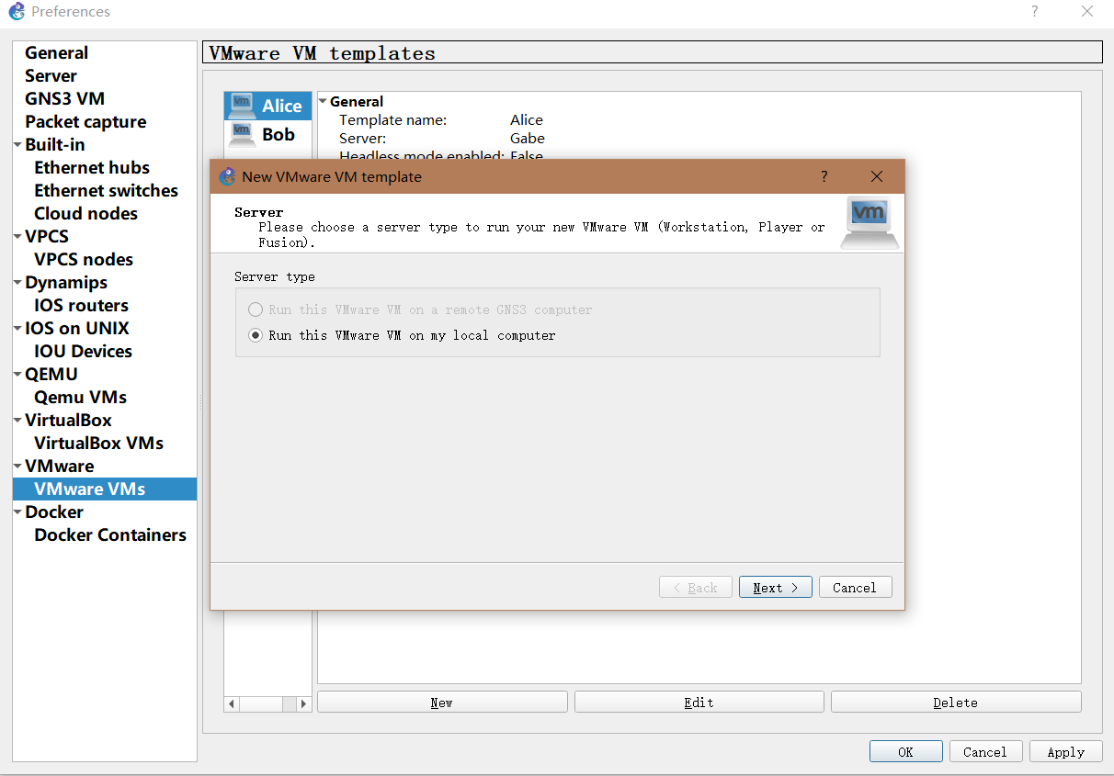

- Choose Kali in the VM list and then click Finish.
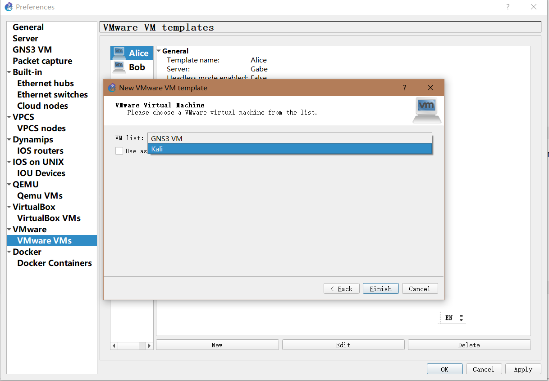

- Now you should have three VMs in total in the VM templates.

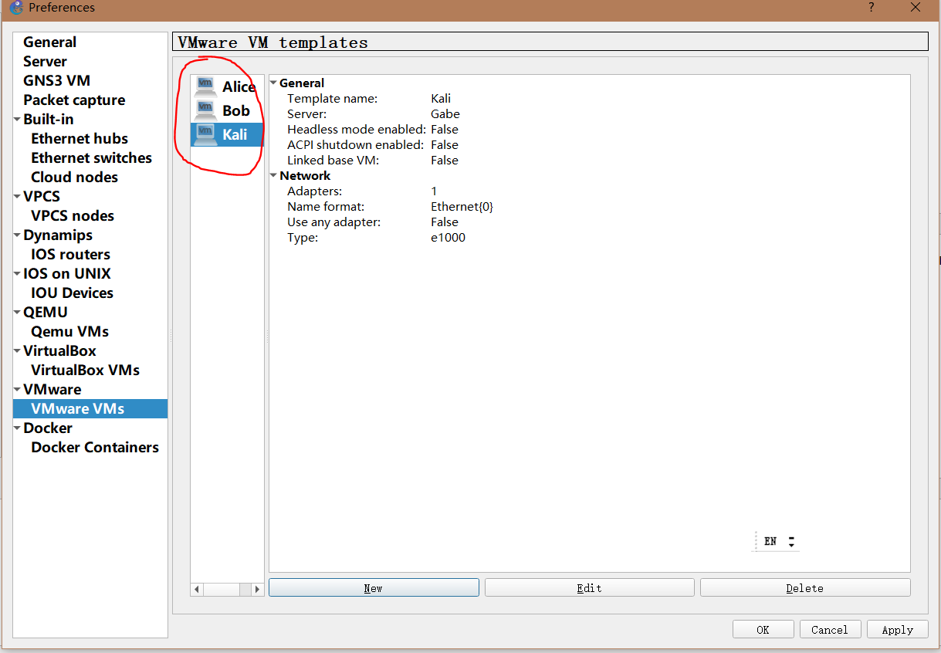

- Click “Apply” to register the changes.

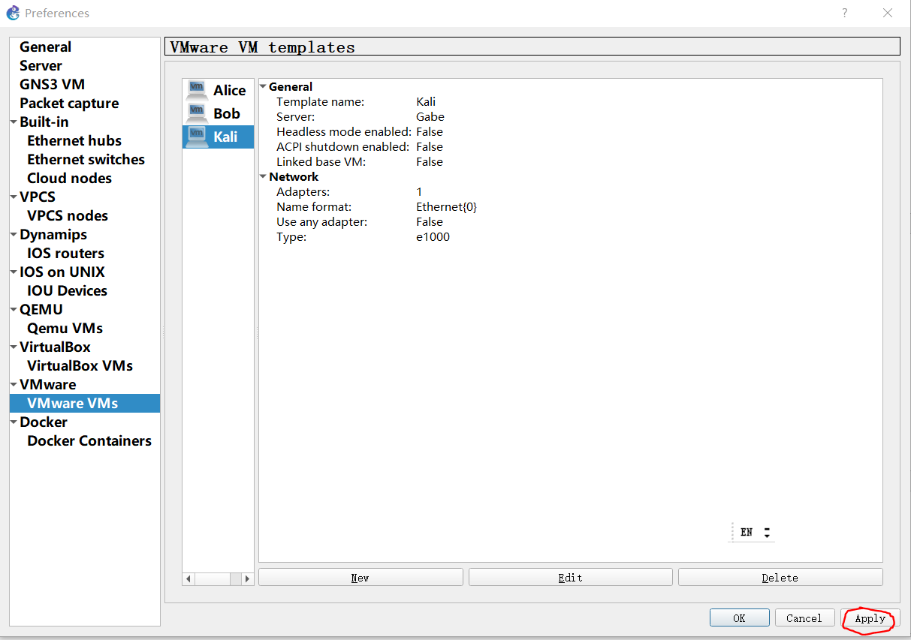

- Now Kali is imported into GNS3 and you should be able to see it in your Installed Appliances list:

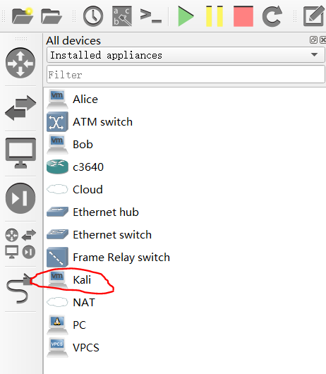

Exercise 3. Testing Interoperability of Installed Appliances
To test the interoperability of ipterm PCs, Alice, Bob and Kali create a new blank project and name it “test”.

Note: This exercise will have all three VMs running at the same time, it might consume a lot of processing power and slow down your laptop significantly. Please be patient when starting GNS3 up.

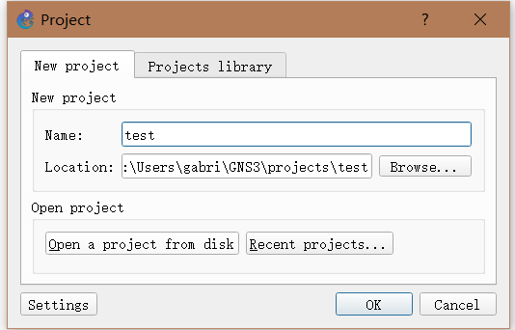

- Go to preference of GNS3 VM and find VMware VMs. Then click the “Edit” button for Alice. You should see the following:
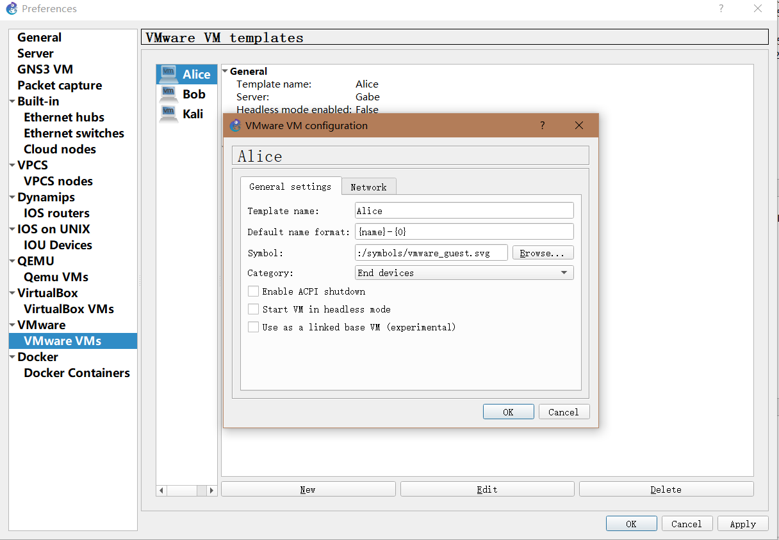

- Then Click the “Network” tab. Check “Allow GNS3 to override non custom VMware adapter and click OK.
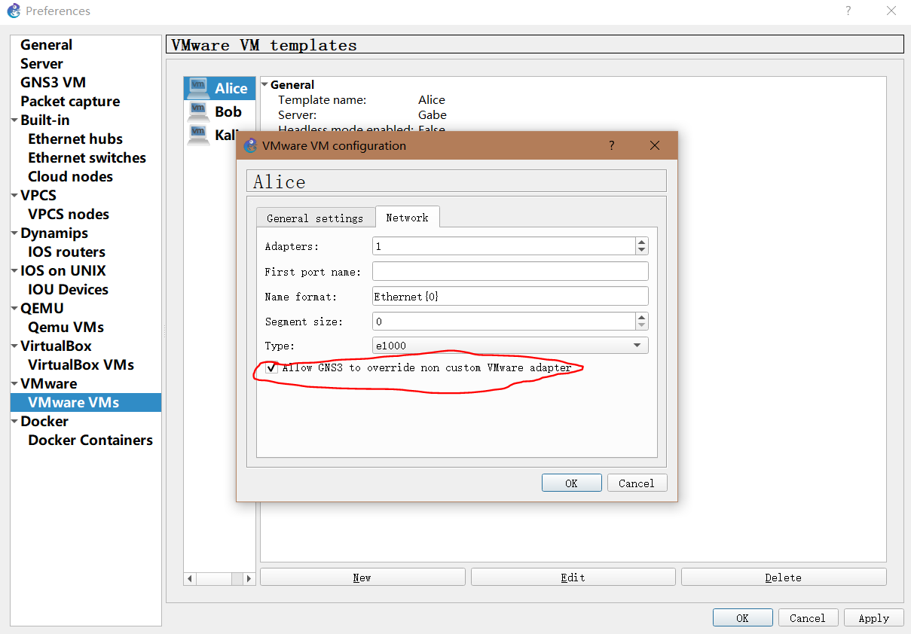

- REPEAT for Bob and Kali.
- Once you are done with making those changes, choose VMware tab and VMware preferences screen will be displayed. Click on the Advanced local settings tab. Click “Block network traffic originating from the host OS”. Then click “Configure”. When the configuration is done, click Apply then OK.
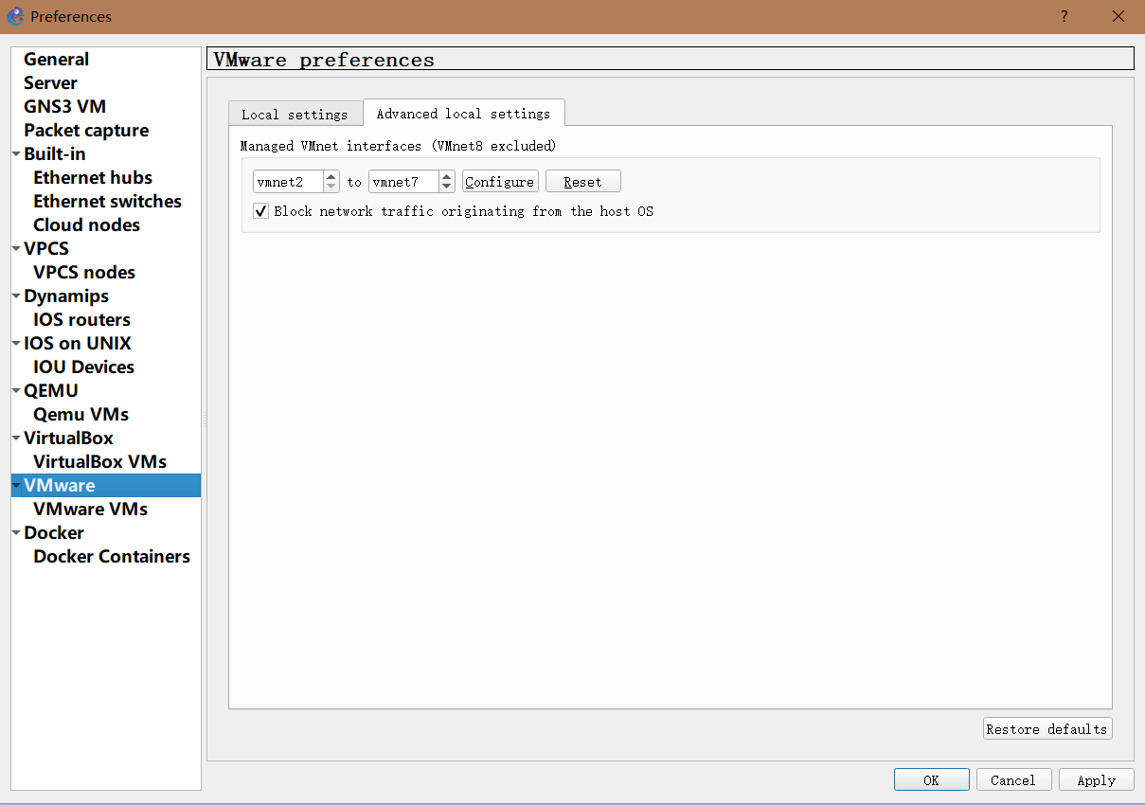
- From the “Browse all devices” button on the left, drag one PC (ipterm), Alice, Bob, and Kali into your test project paneb and use an Ethernet hub to connect the four hosts as shown in the figure below.
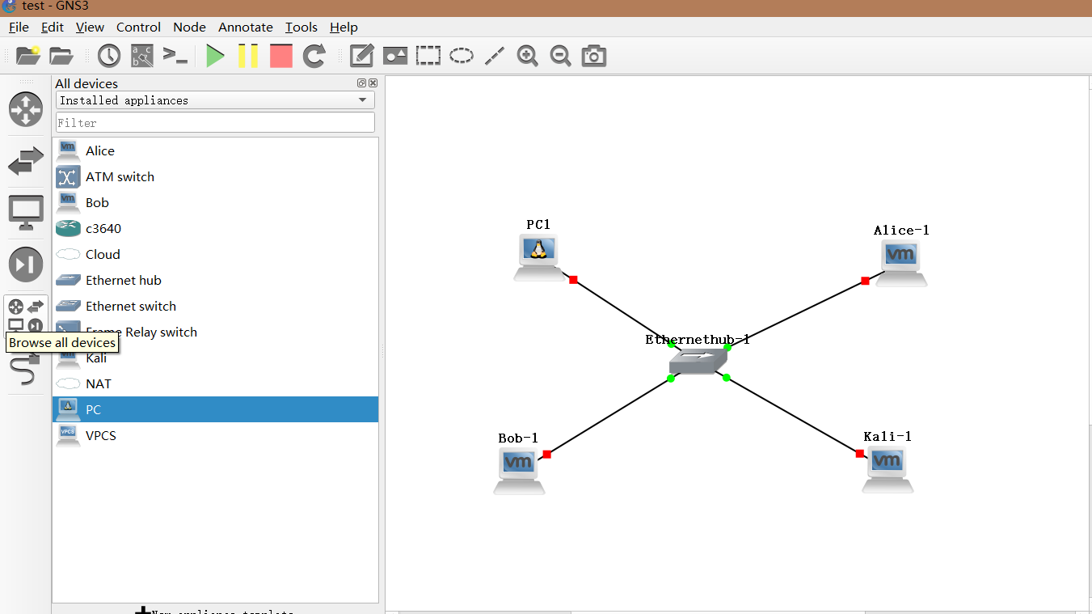

- Hit the Green Play button to start each device. After clicking Play, all the devices will start up, please be patient as it may take awhile.
Note: Alice, Bob and Kali operate inside VMware like an individual machine and the GNS3 consoles don’t work with them. They will open up their own console windows as regular workstations. If they fire up fine, all are showing green in upper right pane, then proceed to step 10.
If you errors pop up as shown in the next few screens, follow below what is recommended you do.

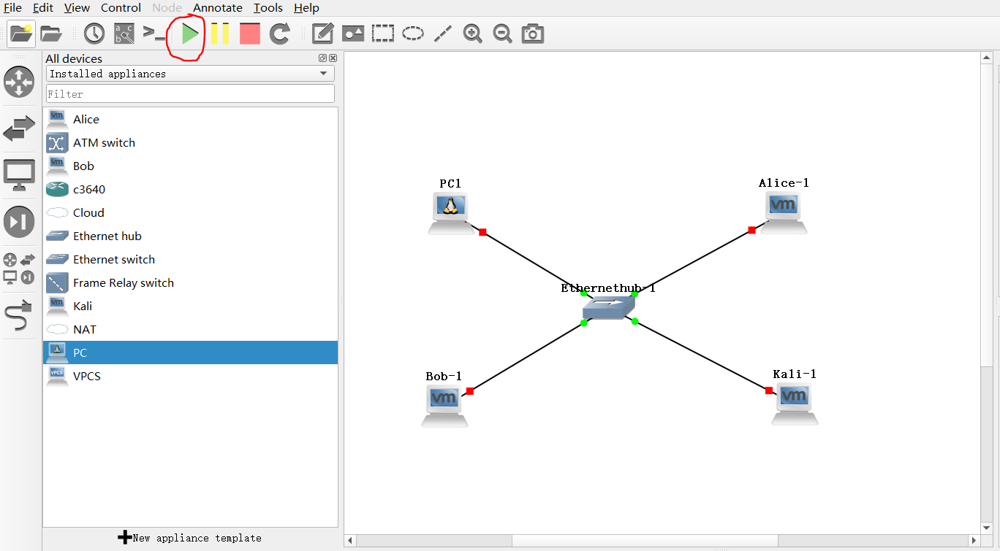

If you see the above error message pop up, click ok. The virtual machine should power on after you press ok.

Click Yes if you see the above message pop up. This should get everything going.

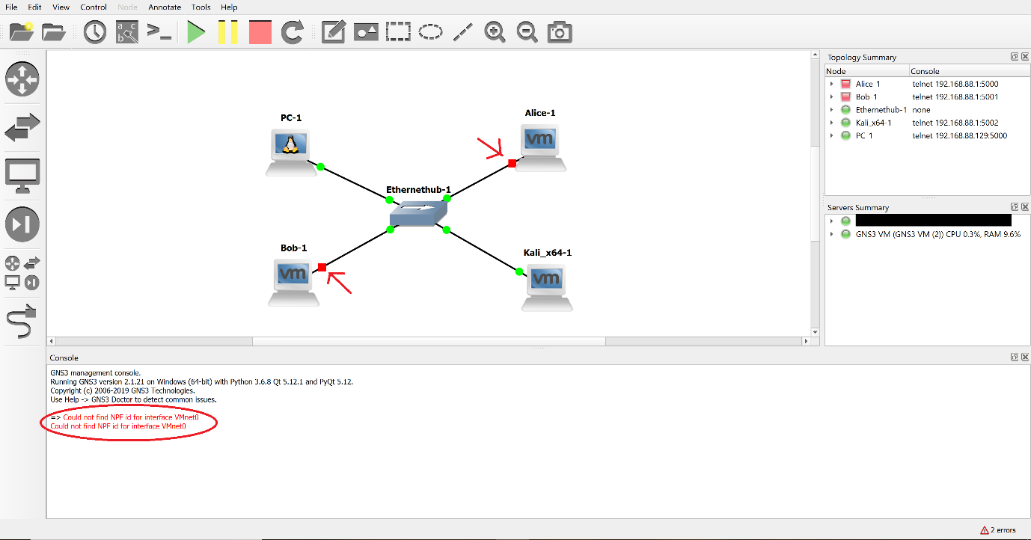

Note: If you see an error as above saying “Could not find NPF id for VMnet0” and/or you see that Alice, Bob or Kali have not started (like in the figure above, VMs Alice and Bob shown as RED in upper right Topology Pane), you need to go to back to VMware and manually set the Network Interface of your Alice, Bob, Kali on a different VMnet. Below we show the process for VMware Workstation for Windows. Exercise 2. above showed steps that need to be followed for WMware Fusion for MAC OS. The steps were given for Kali. Apply the same to Alice and Bob.
- For VMware Workstation you do as follows:
  - Click on a VM, e.g., Alice.
  - Click on Edit virtual machine settings.

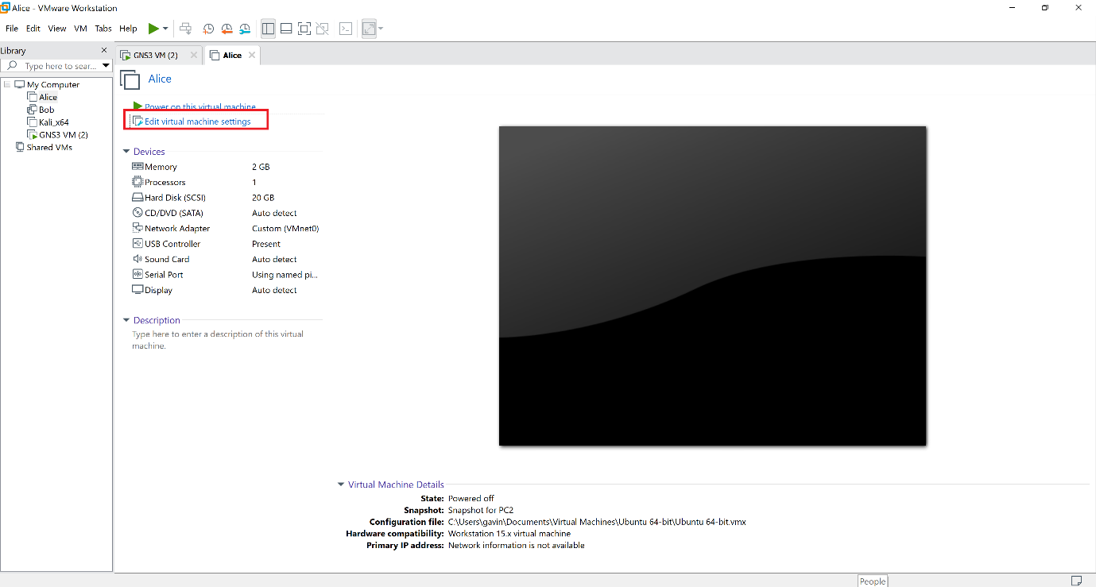
  - Choose “Network Adapter”. Change VMnet0 under “Custom: specific virtual network”, to a different VMnet (shown here VMnet2). DO NOT use a Host-only VMnet.
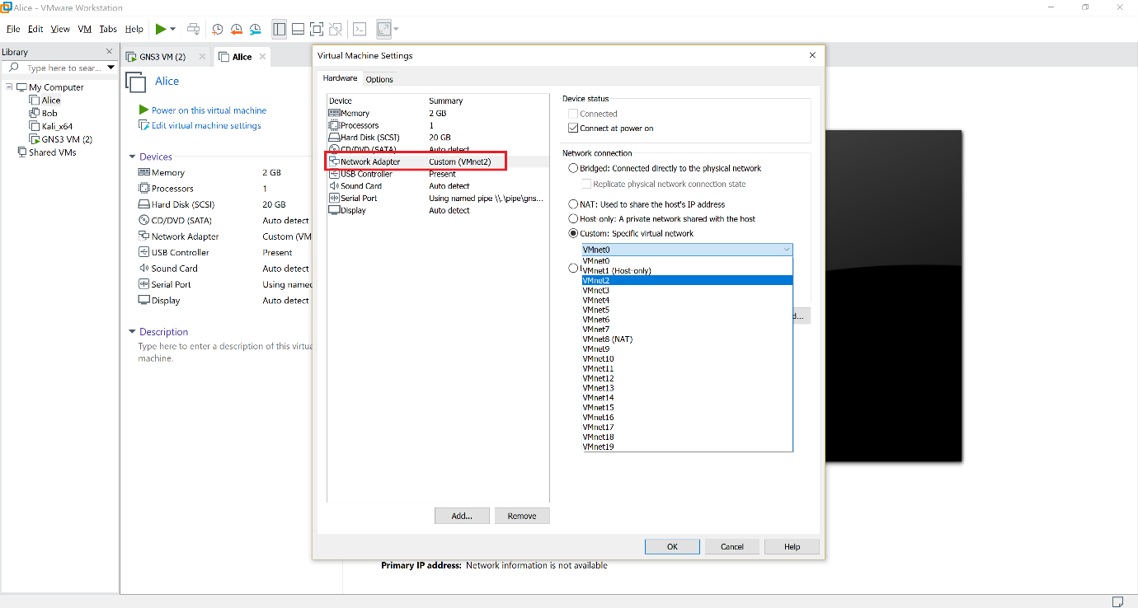
- Repeat for Bob and Kali.
- Now go back to GNS3 and try starting all the VMs. They should fire up.
- For each VM (Kali, Alice and Bob), check the upper right corner of the machine. If it shows Wired Connecting, click on Turn off.
Note: You need to check this every time you start Alice, Bob and Kali in GNS3.

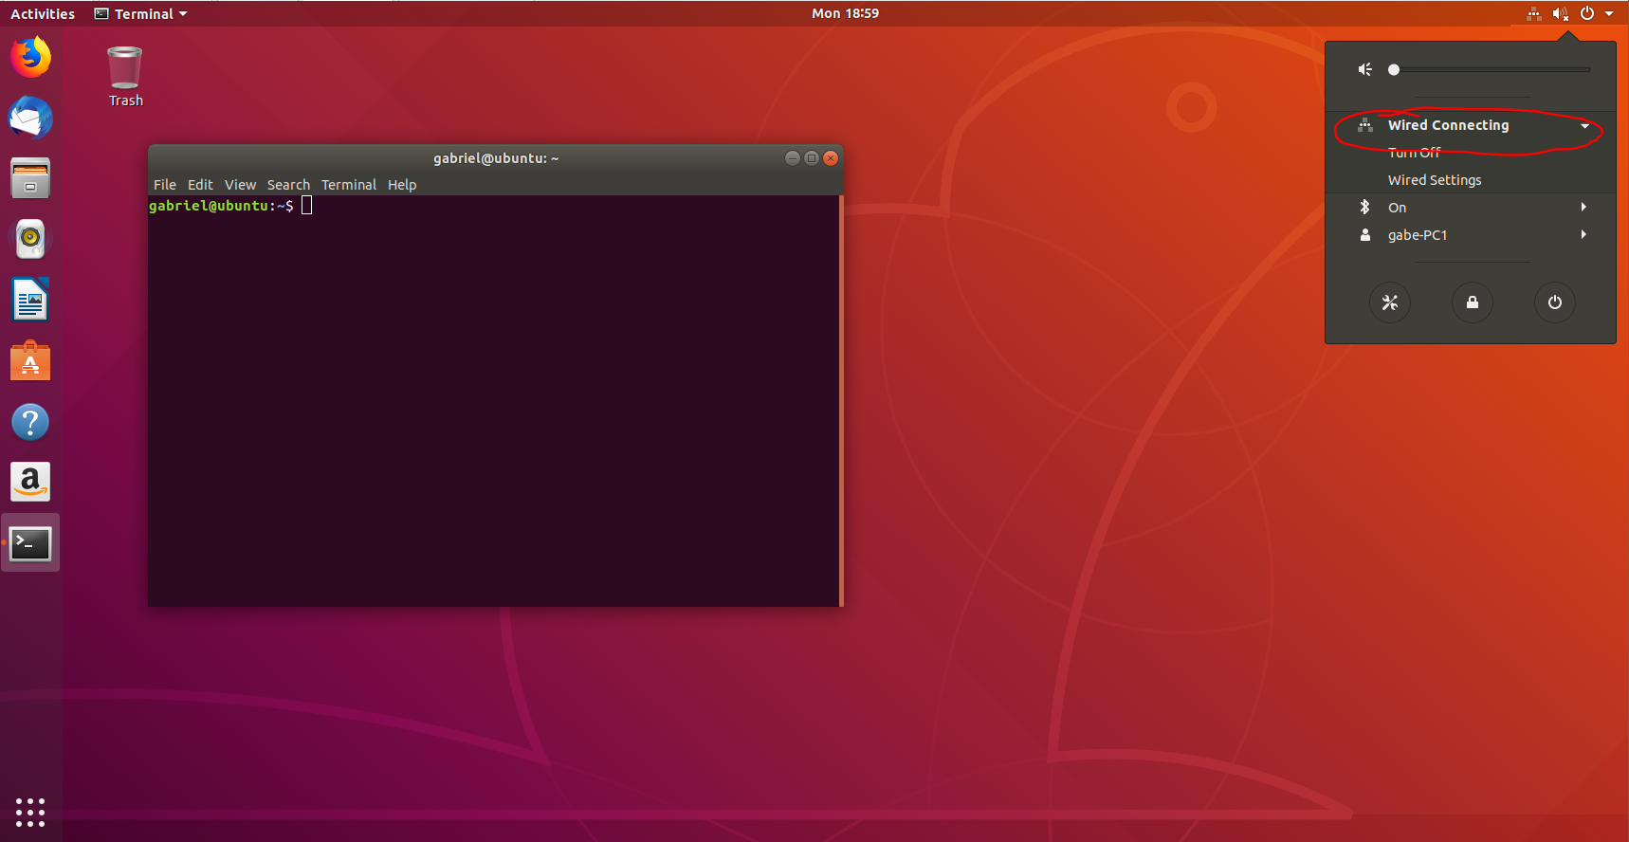

- Now issue the following commands for each of the devices to configure their IP interface.
For PC1: PC1% ifconfig eth0 10.0.1.1/24
For Alice: Alice% sudo ifconfig ens33 10.0.1.2/24
For Bob: Bob% sudo ifconfig ens33 10.0.1.3/24
For Kali: Kali% ifconfig eth0 10.0.1.4/24
- After configuring the interfaces, check to see if all is correct by typing type ifconfig in each of the console screens, you should see the following output for each the device.
PC1:
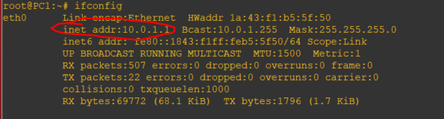
Alice:
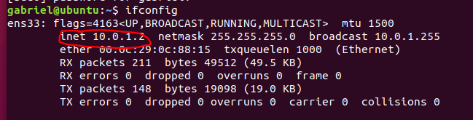
Bob:
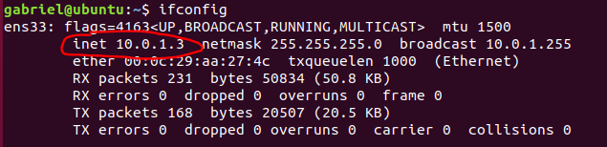
Kali:
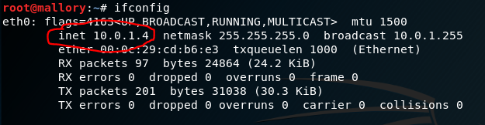

- After verifying all the IP addresses for all the devices, issue a ping command from one to all the others as follows. They should all be successful.
- For PC1:
PC1% ping 10.0.1.2 -c 5
PC1% ping 10.0.1.3 -c 5
PC1% ping 10.0.1.4 -c 5
- For Alice:
Alice% ping 10.0.1.1 -c 5
Alice% ping 10.0.1.3 -c 5
Alice% ping 10.0.1.4 -c 5
- For Bob:
Bob% ping 10.0.1.1 -c 5
Bob% ping 10.0.1.2 -c 5
Bob% ping 10.0.1.4 -c 5
- For Kali:
Kali% ping 10.0.1.1 -c 5
Kali% ping 10.0.1.2 -c 5
Kali% ping 10.0.1.3 -c 5
Phew….. your installation has been completed successfully!
- Now go to GNS3, stop all devices and then close/quit GNS3.
