- Go to “Preference” in the GNS3, and click the VMware VMs under the VMware tab.
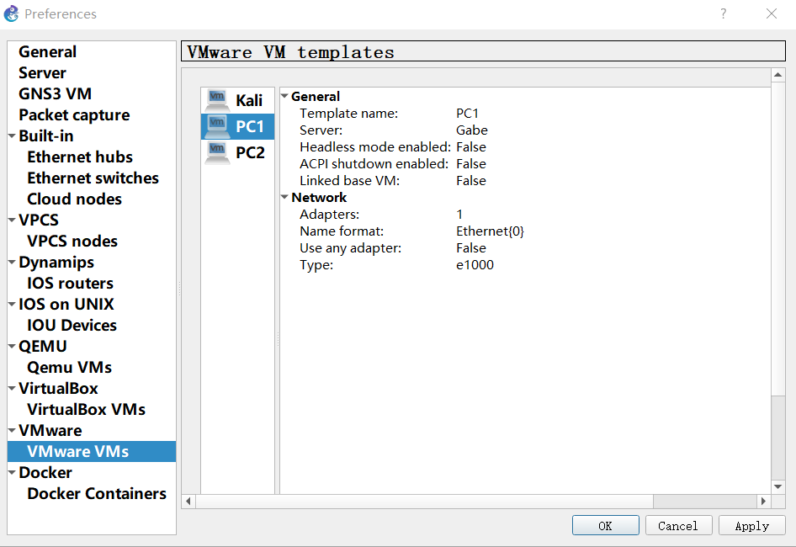
- Click on PC1. Scroll down and click “Edit”
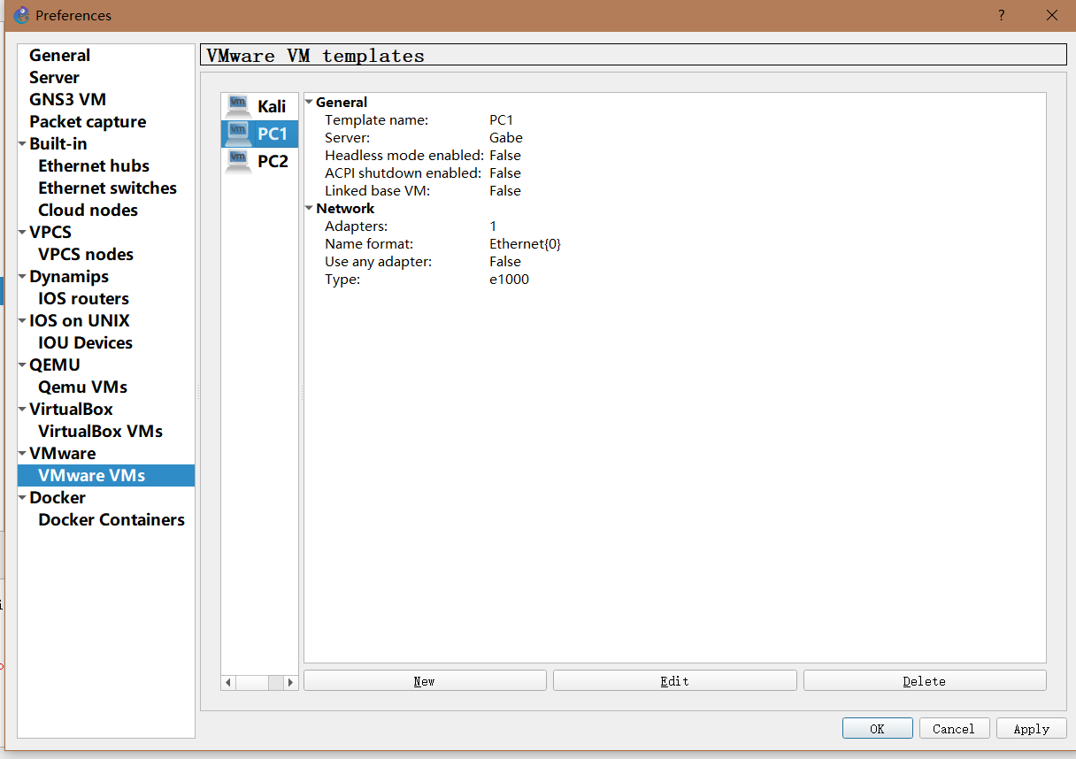

- Change the name of PC1 to “Alice”
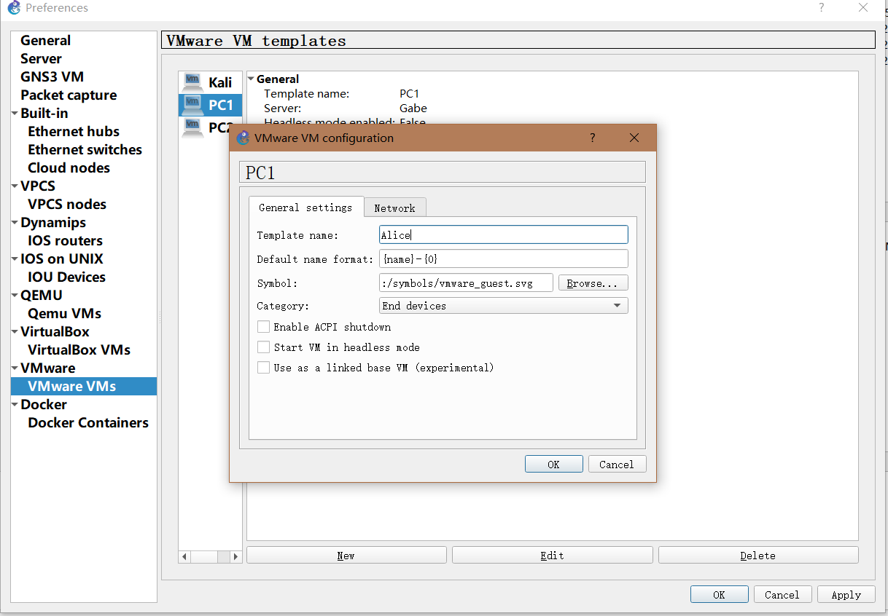
- Repeat for PC2 and name PC2 “Bob”. Now you should see 3 VMs under the VMware VM templates: “Kali”, “Alice” and “Bob”, as shown below.
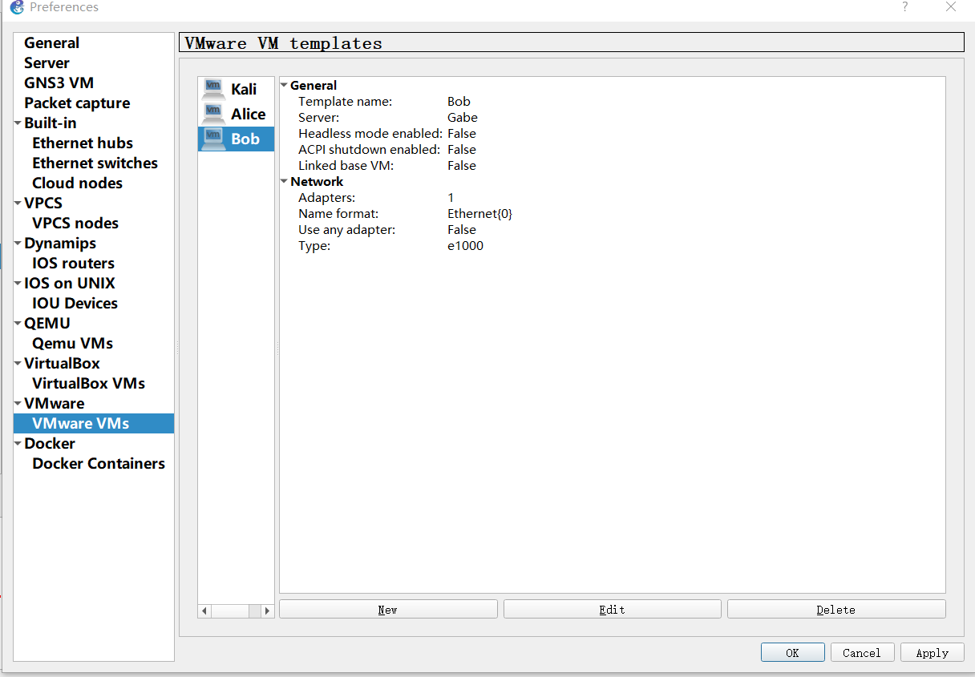
- Click Apply apply, then OK when you are done. Under All devices – Installed Appliances tab you should now see Alice and Bob in the list, as shown below:
