LAB Zero – Mac Installation
In this lab you will download all the necessary software packages and install them on your computer/laptop (Mac) to work on the labs.

You will download VMware, GNS3 and GNS3 VM, Ubuntu Linux and Kali Linux. You will import GNS3 VM into VMware. You will create Ubuntu in VMware. You will install GNS3. There are 5 parts to this lab: A through E. When you are done with Part E you will download Lab1. In Lab1 you will import the VMs and other network devices into GNS3. Once that is done you can start running network simulations (Lab 2 – 7).

Part 1 Downloading and Installing VMware Fusion
- Download VMWare fusion for your Mac platform using the following link:

https://elms.ics.uci.edu

- Login with your ICS account.
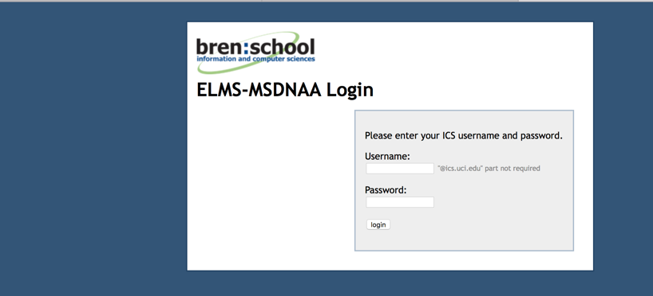

- Select “VMware Fusion” (here shown as Version 11)
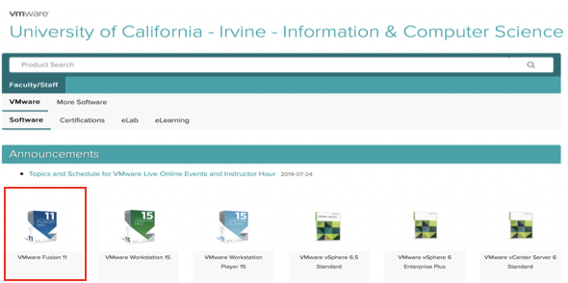

- Click “Add to Cart”.
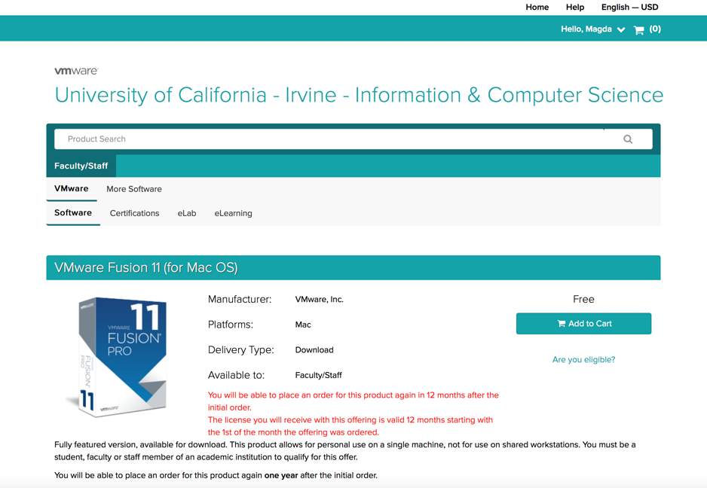

- After checking out, go to “View Orders” and click on “View Details” as shown in screen below.
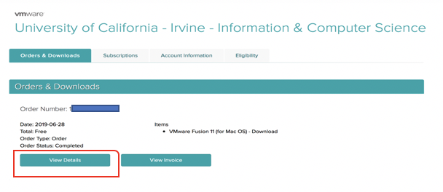
- In the “View Details” page, you will be given a serial number (license key) which you will use to activate your VMWare software, save this number for later. Click “Download”.
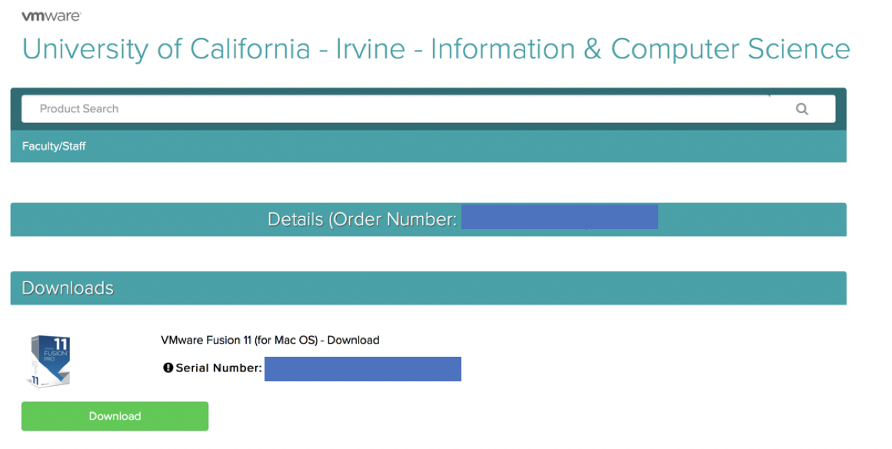
- You may see this screen. Click “Download” again. And the download will start.
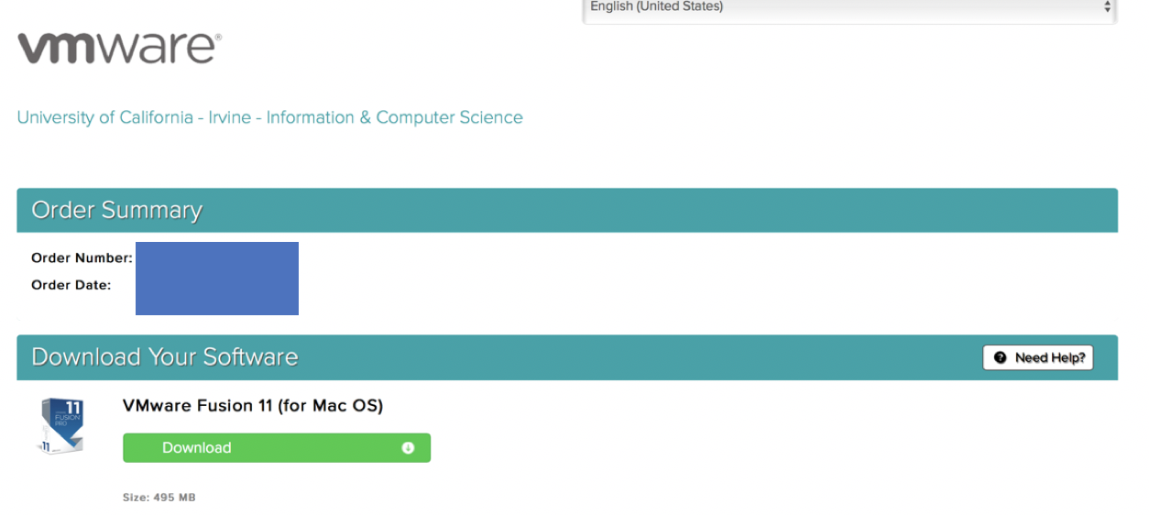

- Click on the downloaded VMware Fusion.“version#”.dmg image. You will see this screen. Double click to install.
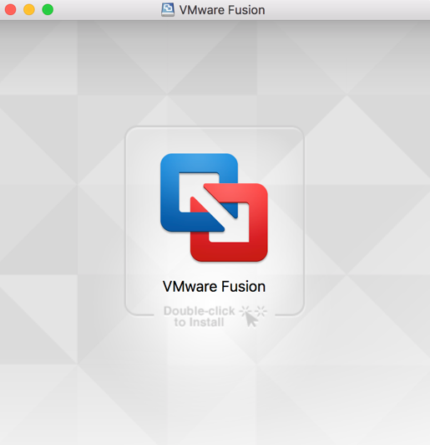

- Your Mac will ask to allow System Preferences from VMware as shown below. Click Allow.
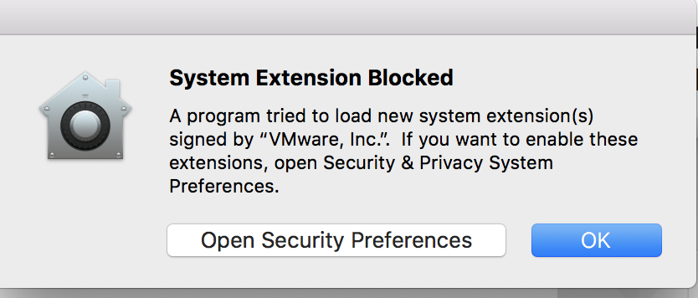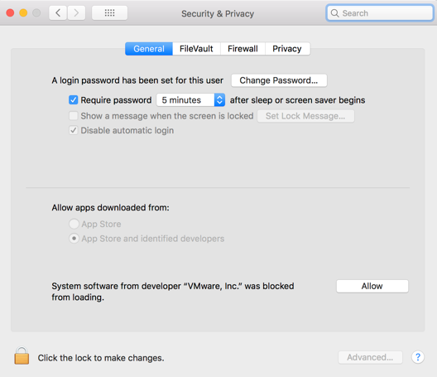

- If you are prompted to “Join the WMware Customer….”. choose No and Click “Done”.

- Upon successful installation of VMware Fusion, you should see the following screen. Minimize it for now. We will first download and install GNS3 and download GNS3 VM before coming back to this screen to import a Virtual Machine (GNS3 VM).

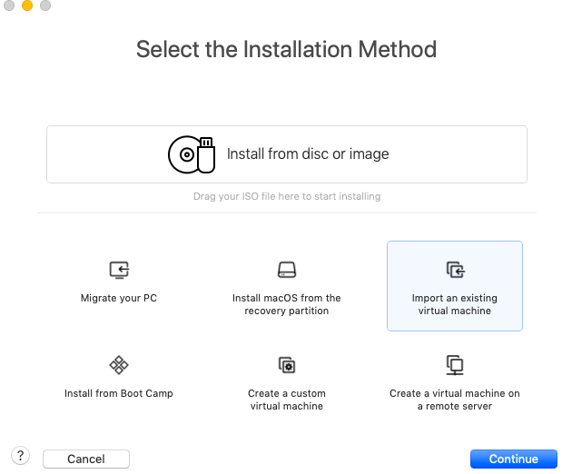

Part 2 – Downloading GNS3 & GNS3 VM and Installing GNS3
- Download GNS3 using this link:

https://www.gns3.com/software

You will see a screen as shown below.

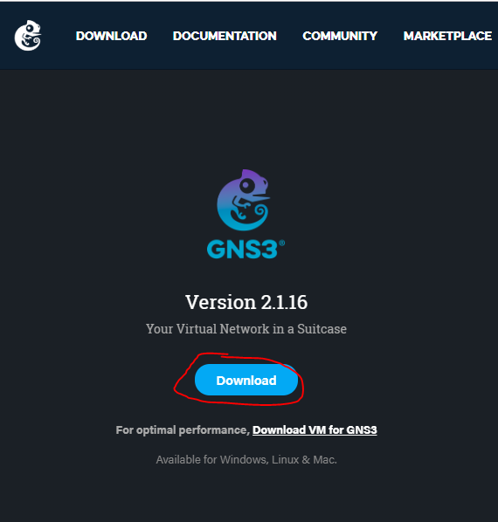

- Click on Download
  - Note: you need to sign up for a GNS3 account the first time you click on Download.
  - After you have setup an account, click on the link again and you will be able to download GNS3.

- Download the version for Mac. Do not install yet. We will do that in step 6.
- Go back to the download page and click on “Download VM for GNS3” as shown:

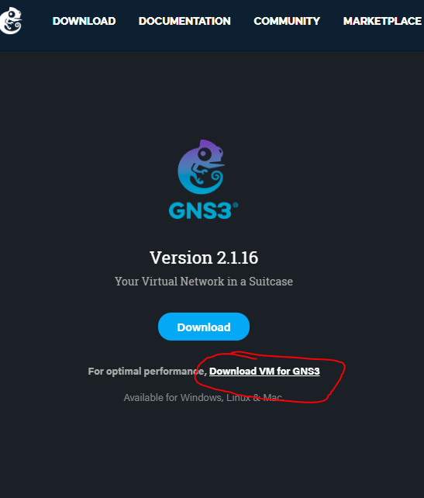

- You will then see this screen. Download the Version for VMWare Workstation and Fusion.
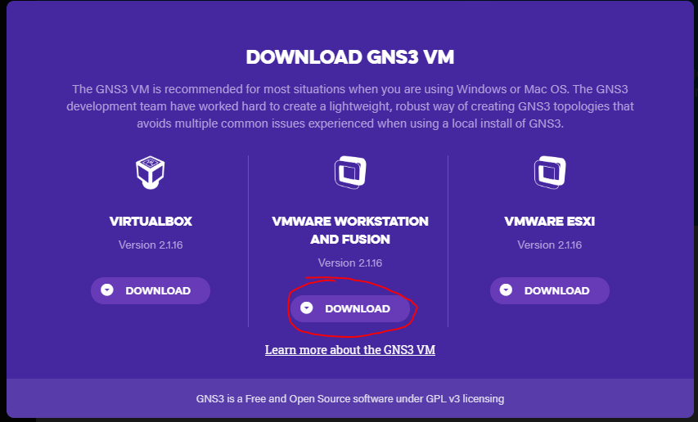

- NOW install the downloaded GNS3 software (from GNS3-“version#”.dmg) and move it to your Applications folder.

Part 3 – Creating a GNS3 VM in VMware Fusion
- In this part you will import GNS3 VM into the VMware environment.
- Go back to the screen shown in Part 1, step 11 (minimized window). If you closed the window, open VMware Fusion application. It should be in your Applications folder. You will see this screen. Select on “Import an existing virtual machine”. Click “Continue”.

- You will see this screen. Click on “Choose File…” Find “GNS3 VM.ova” file on your computer and click Continue.
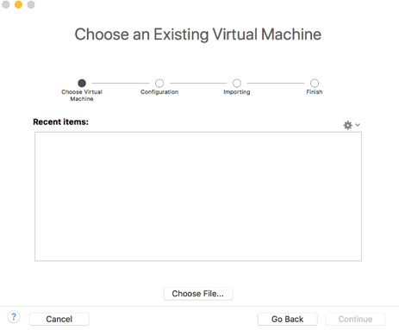

- Use the default settings to import GNS3 VM. When done you should see this screen. Click “Finish”.
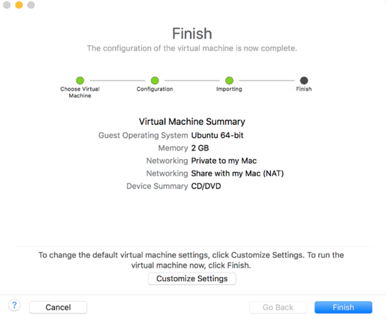
- The Virtual Machine GNS3 VM should power on.
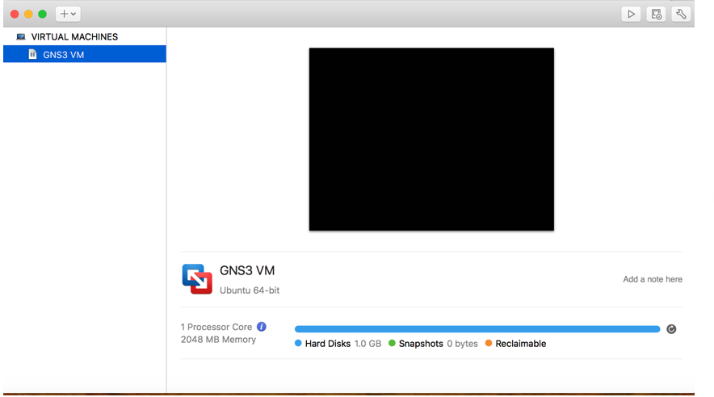

- A GNS3 console window will open too. When you see this screen, select “Yes” and press “return” on your keyboard.
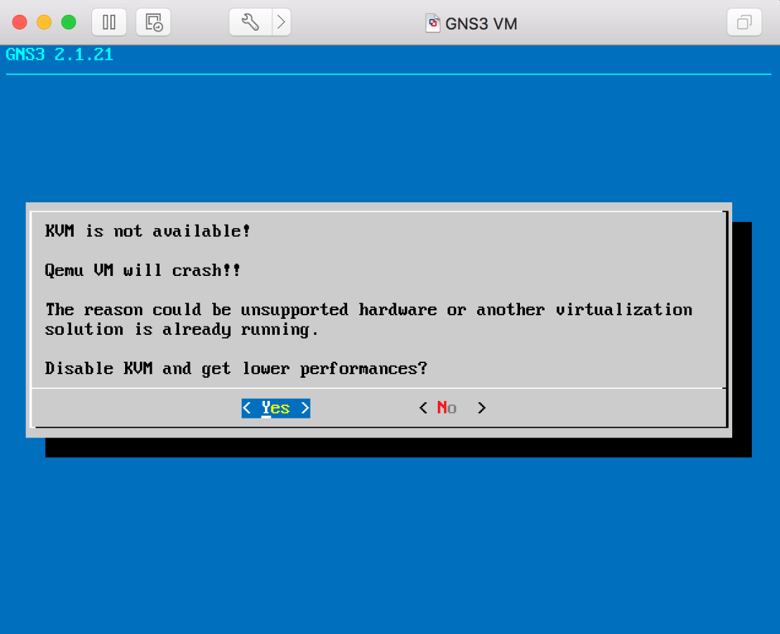
- You will then see this screen with “Information Display VM Information” highlighted. Press return.
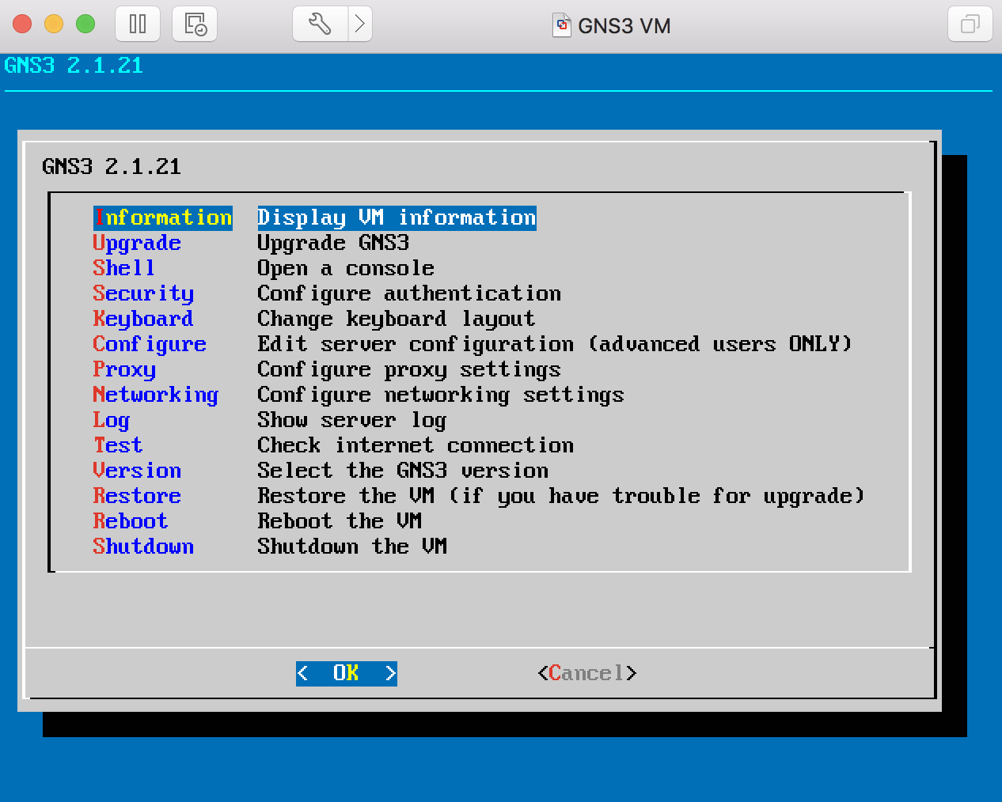
- You will see this screen. Record the IP address of your GNS3 VM. (Shown here as IP: 192.168.125.128. Yours could be different.) Then press “return” for OK.

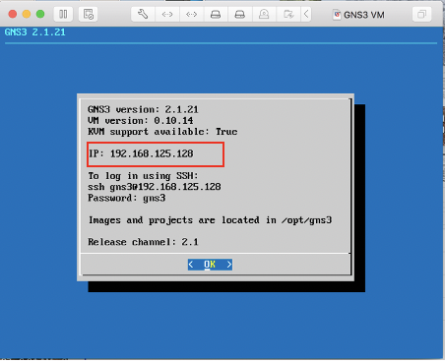

- You will see this screen again. Scroll down till you highlight “Shutdown Shutdown the VM”. Press return.
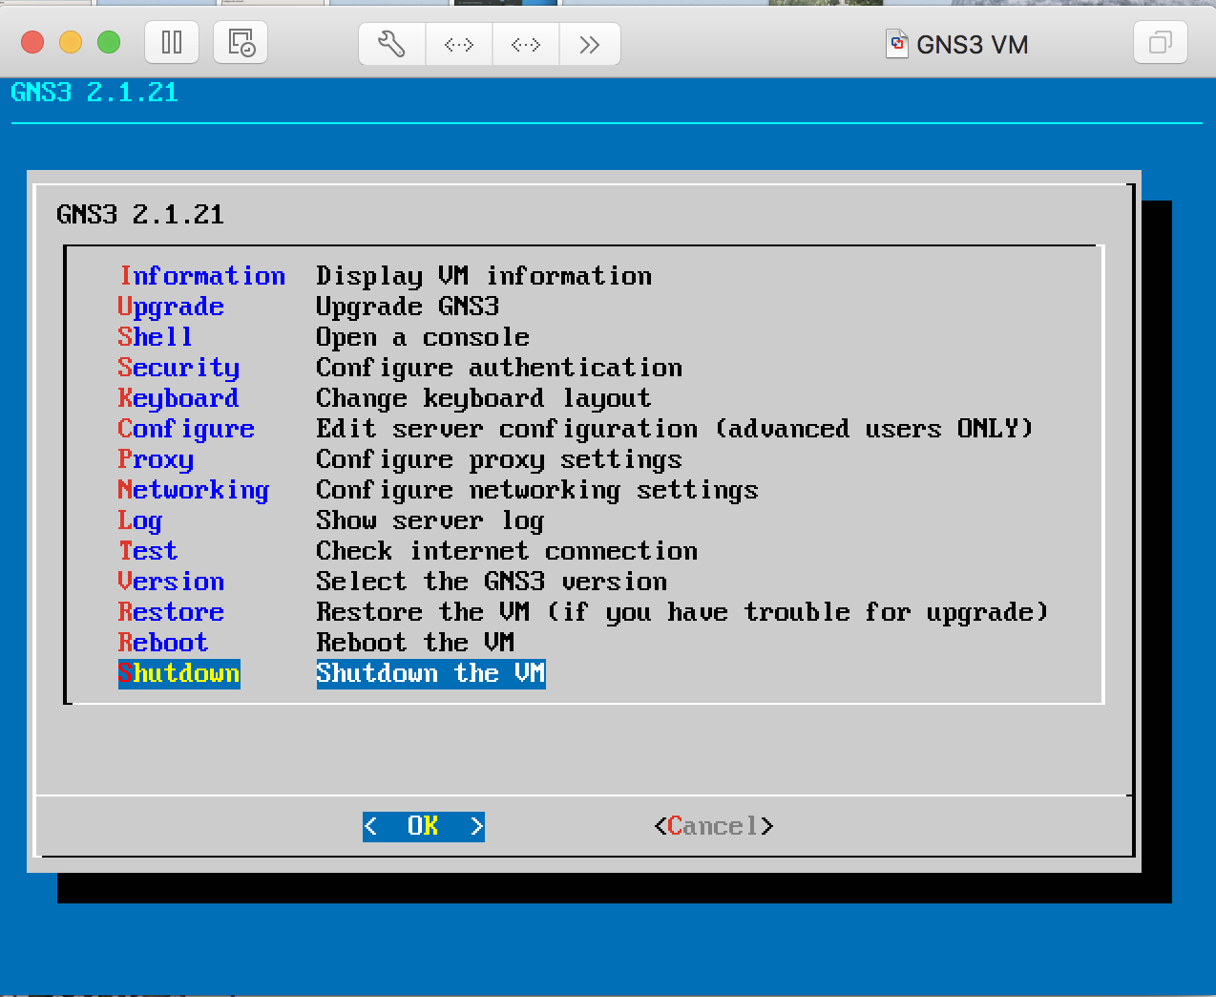

- The screen will turn “black”, this indicates that GNS3 VM is stopped. Minimize this window for now.
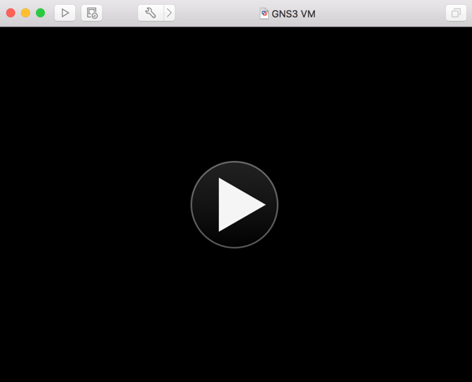

Part 4 – Setting up GNS3
- Open GNS3 from the desktop (in your Applications folder). You will see the following Setup Wizard screen. Please note that you can always restart this Setup Wizard by opening “Help” menu in GNS3 and selecting “Setup Wizard”.
Use the Run modern IOS option for the server as shown in screen below. Check “Don’t show this again”. Click “Next”.
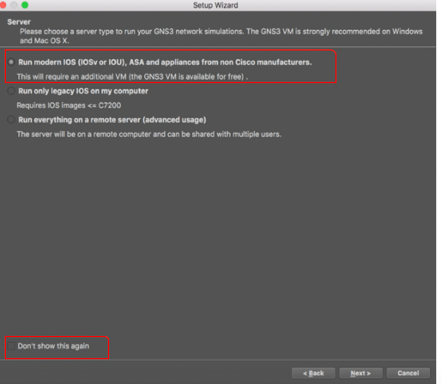
- In left screen below, for “Host binding”, select the IP address option that has the same IP address prefix as your GNS3 VM IP address (from Part 3 above) and then click “Next”.
- e.g. From Part 3: IP address for GNS3 VM: 192.168.154.128. The prefix is underlined here. Then in the GNS3 Setup Wizard choose the IP address with the same prefix, e.g., 192.168.154.1 as shown below.
Note: Pick 127.0.0.1 if you cannot find an IP address corresponding to your GNS3 VM prefix as shown in the right screen.
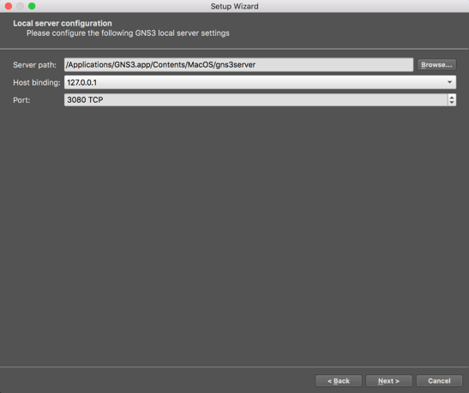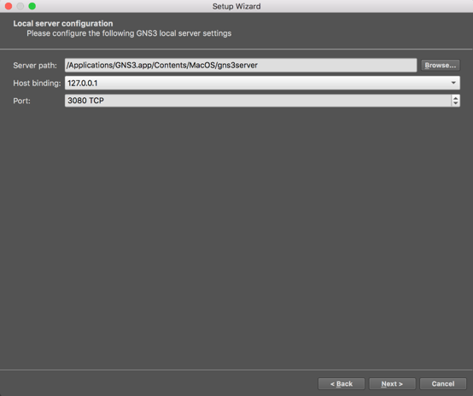
- Select “Yes” when asked to set root permissions to uBridge?
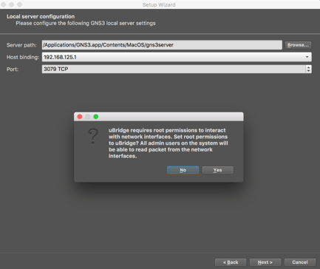
- Click “Next”. Installation is now done.
- Do not upgrade the Virtual Machine when prompted to.
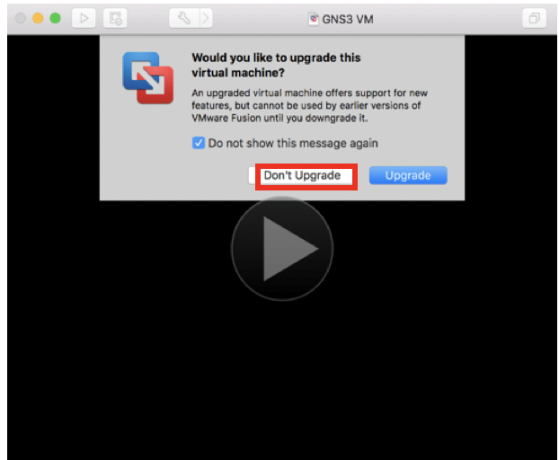

- In the screen below, check “VMware” as shown in red frame. For the VM name, choose “GNS3 VM” from dropdown list as highlighted in red box. (You have already downloaded all the software so ignore “download here”). Make sure you choose both VMWare and GNS3 VM in this screen. Then click "Next".

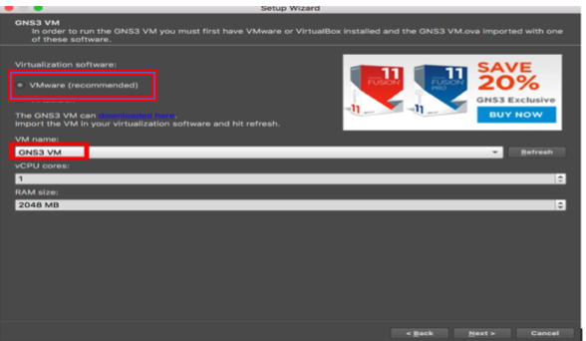

- Upon successful connection, you should now see the GNS3 simulation screen as shown below. In the “Servers Summary” panel, it should show two servers with two green lights indicating the servers are on. Click "Finish". Note: If you don’t see the green dots (red dots indicate servers did not start), skip to step 11 below to debug your installation.
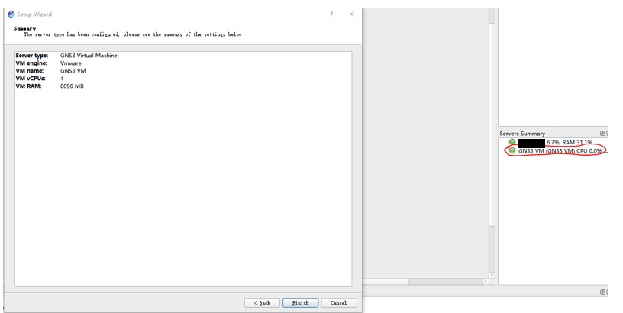
- Click "Cancel" in New appliance template screen should it appear.

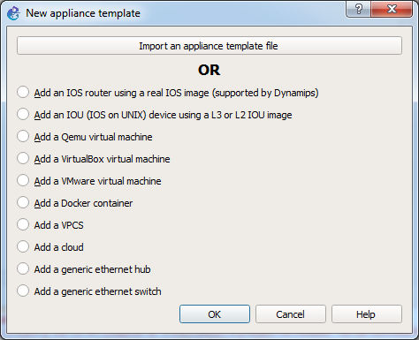
- Click "Cancel" in “Project” screen if it appears.
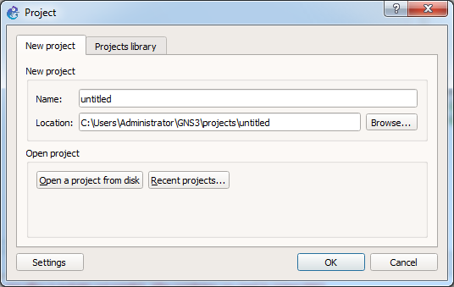

- Go back to VMware Fusion as shown below and got to Preferences. Select under General “Power off the virtual machine” for “When closing a virtual machine”.

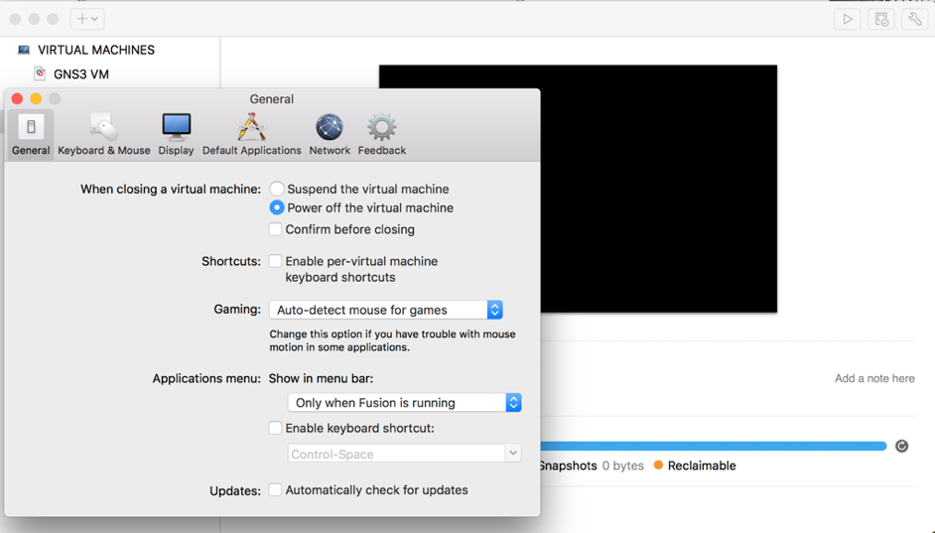

- Fixing the GNS3 start problem.
- If the status indicator of GNS3 VM is not green, quit GNS3 (GNS3 VM will suspend). Restart/Power On the GNS3 VM from VMware – Click on start arrow as shown in red box on screen shown below. Then start GNS3 again from the desktop. It should now come on with the green light for both servers as shown in step 7 above.
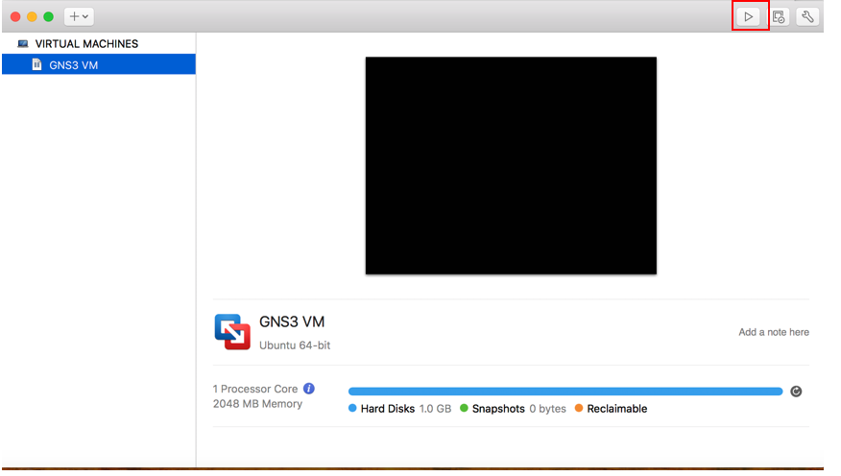

- IF NOT: Restart the setup wizard from the beginning. Go to Part C step 1and open Help menu in GNS3 and select “Setup Wizard”. Follow the steps from there onwards. It should now come on with the green light for both servers as shown in step 7.

- IF NOT: If (1) the GNS3 VM’s status indicator is still red in the “Server Summary” panel, or (2) the GNS3 VM’s screen in VMware Workstation is “black”, or (3) you observe GNU GRUB screen in the GNS3 VM’s booting sequence, then try to check if Hardware Virtualization is enabled from BIOS. Please note that the steps to enable Hardware Virtualization in BIOS could vary depending on the computer manufacturer and the computer models. Sample steps are given here.

- If the server indicators in the Server Summary pane are green (as shown in step 7), then GNS3 software installation is done. Quit GNS3.
Part 5. Creating a Lubuntu VM in VMware Fusion
- First go to the Ubuntu website to download the latest version of Lubuntu (Lightweight Ubuntu) Desktop. It is recommended to download the versions with long term support: i.e LTS version. (Here we show version 19.04, you may find a more recent version on the website)

http://cdimage.ubuntu.com/lubuntu/releases/19.04/release/lubuntu-19.04-desktop-amd64.iso

- Then Open/Start VM Fusion. Choose “Install from disc or image” and click “Continue”.
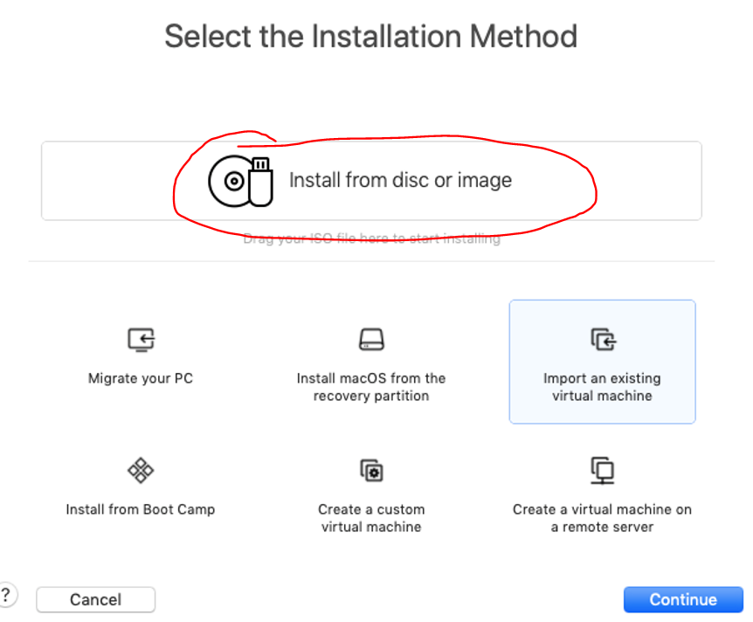

- Choose your just downloaded iso image lubuntu-“version”-desktop-amd64.iso from Downloads folder. You can drag it or click on “Use another disc or disc image…. Click “Continue”.
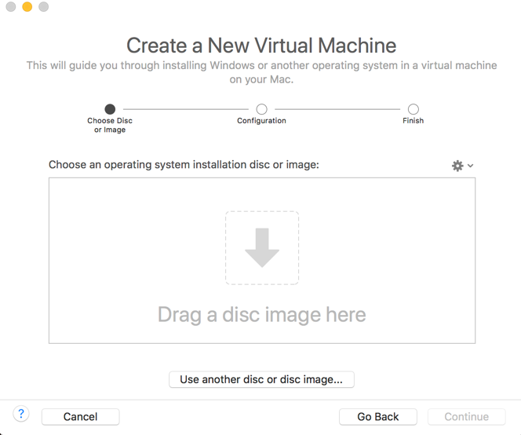
- You will see this screen. Choose Linus and Ubuntu 64bit as shown. Click “Continue”.
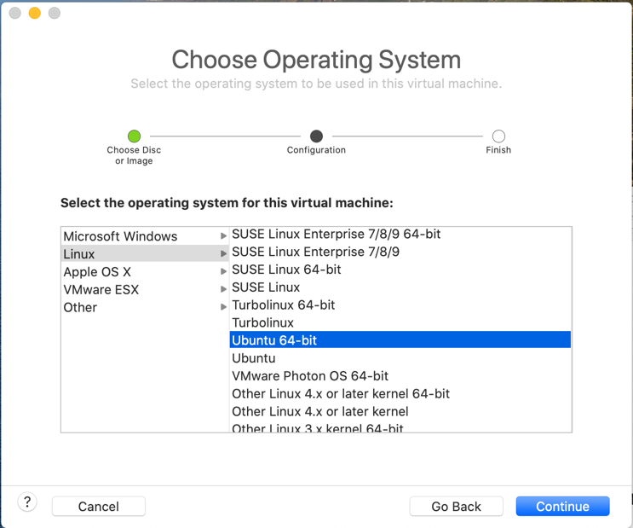

- Then you will see this screen. Chose Legacy BIOS as shown. Click “Continue”.
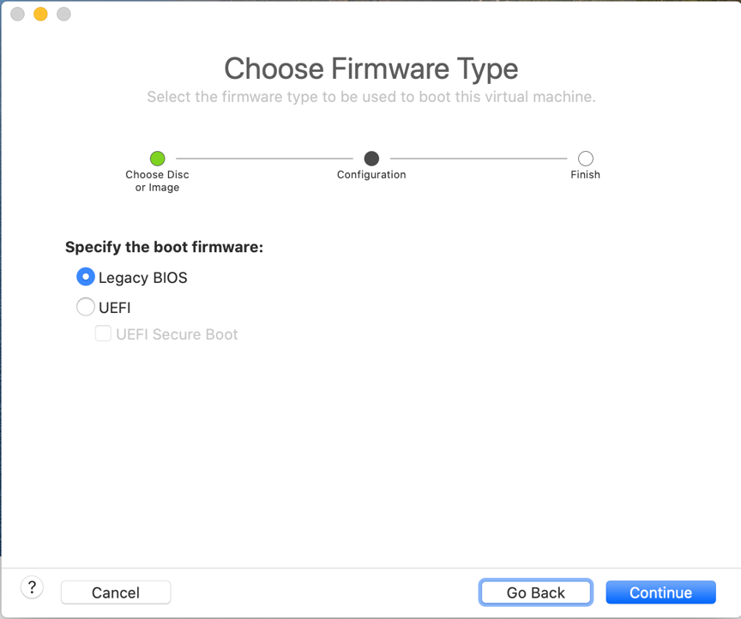
- You will see this screen: Click on “Customize Settings”.
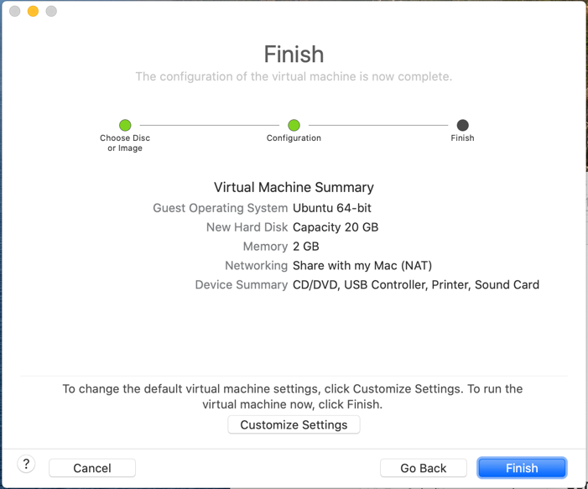
- You will see this screen. Change the “Save As” Ubuntu 64-bit to Alice as shown. Click “Save”.
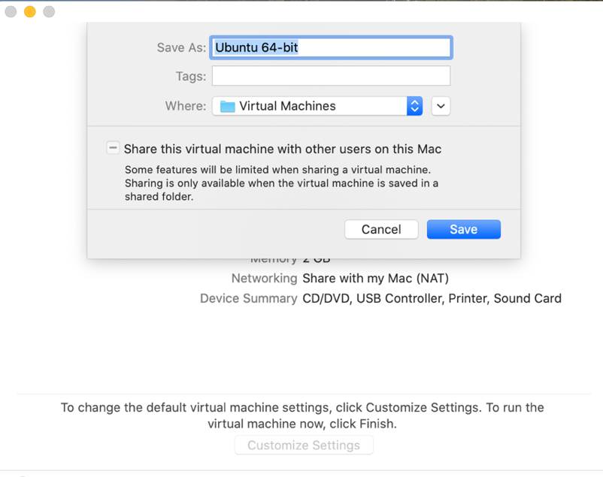
- The VM Alice will power up. And you should see the language screen. Select English by hitting “Enter/Return” on keyboard. You will then be asked to Start Lubuntu, click “Enter/Return” on keyboard.
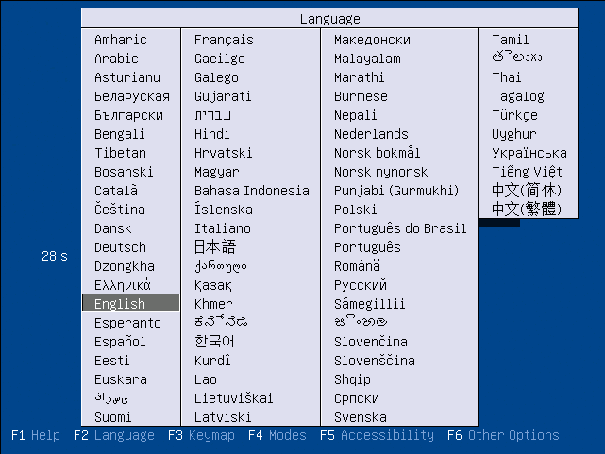
- You will see the following screen, double click the “Install Lubuntu” icon to install:

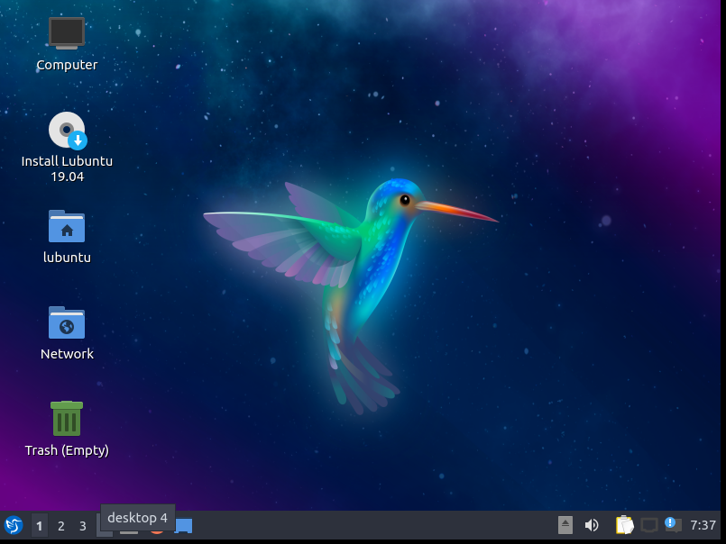

- Then you will be prompted with the following installation screen, click “Next”:

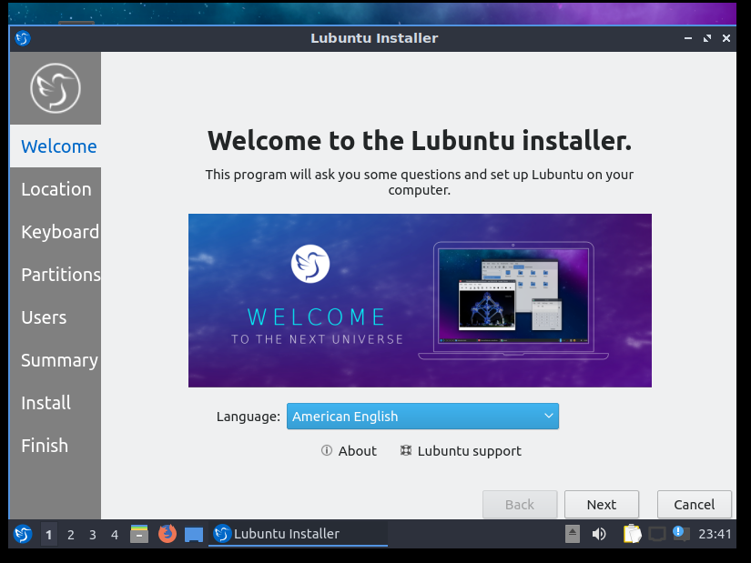

- Use the default Region and zone for convenience. Click “Next” :

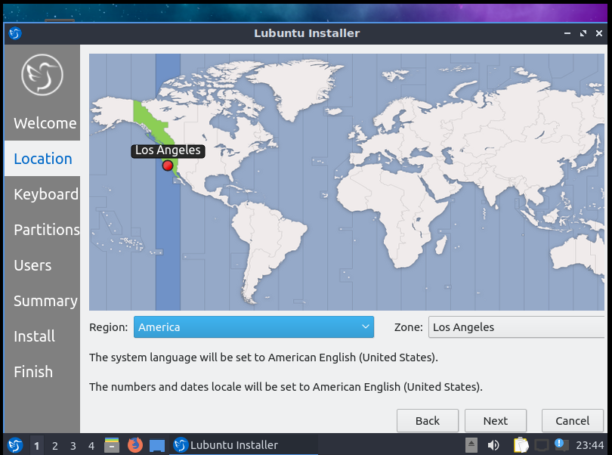

- Use the default keyboard setting. Click “Next”:

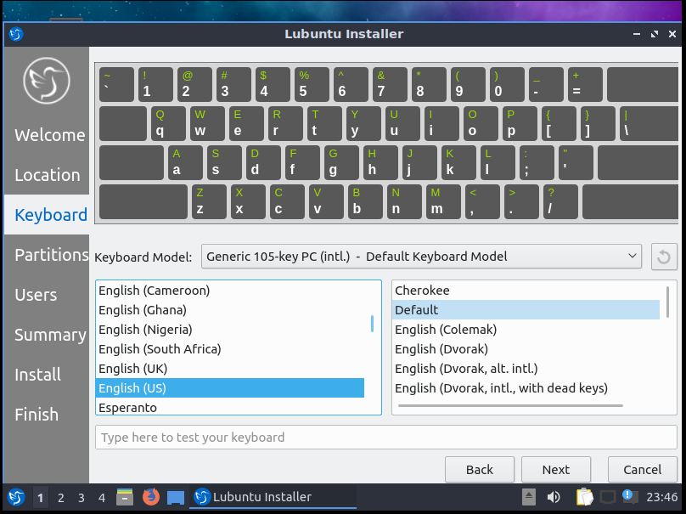

- Since the VMware Disk is newly partitioned within the VMware, you can safely choose Erase Disk and then click “Next”:
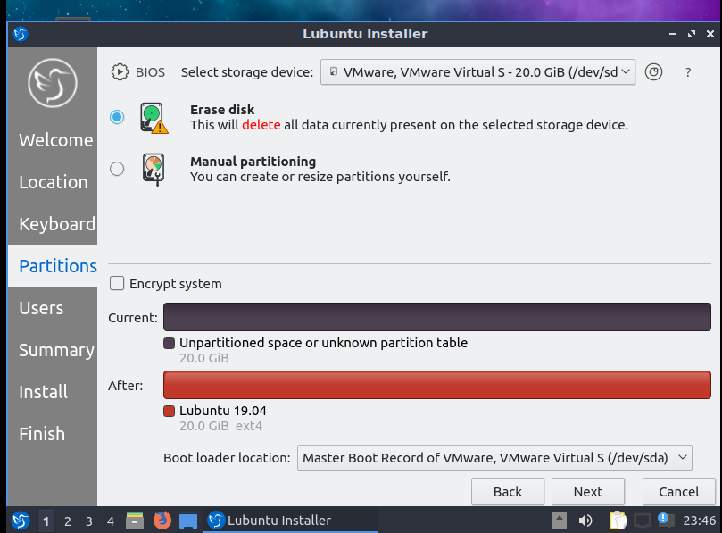

- Choose a user Name and a password. Click “Next”. Note: Full Name will appear in the console window every time you start up the VM. You click on it to login to the VM as a user. You can choose any User name/password, but be sure to remember your name/password.

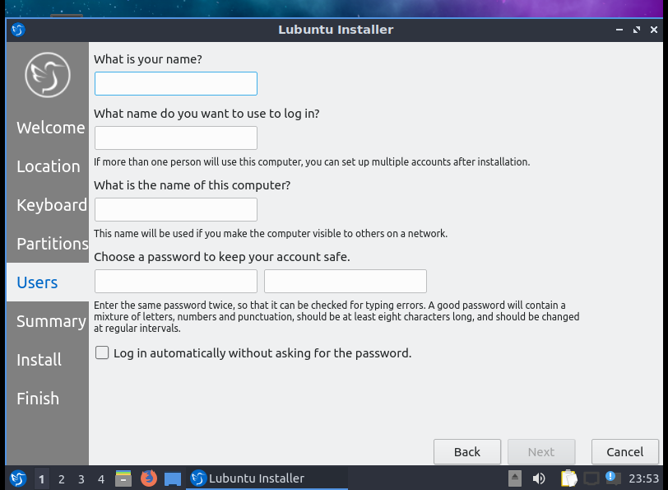
- Click “Install” to start the installation process.

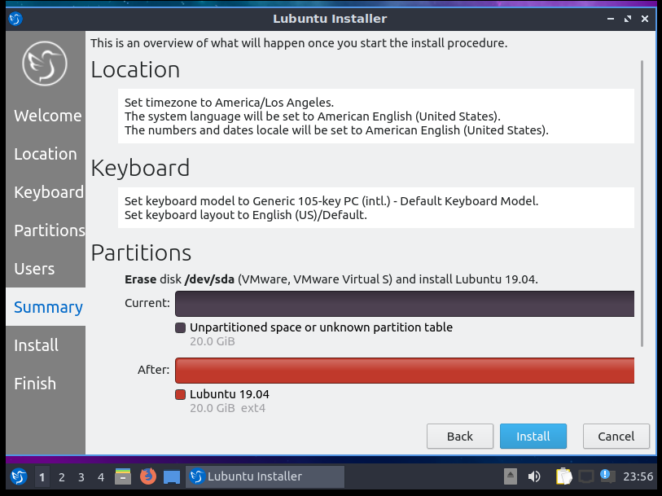

- Wait patiently for the installation process to finish.

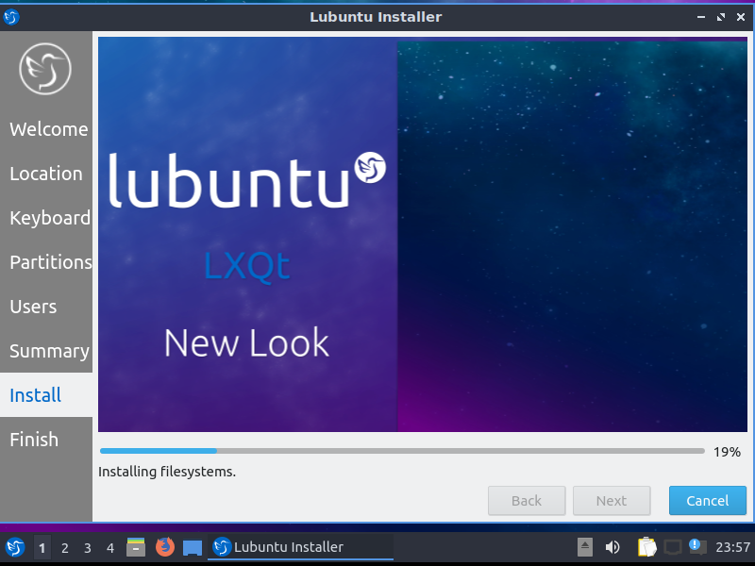

- After the installation finish, you should see the following screen, click “Done” to restart the VM.
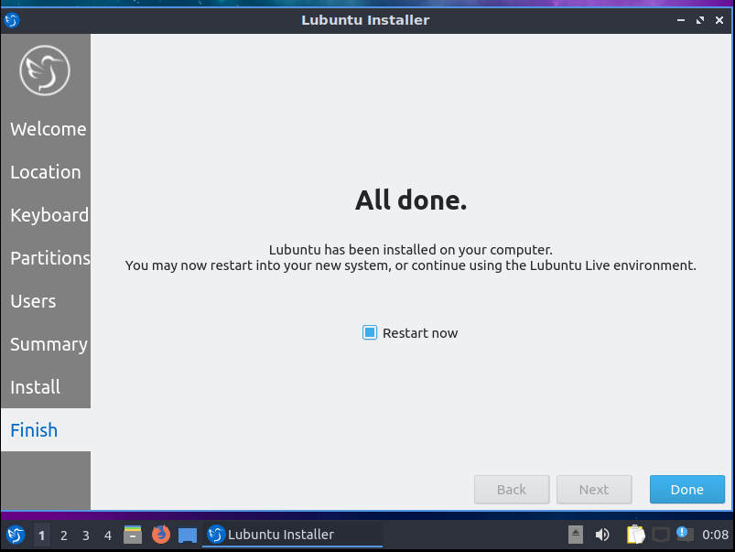

- After restarting, use your password to login. I chose name Alice for my user name as shown here.

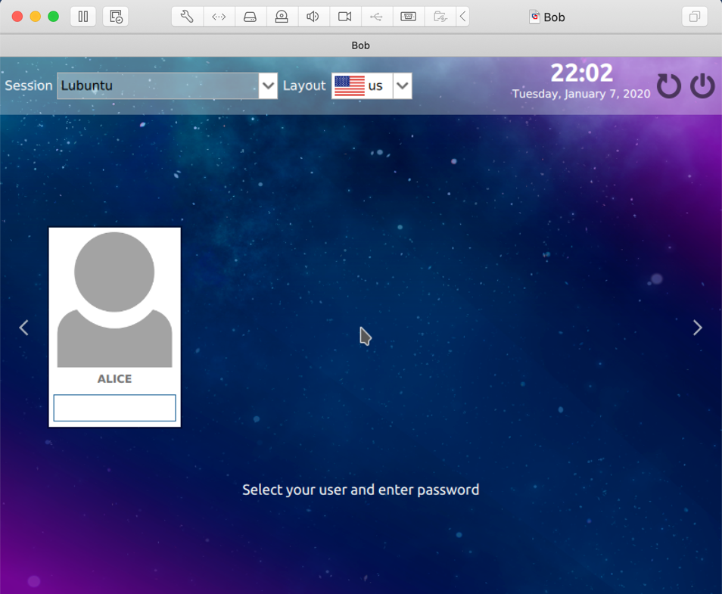

- You will see the following screen after logging in.

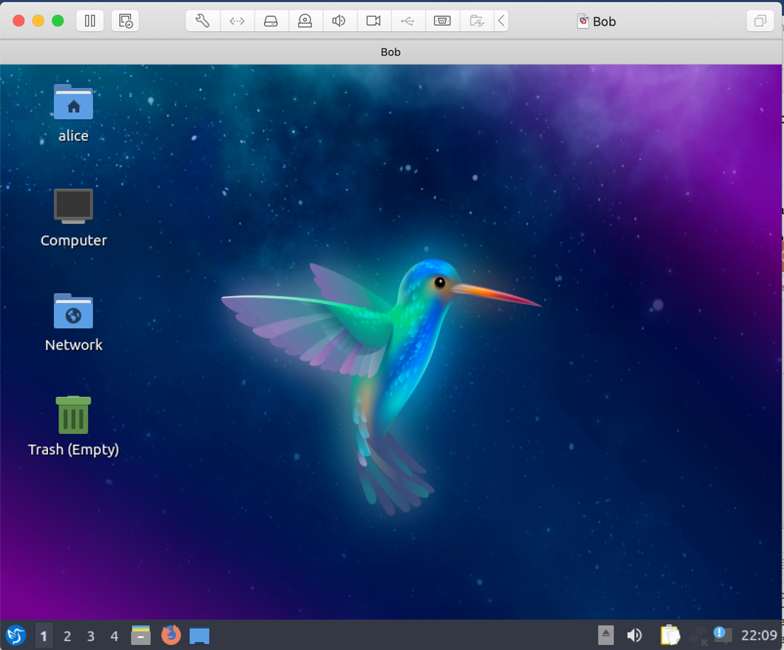

- To start a terminal window, click on “^ (control) option t”. You can also click on bottom, leftmost icon and you will get all the VM options as show in left screenshot. Select “System Tools” and you will see a menu that has a “QTerminal” option. Select it to open a terminal window on the Lubuntu VM. Or type in the search field “terminal” and you will see the right screenshot. Select “QTerminal”.
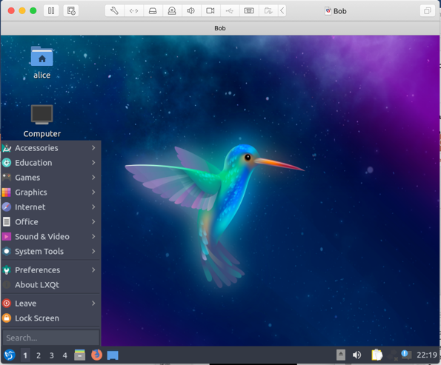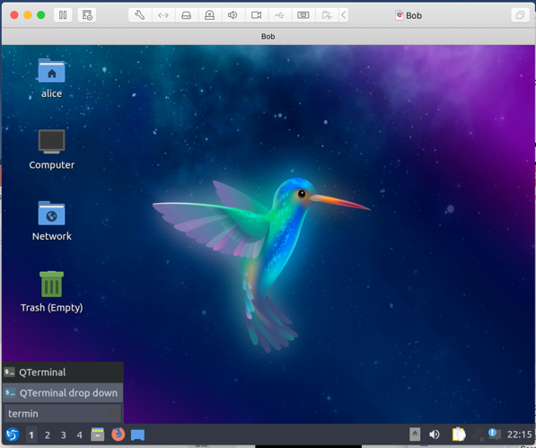

- When the Terminal opens as shown below, run the following commands on the command line in the terminal window
sudo apt-get install net-tools
sudo apt-get install traceroute
sudo apt-get install hping3
sudo apt-get install dsniff
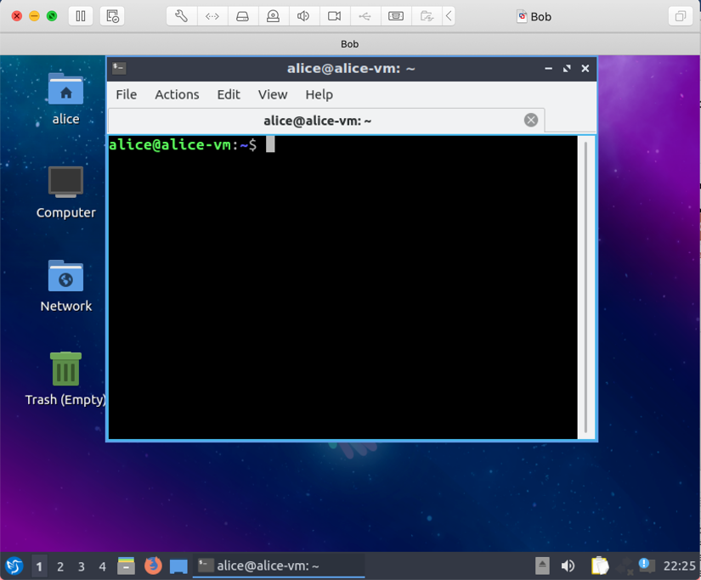
- After you’re done installing the tools, Type ^D to exit “Terminal”. You will be asked if you are sure you want to exit. Click yes and the VM console window will appear.

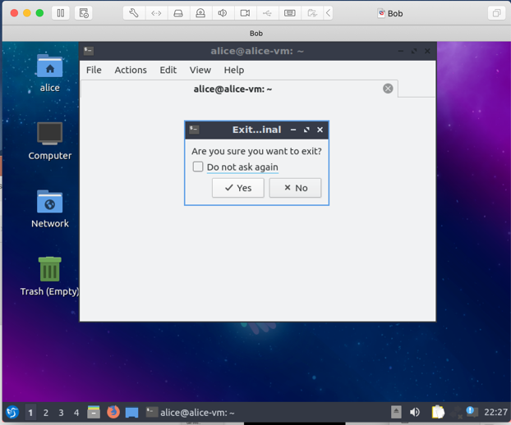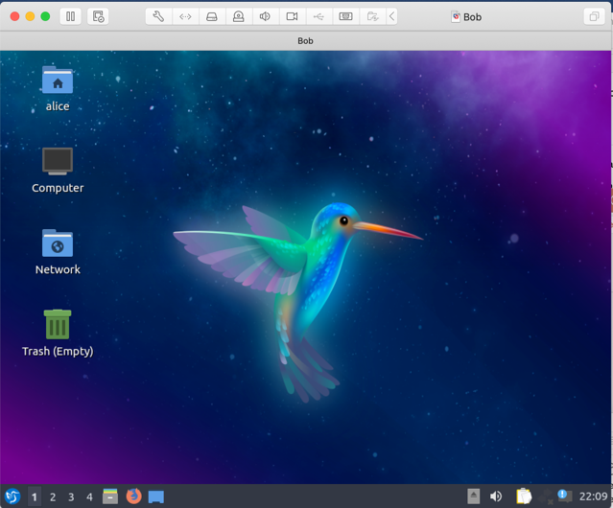

- Power Off your VM in VMware Fusion or by clicking on the bottom leftmost button again and selecting “Leave” from options. That will open a menu with “Shutdown” as an option.

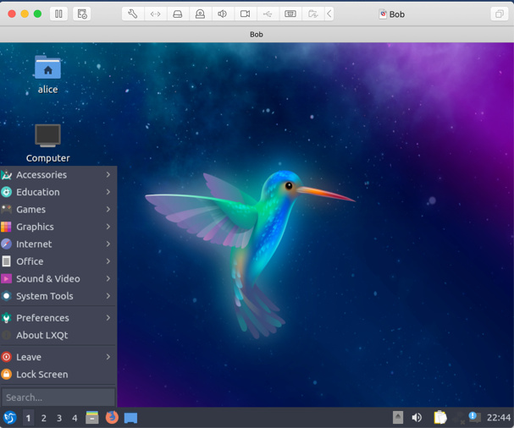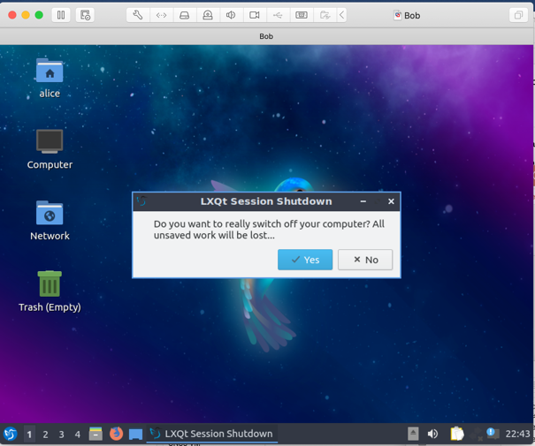

- You will now make two clones of your Ubuntu VM - Alice. One named Bob and the other Mallory.. Go to the VMware Fusion window. Under Virtual Machines on the left hand side, right click “Alice” (hover over Alice and use two fingers to tap on trackpad. A menu will appear, click “Create Linked Clone”.

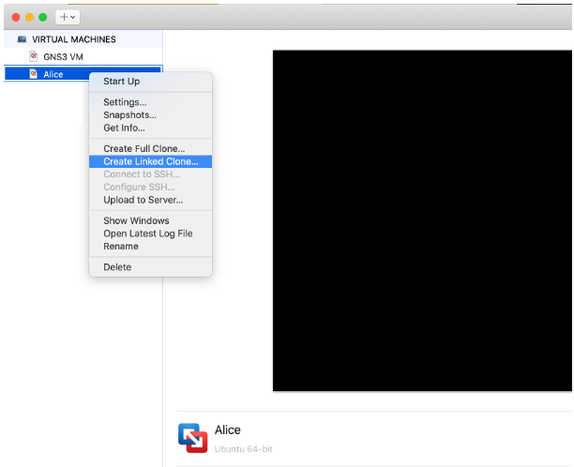

- VMware will then create “Linked Clone of Alice”.
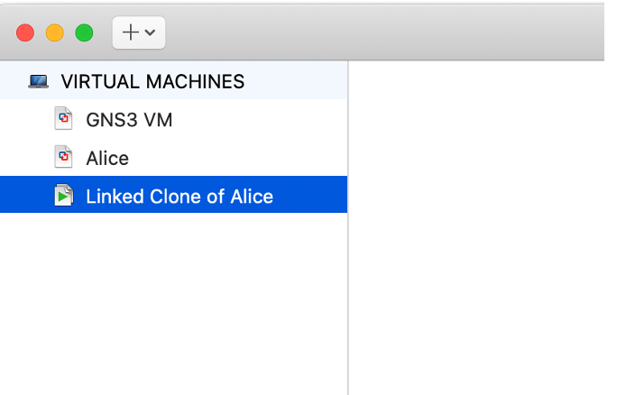
- Change name of “Linked Clone of …” to “Bob” by right clicking “Linked Clone…” and selecting “Rename”. Or double clicking on the name and typing in new name.

- Next step is to set the “Network Adapter” on the Lubuntu VMs (Alice, Bob and Mallory. Right click anyone of the 3 VMs and choose Settings... Repeat for the others.

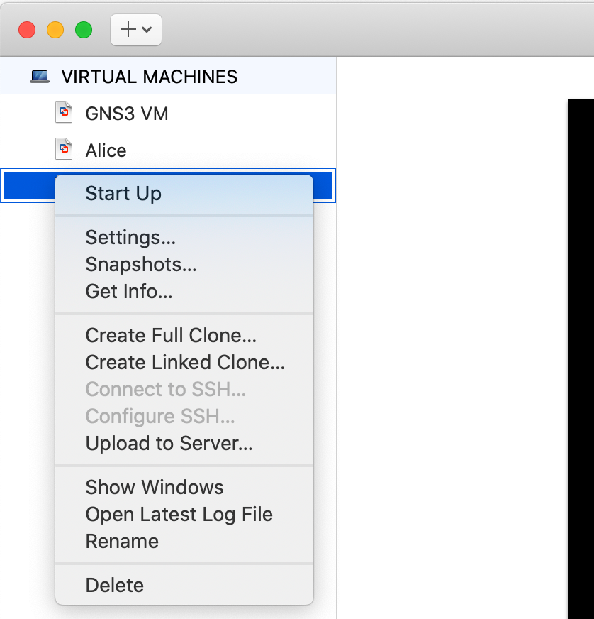
- The Mac Settings window will open. Find the “Network Adapter” and click.

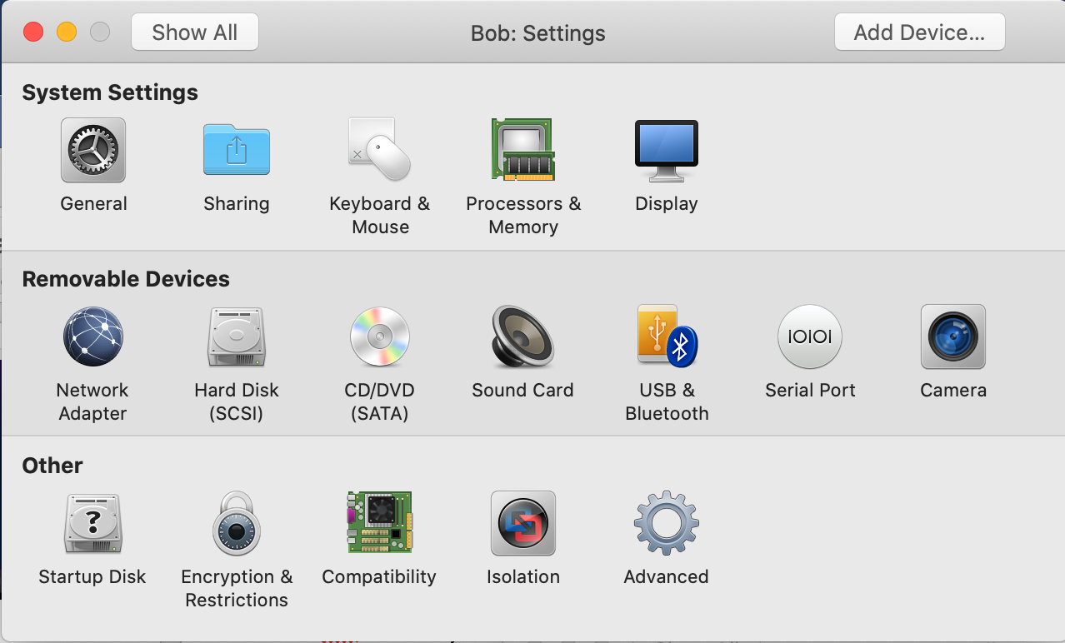

- “Network Adapter” window will open. Select under Custom “vmnet2”. Note that any choice through vmnet7 seems to work fine. Close “Settings” window.
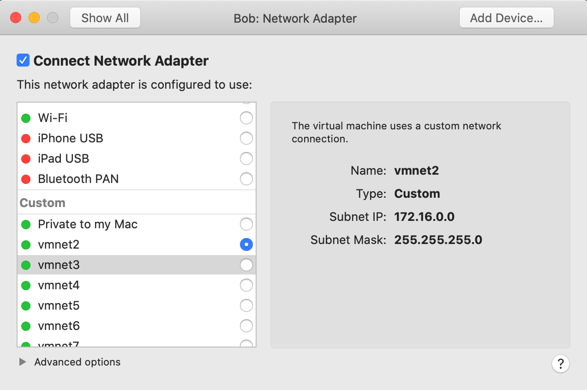
- Recall, you need to do this for each of “Alice” “Bob” and “Mallory”.

- Installation is now done.

You may be asked to enter a license key during installation. Enter the key you saved.
When done with the installation, download the "GNS3 Getting Started Guide" for future reference. This lab walks you through a simplified installation process. The guide has more information.
You will see an unzipped file “GNS3 VM OVA” in your download folder. Leave it there for now.
Note: DO not install GNS3 VM. That will be imported as shown in Part 3.
In Lab1 we will show you how to login as root and then you will not need to type “sudo” before every command.
NOTE that each clone will have the same User name (here Alice) and same password even after changing the name to Bob or Mallory. When you start them up the user window will always be “Alice”
It turns out that for some older MacOS systems, there is no choice for “vmnet”. In that case select “Private to my Mac.”

