LAB Zero – Windows Installation
In this lab you will download all the necessary software packages and install them on your computer/laptop (PC) to work on the labs.

You will download VMware, GNS3 and GNS3 VM, Ubuntu Linux and Kali Linux. You will import GNS3 VM into VMware. You will create Ubuntu VMs in VMware. You will install GNS3. There are 5 parts to this lab: A through E. When you are done with Part E you will download Lab1. In Lab1 you will import the VMs and other network devices into GNS3. Once that is done you can start running network simulations (Labs 2 – 7).
Part 1 Downloading and Installing VMware
- To install the VMware Workstation Pro and obtain a license key, go to the following website and log in using your ICS account:

https://elms.ics.uci.edu

- Login with your ICS account.
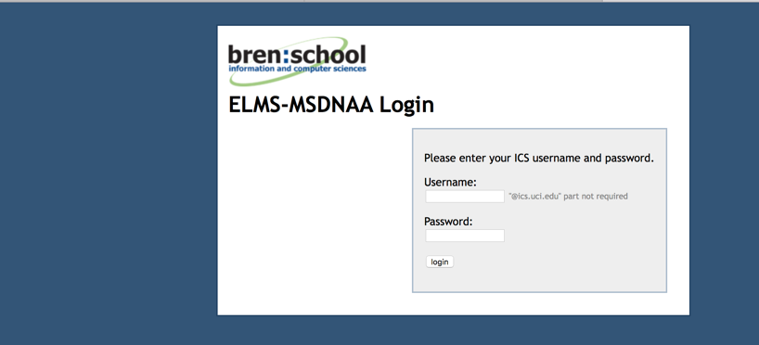

- Select “VMware Workstation” (here shown as Version 15).

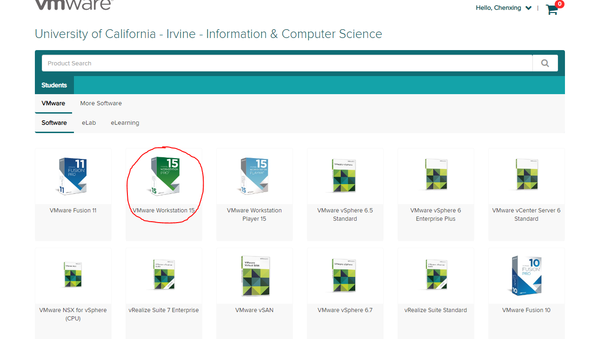
- Click “Add to Cart”.

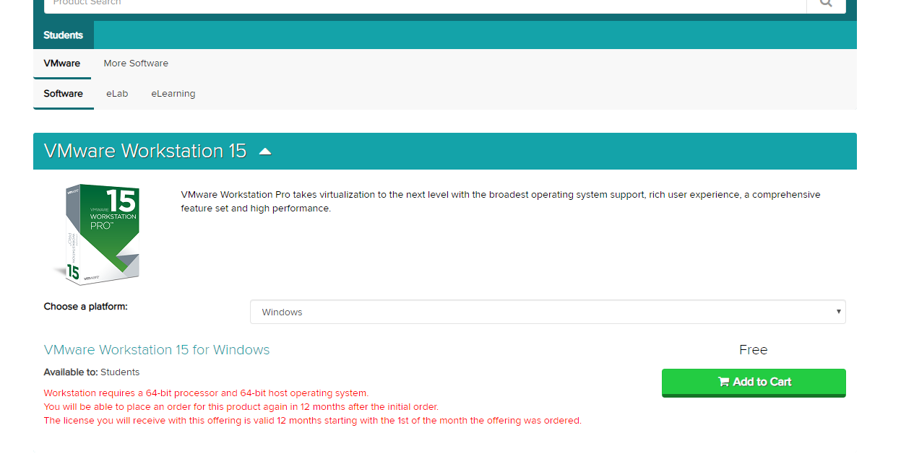

- After checking out, go to “View Orders”, and click on “View Details” as shown in screen below.
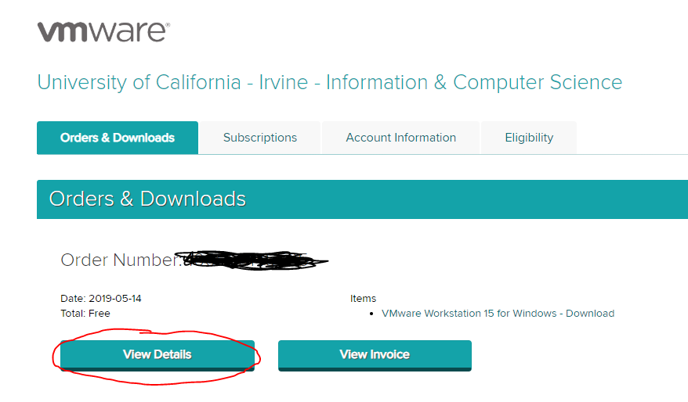

- In the “View Details” page, you will be given a serial number (license key) which you will use to activate your VMWare software, save this number for later. Click “Download”.

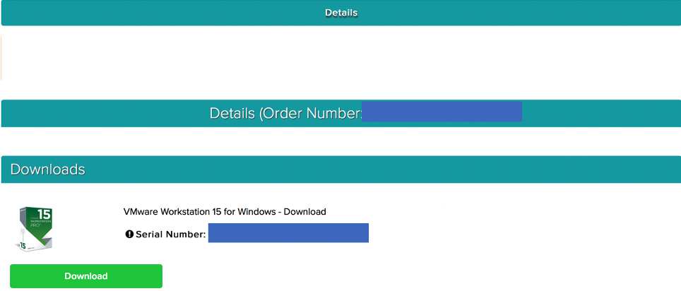
- Go through the setup wizard to install VMWare Workstation from your .exe file.

- If you are prompted to “Join the WMware Customer….”. choose No and Click “Done”.

- Once you’re finished you should see the following screen, the WMware home page. Minimize it for now. We will first download and install GNS3 and download GNS3 VM before coming back to this screen to import a Virtual Machine (GNS3 VM).
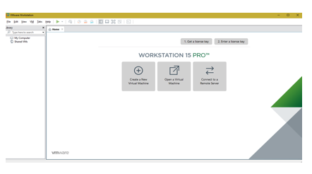

Part 2 – Downloading GNS3 & GNS3 VM and Installing GNS3
- Download GNS3 using the link below.

https://www.gns3.com/software

You will see a screen as shown below.

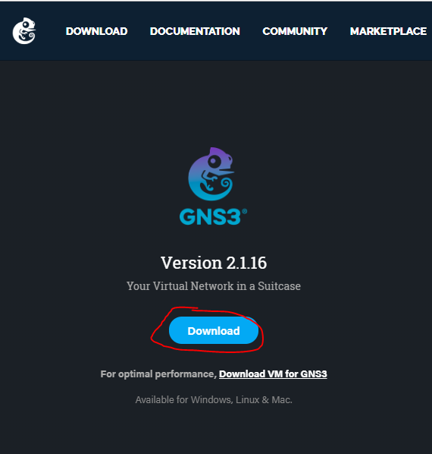

- Click on Download
  - Note: you need to sign up for a GNS3 account the first time you click on Download.
  - After you have setup an account, click on the link again and you will be able to download GNS3.

- Download the version for Windows. Do not install yet. We will do that in step 6.
- Go back to the download page and click on “Download VM for GNS3” as shown:

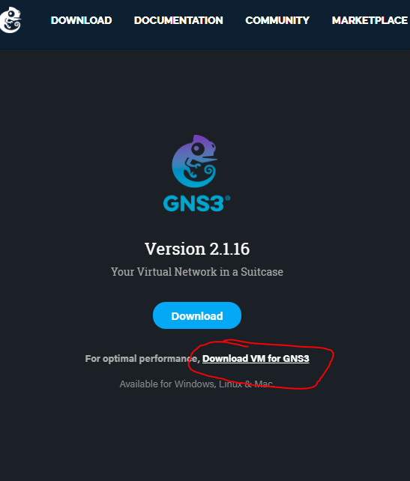

- You will then see this screen. Download the version for VMWare Workstation and Fusion.
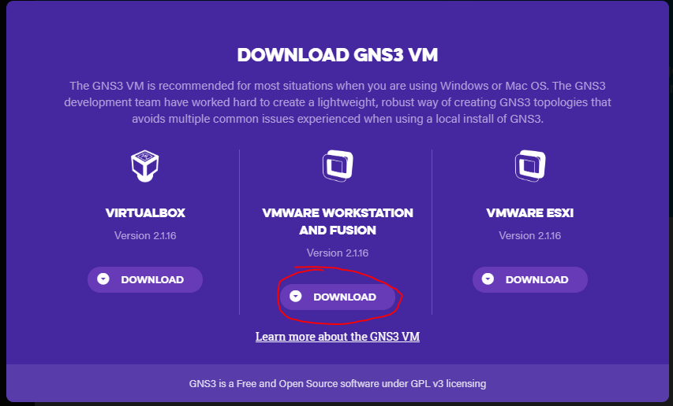

- Now install the downloaded GNS3 software. Follow the default instructions.
- When prompted for “Choose Components”, please uncheck “Solar-PuTTY” as shown high-lighted in screen below. “Click “Next”.

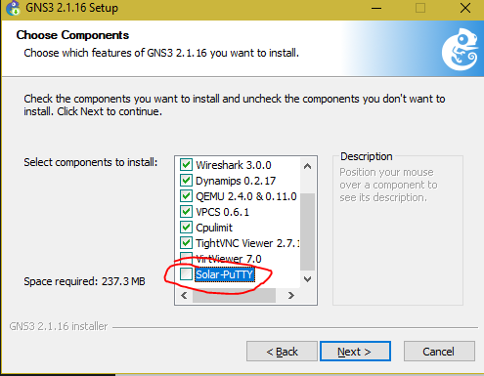

- In the following screen choose No for Toolset as shown. Click “Next”.

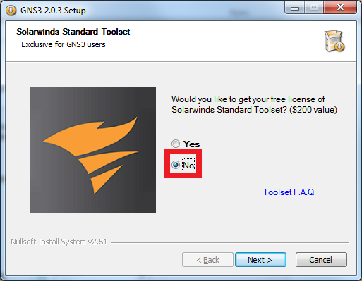

- In the next screen, when prompted for “WinPcap” installation, use the default settings to install it. GNS3 will automatically download and install a software package called Wireshark (a tool to capture network traffic which you will use extensively in the labs).

- Finish the installation process.

- When done with the installation, the GNS3 simulator will open automatically if “Start GNS3” is checked as shown below. Uncheck.. Click “Finish”.

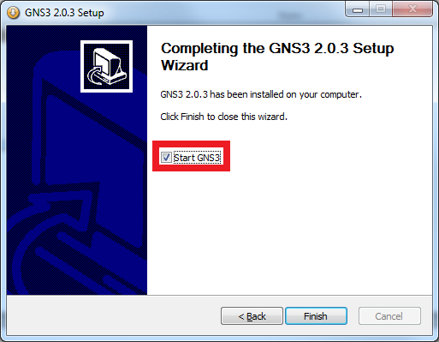

Part 3 – Creating a GNS3 VM in VMware Workstation
- In this part you will import GNS3 VM into the VMware environment.

- Open the minimized VMware window or Start/Open VMware Workstation and click on ‘Open a Virtual Machine” as shown below.

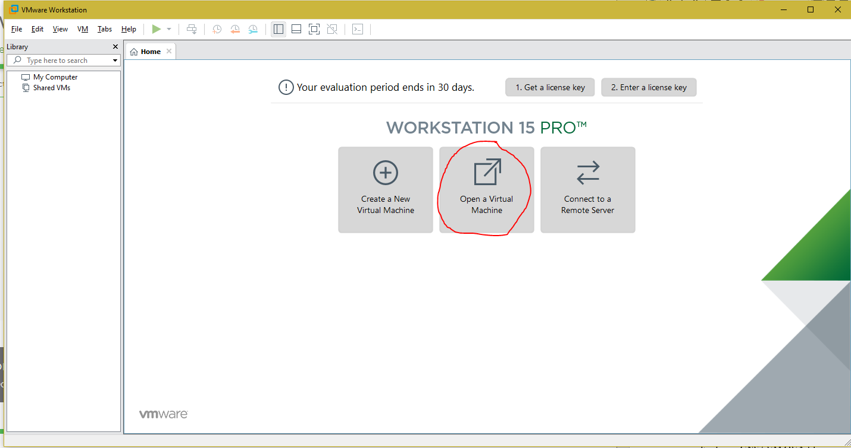

- Look for the “GNS3 VM OVA” file in your unzipped folder and click Open.

- Use the default settings to import the GNS3 VM. When done you will see the following GNS3 VM - VMware Workstation screen. The screen shows the tab for GNS3 VM. That is the console window for GNS3 VM.

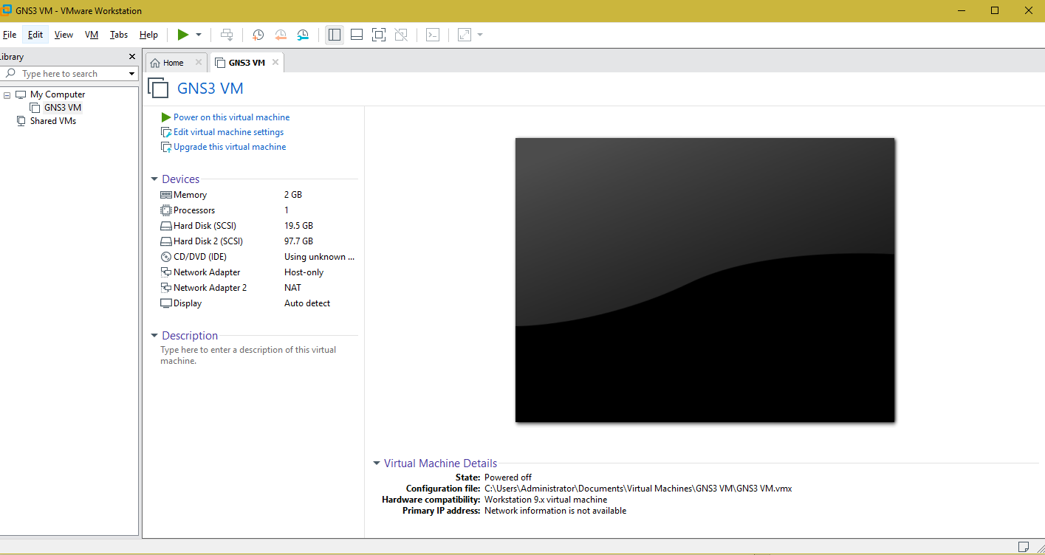

- Click “Power on this virtual machine” in the tab. You can also Power on a VM when you are in its tab by clicking on “green arrow” at the top of the VMware screen as shown below.
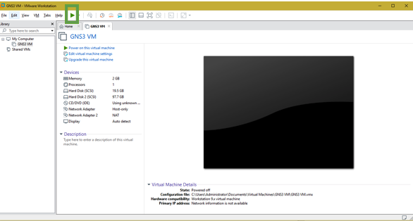

- You will see the following screen in the GNS3 VM tab. Record the IP address of your GNS3 VM. (Shown here as IP: 192.168.125.128. Yours could be different.) Then press “enter” for OK.
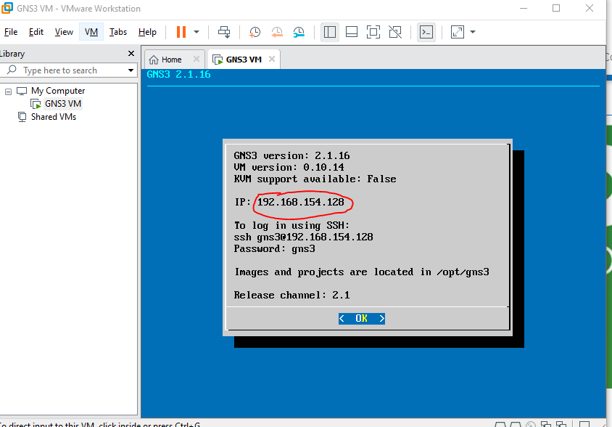

- Power Off GNS3 VM. When in “GNS3 VM” tab click on button shown in green box in screen below and choose “Off” in dropdown menu.

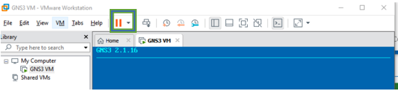

Part 4 – Setting up GNS3
- Open GNS3 from your PC desktop. You will see the following Setup Wizard screen. Note that you can always restart this Setup Wizard by opening “Help” menu in GNS3 and selecting “Setup Wizard” should you need to do so at a later stage.
Use the Run modern IOS option for the server as shown in screen below. Check “Don’t show this again”. Click “Next”.
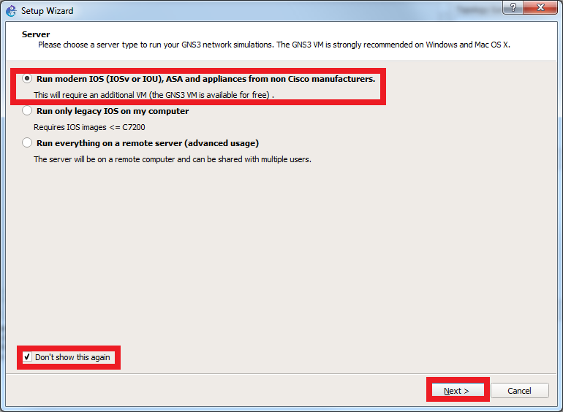
- In screen below, for “Host binding”, select the IP address option that has the same IP address prefix as your GNS3 VM IP address (from Part C above) and then click “Next”.
- e.g. From Part C: IP address for GNS3 VM: 192.168.154.128. The prefix is underlined here. Then in the GNS3 Setup Wizard choose the IP address with the same prefix, e.g., 192.168.154.1 as shown below.
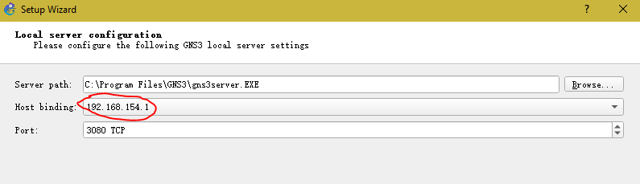
- You will see screen below. Wait till DONE. Don’t click on anything.
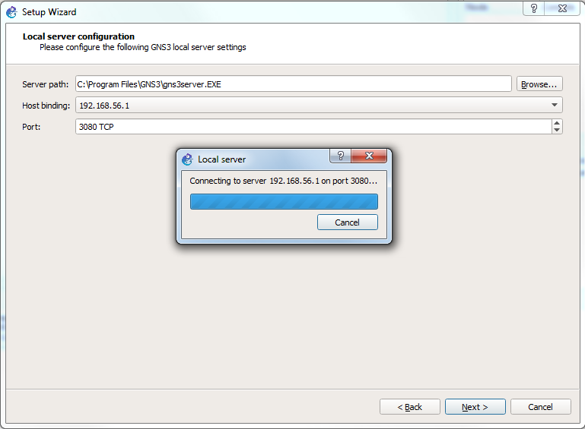
- Installation is done when you see the screen below. Click “Next”.
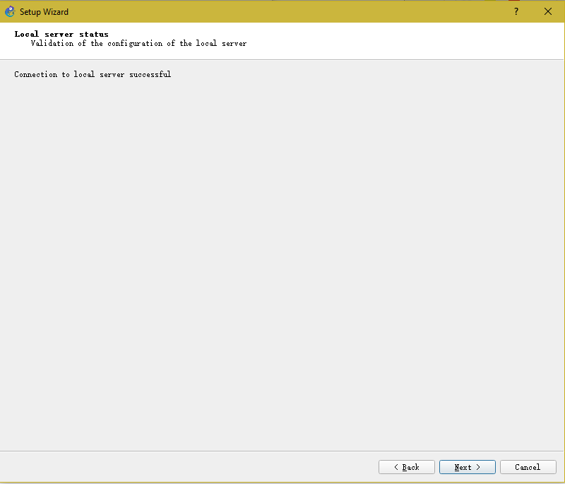
- In the screen below, check “VMware”. For the VM name choose GNS3 VM from dropdown list as highlighted in red. (You have already downloaded all the software so ignore “download here”). Make sure you choose VMWare and GNS3 VM. Then click "Next".
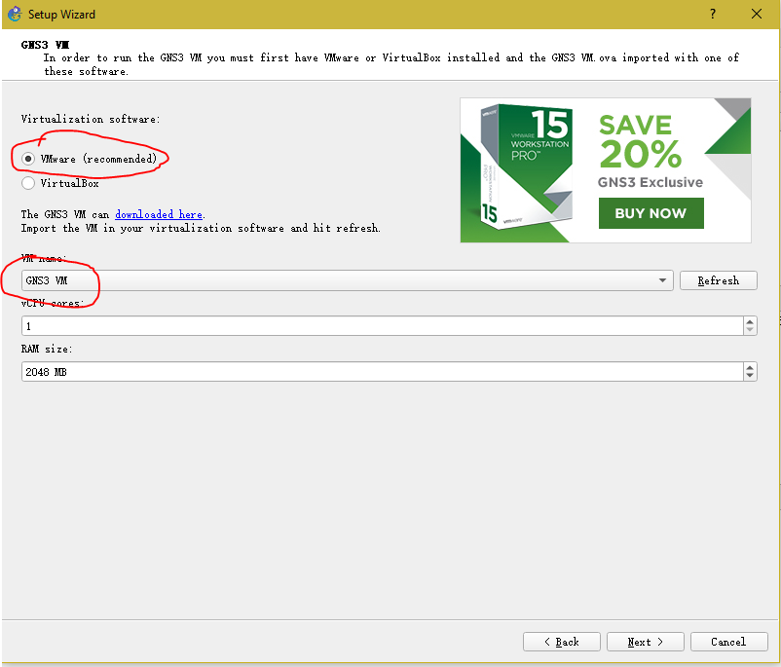

- Upon successful import, you should now see the GNS3 simulation screen as shown below. In the “Servers Summary” panel, it should show two servers with two green lights indicating the server status. Click "Finish". Note: If you don’t see the green dots, skip to step 10 below to debug your installation.
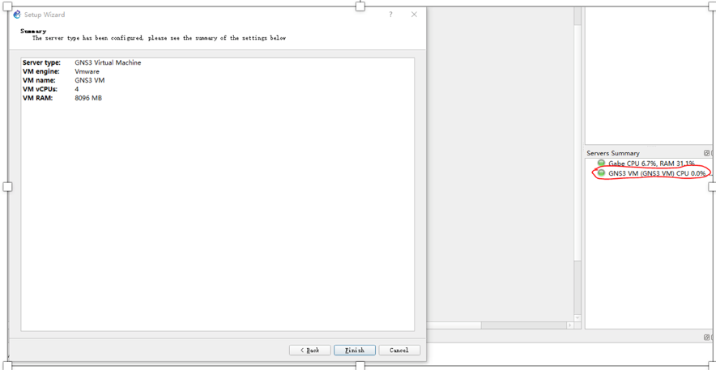
- Click "Cancel" in “New appliance template” screen should it appear.
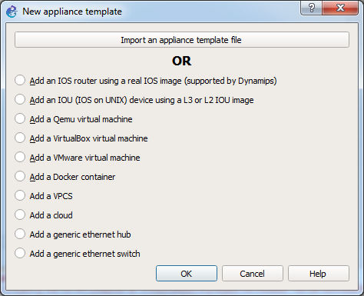
- Click "Cancel" in “Project” screen if it appears.
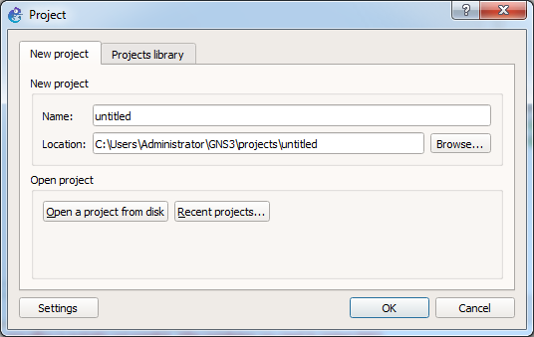

- You should now see the GNS3 simulation screen as shown below. In the “Servers Summary” panel, it should show two servers with two green lights indicating the server status as mentioned in step 6. above. If not, read notes below to get GNS3 to start up properly.
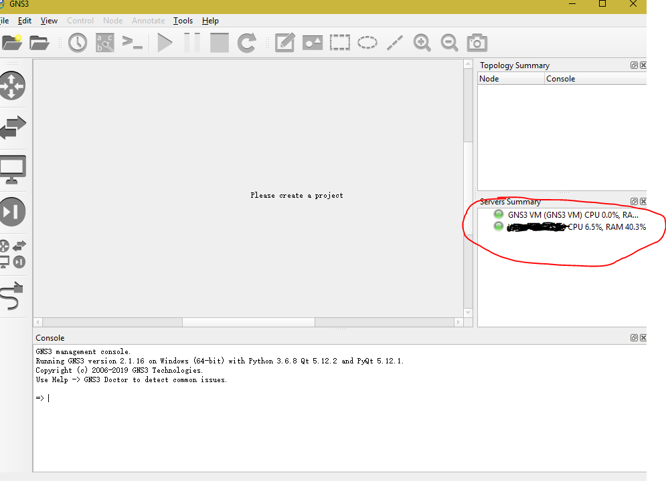
- Fixing the GNS3 start problem.
- If the status indicator of GNS3 VM is not green, quit GNS3 (GNS3 VM will suspend). Restart (Power On) the GNS3 VM from VMware as shown below. Then start GNS3 from the desktop. It should now come on with the green light for both servers as shown in step 9 above.

- IF NOT: Restart the setup wizard from the beginning. Go to Part C step 1and open Help menu in GNS3 and select “Setup Wizard”. Follow the steps from there onwards. It should now come on with the green light for both servers as shown in step 9.

- IF NOT: If (1) the GNS3 VM’s status indicator is still red in the “Server Summary” panel, or (2) the GNS3 VM’s screen in VMware Workstation is “black”, or (3) you observe GNU GRUB screen in the GNS3 VM’s booting sequence, then try to check if Hardware Virtualization is enabled from BIOS. Please note that the steps to enable Hardware Virtualization in BIOS could vary depending on the computer manufacturer and the computer models. Sample steps are given here.

- If the server indicators in the Server Summary pane are in green, then GNS3 software installation is done. Quit GNS3.

Part 5. Creating a Lubuntu VM in VMware Workstation
- First go to the Ubuntu website to download the latest version of Lubuntu (Lightweight Ubuntu) Desktop. It is recommended to download the version with long term support: i.e LTS version.

http://cdimage.ubuntu.com/lubuntu/releases/19.04/release/lubuntu-19.04-desktop-amd64.iso

- Then open VMWare Workstation and click “Create a New Virtual Machine”.

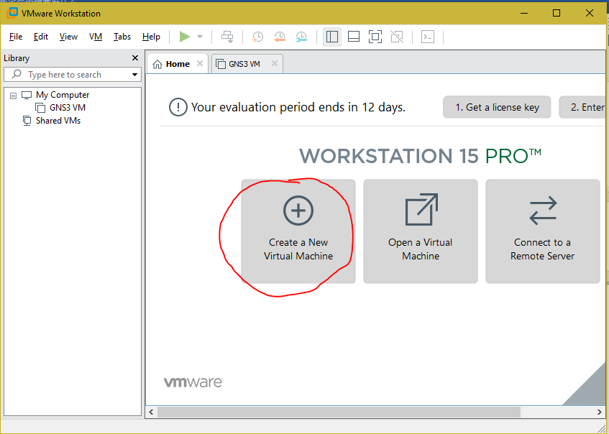

- Use the default installation. Select the downloaded iso image shown as “lubuntu--“version”--desktop-amd64.iso” and click “Next”.

- Here, you will be asked for the Version of the OS that you use. Choose Linux and Ubuntu 64-bit Version.

- In the next screen you will be asked to name your Lubuntu Virtual Machine. Name it “Alice” as shown below. Click “Next”.
Note: Henceforth, the name “Alice” will refer to this Lubuntu VM machine.

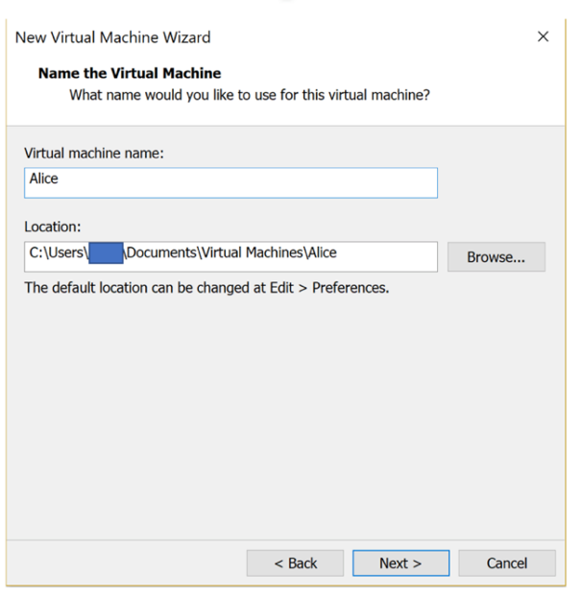

- Select “Store virtual disk as a single file”, also use the default Maximum disk size (GB), shown here as 20.0. Click “Next”.
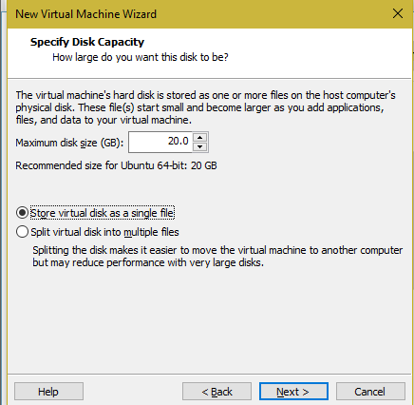
- Click “Finish” to complete the import.
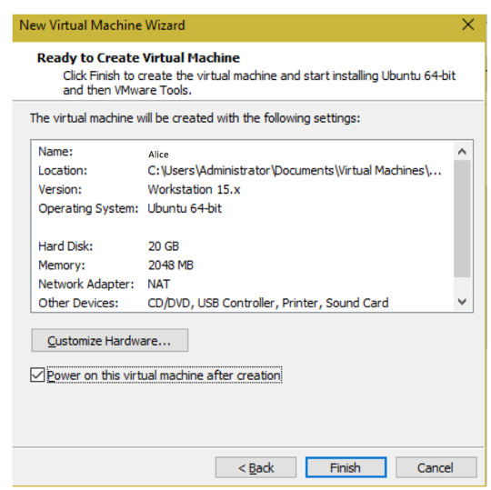

- After clicking “Finish, power up Alice and you should see the following Language Choice:

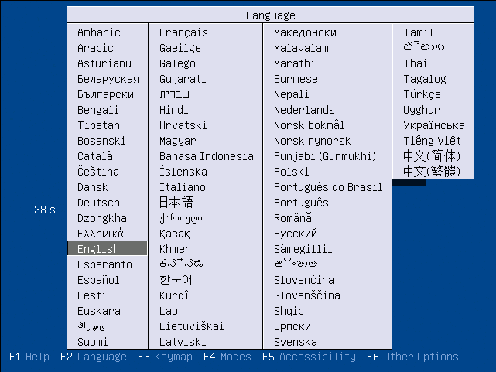

- After choosing the desired language, you will be prompted with the following screen, double click the “Install Lubuntu” icon to install:

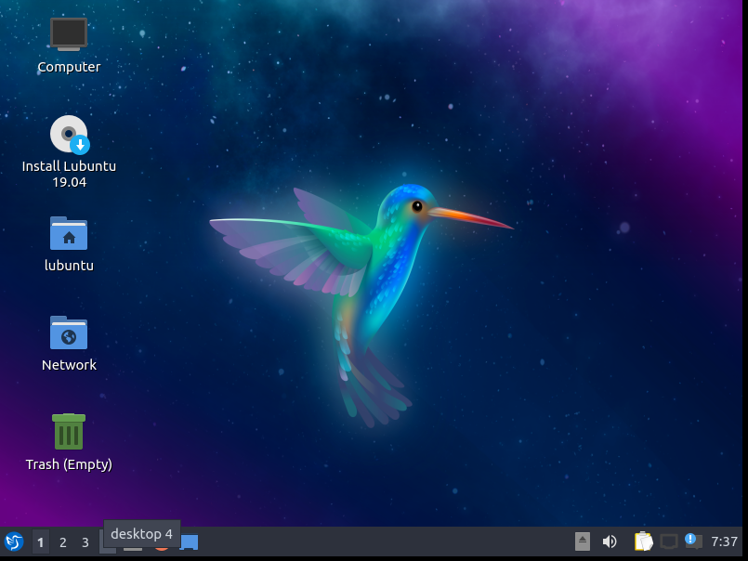

- Then you will be prompted with the following installation screen, click “Next”:
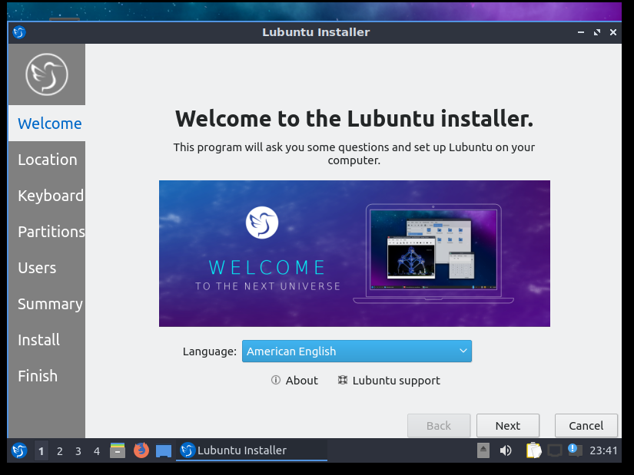

- Use the default Region and zone for convenience and then click “Next” :

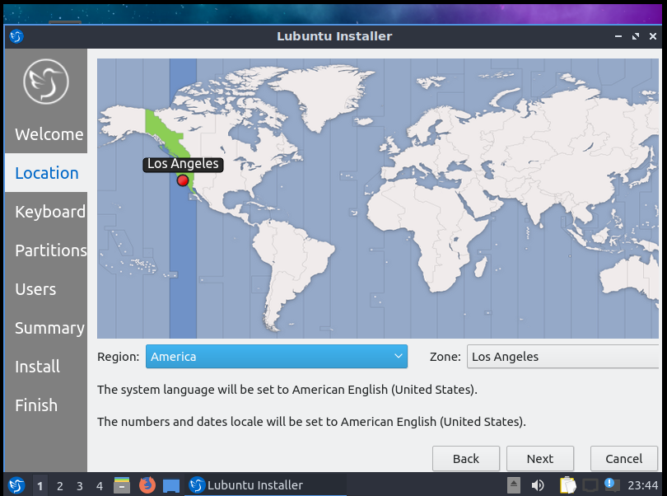

- Use the default keyboard setting, and click “Next”:

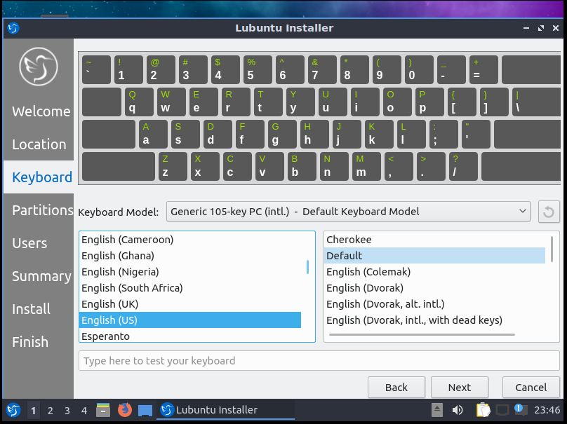

- Since the VMware Disk is newly partitioned within the VMware, you can safely choose Erase Disk and then click “Next”:
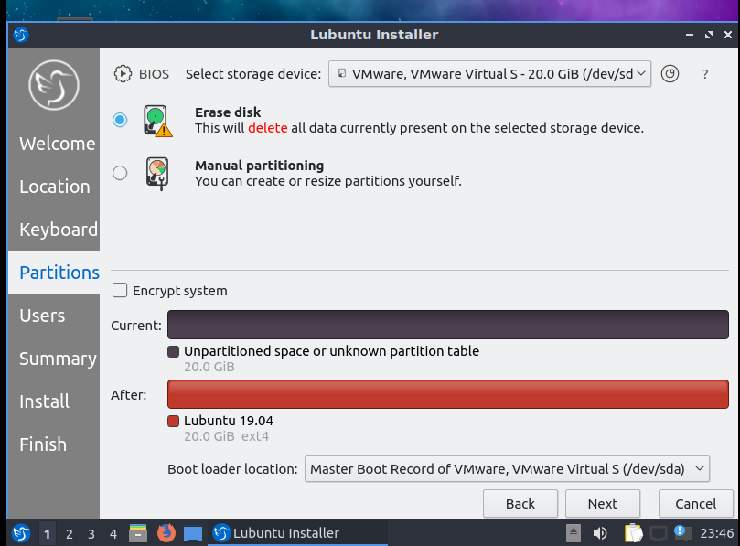

- Choose a user Name and a password. Note: Full Name will appear in the console window everytime you start up the VM. You can choose any User name/password, but be sure to remember your name/password.

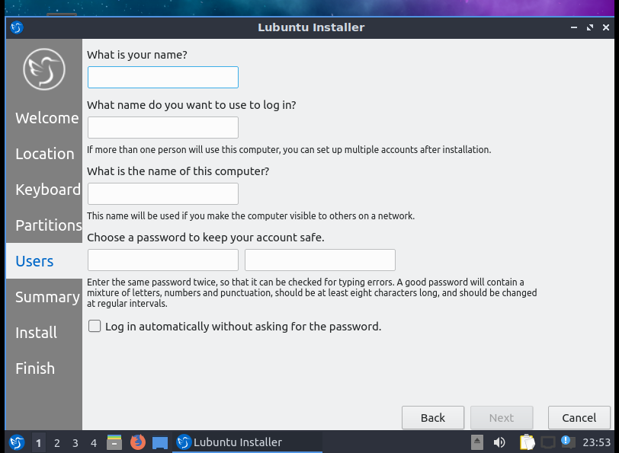
- Click “Install” to start the installation process.

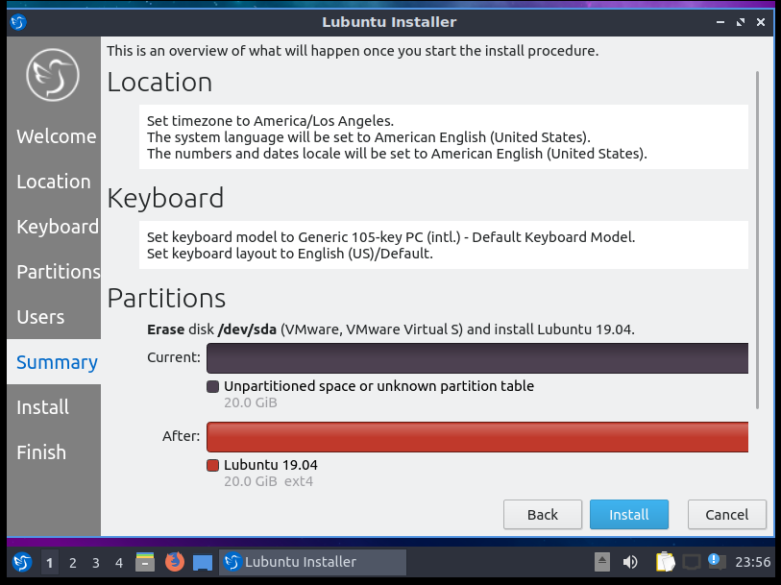

- Wait patiently for the installation process to finish.

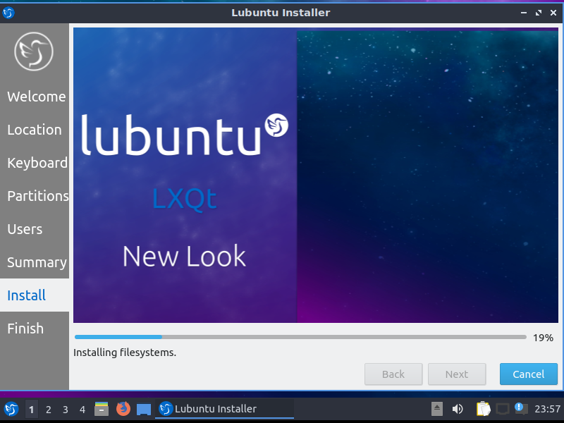

- After the installation finish, you should see the following screen, click “Done” to restart the VM.
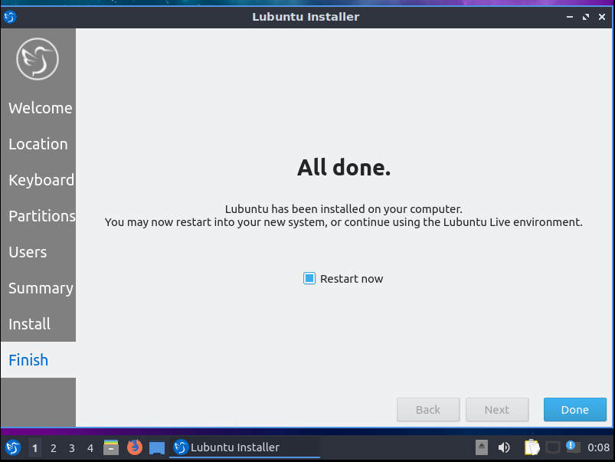

- After restarting, use your password to login. I chose name Alice for my user name as shown here.

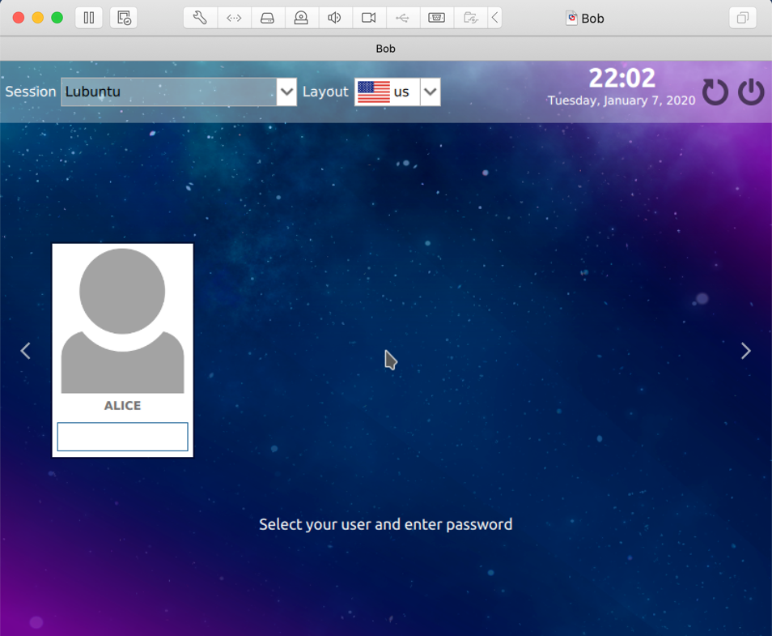
- You will see the following screen after logging in.
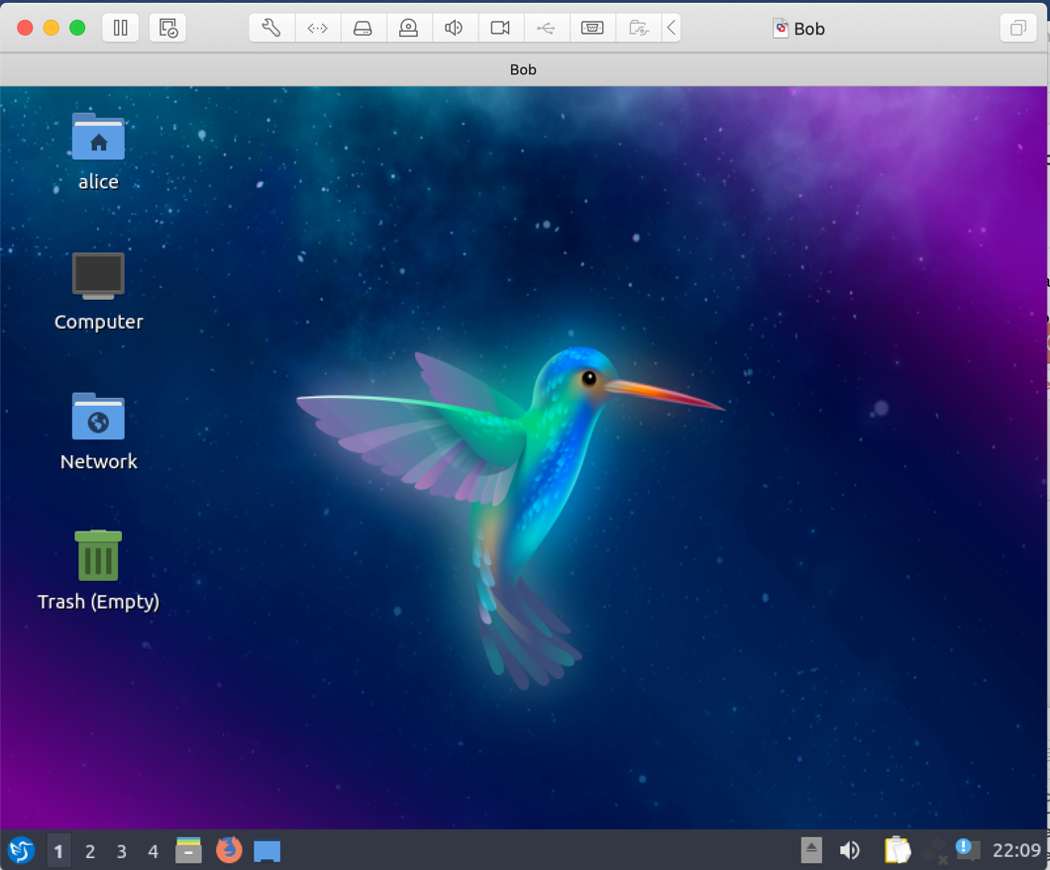
- To start a terminal window, click on “control ALT t”. You can also click on bottom, leftmost icon and you will get the search window. Select “QTerminal”. Select it to open a terminal window.

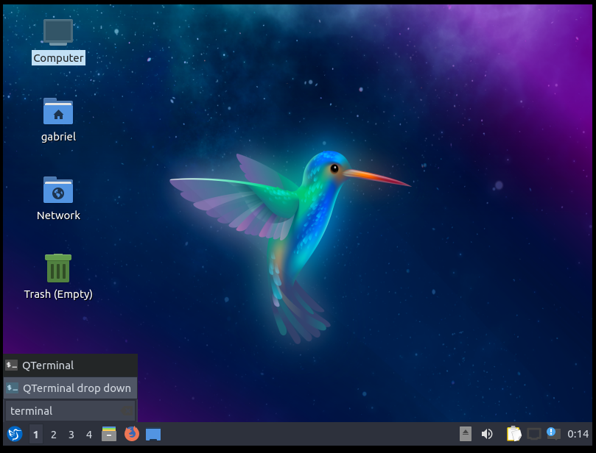

- When the Terminal opens, run the following commands:
sudo apt-get install net-tools
sudo apt-get install traceroute
sudo apt-get install hping3
sudo apt-get install dsniff
- After you’re done installing the tools, Type ^D to exit the Terminal.

- Power Off your VM in the VMWare.

- You will now make a Clone of your Lubuntu VM, right click Alice and find Clone under Manage.

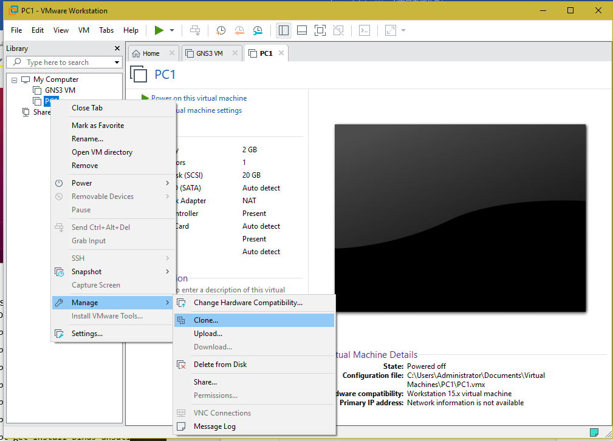

- Select “The current state in the virtual machine”. Click “Next”.
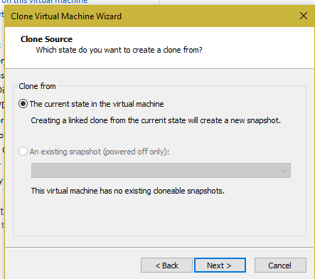
- Select “Create a linked clone”. Click “Next”.

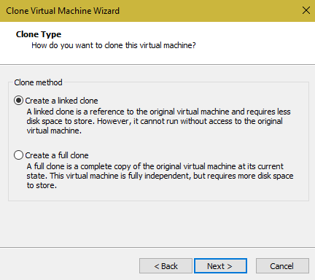

- For Virtual machine name, give it the name Bob. Click “Finish”.

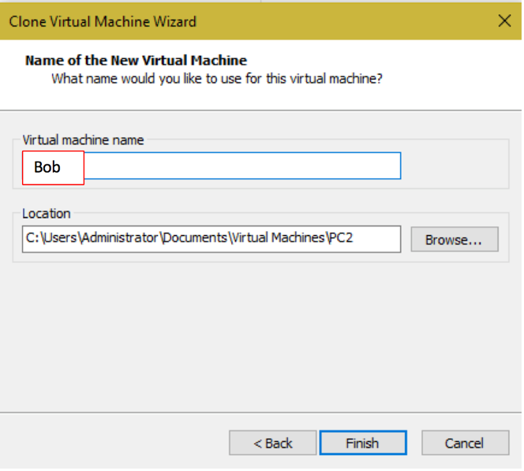

- Repeat for Mallory. Now should see three Lubuntu VMs:

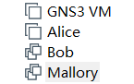

- You are done with all installations.

You may be asked to enter a license key during installation. Enter the key you saved.
When done with the installation, download the "GNS3 Getting Started Guide" for future reference. This lab walks you through a simplified installation process. The guide has more information.
You will see an unzipped file “GNS3 VM OVA” in your download folder. Leave it there for now.
Note: DO not install GNS3 VM. That will be imported as shown in Part 3.
In Lab1 we will show you how to login as root and then you will not need to type “sudo” before every command.

