Wireframing

The purpose of this exercise is to introduce the concepts of wireframing and mockups as well as serve as a precursor to next week’s discussion. We discussed these two concepts briefly in class already, and we will talk about them in more detail during class, however for the time being wireframing is sketching out an idea for an interface as a line drawing, without regards to color, specific iconography, branding, or anything else. A mockup is filling in the details of the wireframe. Another way to think about it that a wireframe is akin to the line drawing in a coloring book, whereas a mockup is the final, fully colored result. These terms are often used interchangeably, however in here we keep them separate.

Keeping that in mind, I would like the group to develop an interface for anything you want but only as a wireframe. One member can serve as the person who does the actual wireframe (or all can if you would like to do it collaboratively), but all members should participate.

Remember, a wireframe is just a line drawing. Non-specific elements can be included if necessary. An example is shown below.

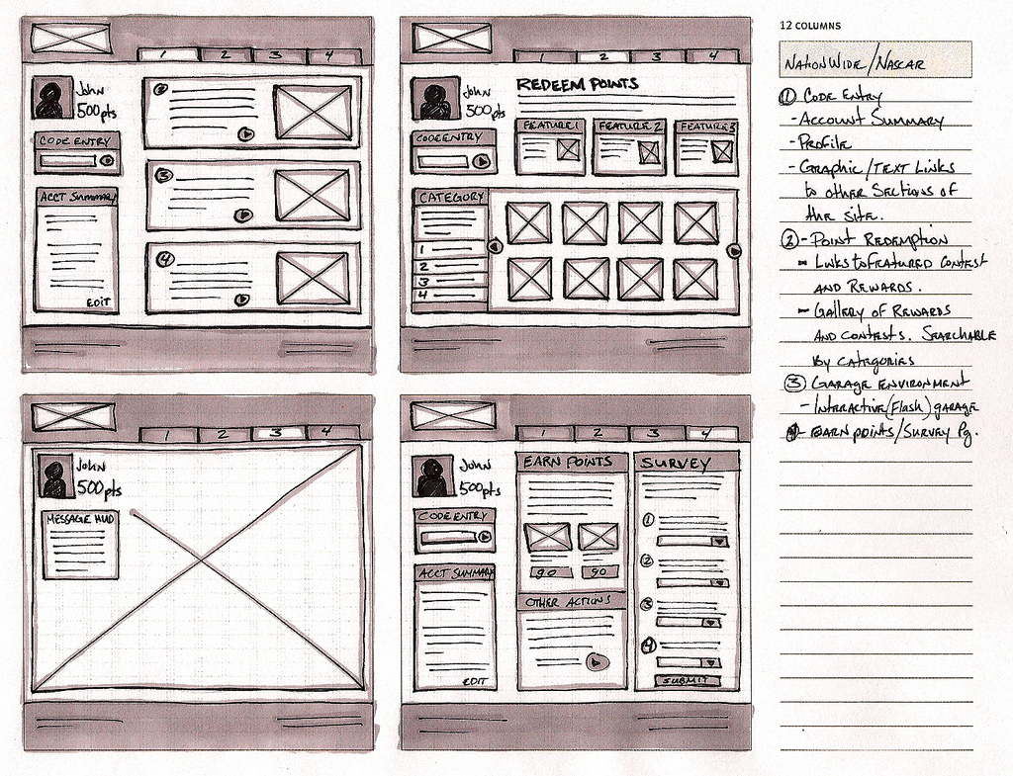
As you can see, a wireframe can be very generic, and can be drawn on binder paper, done digitally using a toll (which we will talk about in a minute), even sketched out a napkin. That last one is so common it’s referred to as a napkin sketch.

They can contain more detail than just lines in place of text, however. Consider the following wireframe example:

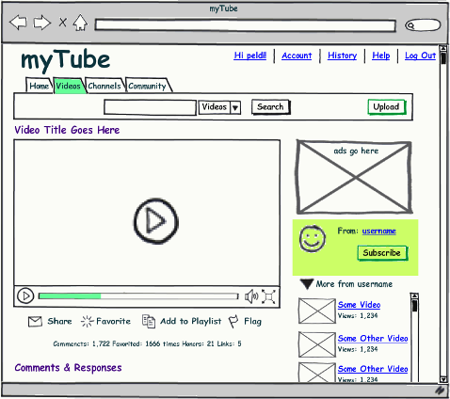

As you can see, this has taken a more completionist approach, however it is clearly not meant to be the final thing. Changes can be easily made, elements can be added, removed, or rearranged, all with minimal cost to the pace of the overall design.

For this exercise, the group will design an interface containing at least two screens for anything you want, however it can’t be the interface you are evaluating for your project. It could be a reservation system, a remote access terminal, the altimeter in an airplane, anything at all. The main purpose is to become familiar with the wireframing process.

Before the first wireframing step, describe the system your group has decided on and what its main function is supposed to be; why will people use it?

Next, your interfaces should be sketched out on paper. The group should discuss the design as it iterates, making changes as the discussion moves forward. It’s common to have scratches, erasure marks, and what have you. Those can be submitted as well, however the final drawn sketch (wireframe) should be devoid of all of those.

Then, head over to Balsamiq (www.balsamiq.com, click ‘launch demo version’ on the home page). Experiment with the software and try to become familiar with it. This is something all members of the group should do as it will become more important later in the session. Once you have become more familiar with it, see if you can recreate your sketched interfaces using Balsamiq. Once created, you can click on ‘Project’ in the upper right hand corner which will allow you to export your screens to a pdf. If you want to save them, you’ll have to register, which gives you free access for thirty days.

Everyone should participate in the design, offering feedback, and becoming familiar with the program, however one person will likely have to take the responsibility of actually creating the interface using the tool.

Submit all drawings including the final sketch, as well as the exported pdf from Balsamiq. Then, in one page, describe the design process. How did you come up with the final design, why do you feel it’s a good design, and were there any surprises or anything unexpected while you were designing. How far off of your original ideas is the final result? Lastly, what did you think of the Balsamiq tool? Did it help the design process, was it easy to learn, or was it not intuitive or cumbersome?

All materials should be submitted as a single document with a cover/title page, and will be due in class on Monday, Feb. 22th.

