Discussion 5 – Fitt’s Law

This week we discussed many important topics, the most impactful of which was likely Fitt’s Law. It’s one of the cornerstones of the HCI discipline and has been researched and tested extensively. Essentially, it tells us what the movement time should be from an origin to a destination, contingent on the characteristic of the pointing device being used, the distance to the target, and the width of the target. Ingeniously, distance and width are embedded in what is known as the ‘Index of Difficulty,’ which determines the difficulty of the task based on distance (Amplitude, or A) and Width (W) as part of the log function.

This exercise will show you in a very immediate way the impact of the target size and distance. The interactive portion can be done by each individual member of a group, however the analysis should be based on the results of everyone in the group.

First, go to this webpage:

http://www.simonwallner.at/ext/fitts/

It has an interesting writeup of Fitt’s Law, however we are interested in the interactive test in the middle of the page. It looks like this:

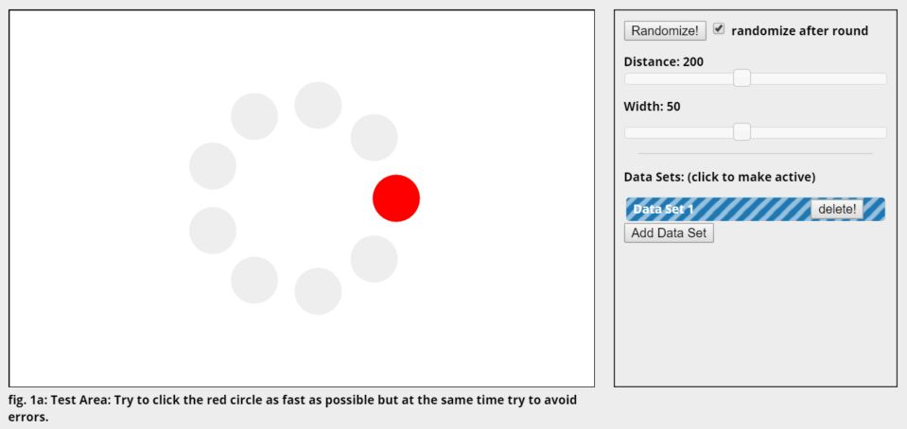

Be sure to uncheck ‘randomize after round.’ Also make note of the ‘Add Data Set’ button.
You will see the test starts with a target width of 50 and a distance of 200. Begin the first test by following the instructions it gives: Try to click the red circle as fast as possible, but at the same time try to avoid making errors (meaning try not to miss).

Run through the ring twice, a total of 19 clicks, which will put you back at the starting circle. Once that is complete, click on the ‘Add Data Set’ button (it will draw a line as you move the mouse from the test area to the button, which is fine). Reduce the distance to 120 and increase the width to 100. Repeat the test, clicking 19 times.

Add another data set; you should also be noticing that each data set is color coded. This time, increase distance to 300 and reduce width to 20. Repeat the test with these settings.

Finally, complete the test one more time using settings of your choice, being sure to indicate what your settings were in the written response. You will have four data sets in all.

We want to focus on the results provided in Figure 1e (Figure 2 shows essentially the same data only using a modified ID, and might present an easier-to-see version of Figure 1e), Figure 4 and Figure 5.

Figure 1e shows how long it took to click the target in milliseconds as represented by plot points, and the line is the average time. Figure 4 shows how far you deviated from a straight line when moving from one circle to the next, and figure 5 shows movement speed in pixels / millisecond for each trial.

After having completed the tests, evaluate your performance in terms of each of these graphs. For each one, each graph, compare the results of the four tests. What does each tell you? Does anything stand out, do you notice any patterns? How do the results/data sets reflect the size and distance of the targets? Are you surprised by any of the results? How could you use these results in terms of interface design?

Compare the results achieved by all the group members. Was performance consistent with the first three tests among everyone? Or was there variation? What about test four, with individual settings? Compare the results from those and offer thoughts on the comparisons; what do they tell you?

For the next part of the project, at least one group member (more if they would like) needs to download IOGraph, a very simple program that requires no installation, runs on Windows, Mac and Linux, and traces mouse movements using colored lines to indicate where the mouse moves and colored circles whose size indicates how long the mouse was at rest.

Use the program for one activity session of any type (Coding, gaming, web browsing, whatever) of at least two hours. Everyone who does it should save the resulting graphic and send it to me via email, with the file name being your name and your group name.

Even though there’s no hard data presented, does the graphic tell you anything about your mouse movement habits? If so, what? Is it what you expected, or are you surprised by what it shows.

Final document should be an assembly of all members’ test results and IOGraph response(s) into a single, cohesive document, not just multiple individual responses stapled together.

Due Friday, Feb. 19th, in discussion. That’s the same day as the deliverable so be sure to assign appropriate time.

