Keynote Speakers
CRAW/ CDC Discipline Specific Workshop on Diversity in Design Automation
Co-located with DAC, San Francisco, May 31- June 1, 2014.

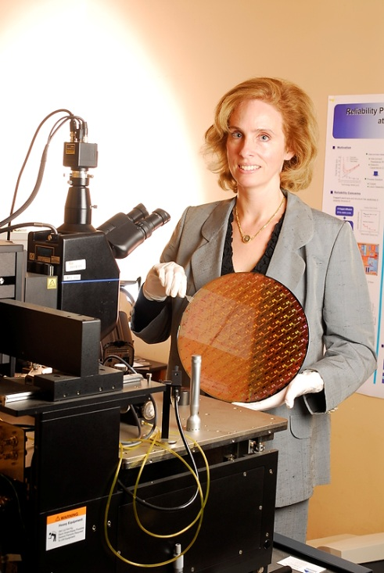
Linda S Milor

Dr. Milor has worked in the fields of yield analysis, reliability, and testing since the mid-1980s and has over 100 publications in these areas. She received her Ph.D. from U.C. Berkeley in Electrical Engineering. She is currently a Professor of Electrical and Computer Engineering at Georgia Tech.
Dr. Milor has worked both in academia and industry. In academia she received the prestigious NSF Career Award and the 2004 Best Paper in the IEEE Transactions on Semiconductor Manufacturing for M. Orshansky, L. Milor, and C. Hu, “Characterization of Spatial Intra-Field Gate CD Variability, Its Impact on Circuit Performance, and Spatial Mask-Level Correction,” published in Feb. 2004. She received a best paper award from the International Conference on Computer Design in 2009 for F. Ahmed and L. Milor, “Reliable Cache Design with Detection of Gate Oxide Breakdown Using BIST.” She received the best interactive presentation award from Design and Test in Europe in 2010 for M. Bashir and L. Milor, “Towards a Chip Level Reliability Simulator for Copper/Low-K Backend Processes.” She is currently an Associate Editor for the IEEE Transactions on Semiconductor Manufacturing. In industry, she worked as a Product Engineering Manager at Advanced Micro Devices (AMD), where she was responsible for yield and wafer quality.

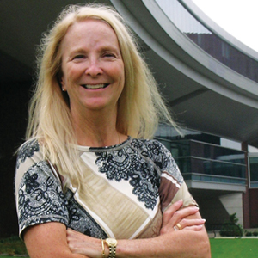
Mary Jane Irwin
Dr. Irwin has been on the faculty at Penn State since 1977 where she currently holds the title of Evan Pugh Professor and A. Robert Noll Chair in Engineering in the Department of Computer Science and Engineering. Her research and teaching interests include computer architecture, multicore systems design, power and reliability aware design, embedded systems, and emerging technologies in computing systems. Dr. Irwin received her Ph.D. from the University of Illinois and an Honorary Doctorate from Chalmers University, Sweden. She was named a Fellow of The Institute of Electrical and Electronic Engineers (IEEE) in 1995, a Fellow of The Association for Computing Machinery (ACM) in 1996, was inducted into the National Academy of Engineering (NAE) in 2003, and inducted into the American Academy of Arts and Sciences (AAAS) in 2009. Awards she has received include the 2003 IEEE/CAS VLSI Transactions Best Paper of the Year Award, the 2004 DAC Marie R. Pistilli Women in EDA Award, the 2005 ACM Distinguished Service Award, the 2006 Computing Research Association (CRA) Distinguished Service Award, the 2007 Anita Borg Technical Leadership Award, the 2010 ACM Athena Lecturer Award, and the 2012 Ten-Year Retrospective Most Influential ASP-DAC Paper Award.
Dr. Irwin is currently serving as a member of ACM's Fellows Selection Committee (Chair for the Class of 2012), of the Swiss NSF NanoTera Panel, and as Chair of NAE's Membership Policy Committee. In the past she has served as a founding co-Editor-in-Chief of ACM's Journal on Emerging Technologies in Computing Systems and as Editor-in-Chief of ACM's Transactions on the Design Automation of Electronic Systems, on NAE's Committee on Membership (Chair for the Class of 2012), and as an elected member of the CRA's Board of Directors, of the IEEE Computer Society's Board of Governors, of ACM's Council, and Vice President of ACM. Visit (http://www.cse.psu.edu/research/mdl ) group's webpage for more details.
She and her husband celebrated their 45th wedding anniversary in July 2011 and have two grandchildren, Kai and Milo.

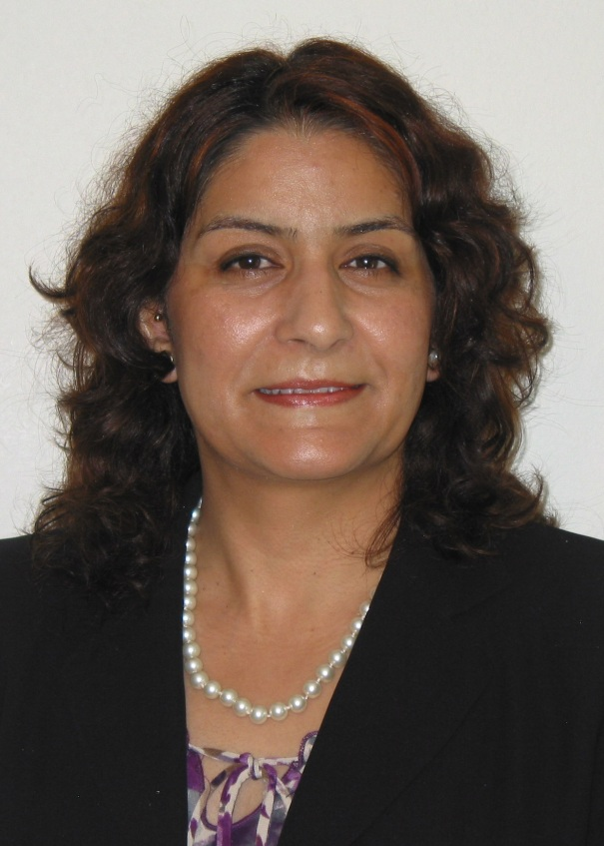
Anupama B. Kaul, Jet Propulsion Labs (NASA), California Institute of Technology and The National Science Foundation
Title of Talk: Low-dimensional Nanomaterials: Towards Their Applications in Devices For Energy, Sensors and Nanoelectronics

Anupama Kaul is a Program Director at the National Science Foundation where she is serving as an IPA from the Jet Propulsion Laboratory (JPL), California Institute of Technology. Her research interests are in characterizing the properties of nanoscale materials, developing bottom-up assembly and top-down nanofabrication techniques, and integrating such materials into novel devices which have applications in electronics, energy harnessing, sensing, and quantum-scale systems. Dr. Kaul obtained her M.S. and Ph.D. degrees from UC Berkeley in Materials Science and Engineering with minors in Electrical Engineering and Physics, while her B.S. degrees (with Honors) were in Physics and Engineering Physics. She has also held industrial research positions at Motorola Labs and the Hewlett-Packard Company. Dr. Kaul is the recipient of the NASA Service Award, a NASA Team Accomplishment Award, multiple NASA Patent Awards and numerous NASA Technology Brief Awards. In 2013, Dr. Kaul was the recipient of the National Science Foundation’s Director’s Award for program management excellence for her leadership in the creation of a new $30 Million research initiative at NSF that was launched in collaboration with the Department of Defense. Dr. Kaul was also selected to be a participant in the US National Academy of Engineering (NAE) 2012 Frontiers of Engineering (FOE) Symposium and the bi-lateral Indo-American FOE held in 2014. She has given more than 50 invited and keynote talks and meetings sponsored by professional societies such as the IEEE, SPIE, MRS and NSTI, among others. She is currently the Associate Editor of the IEEE Sensors Journal, serves on the International Advisory Panel of the Materials Research Express, American Editor of Nanoscience and Nanotechnology Letters, Associate Editor of Reviews in Advanced Sciences and Engineering and serves on the Editorial Board of several other journals. Dr. Kaul is also the Editor of Microelectronics to Nanoelectronics: Materials, Devices and Manufacturability, that was recently published by CRC Press.
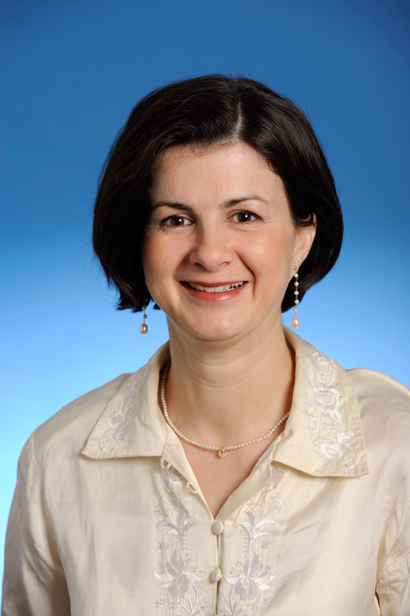
Diana Marculescu
Diana Marculescu is a Professor of Electrical and Computer Engineering at Carnegie Mellon University. She received her Dipl. Ing. degree in Computer Science from "Politehnica" University of Bucharest, Romania in 1991 and her Ph.D. in Computer Engineering from University of Southern California in 1998. She is the recipient of a National Science Foundation Faculty Career Award (2000-2004), an ACM-SIGDA Technical Leadership Award (2003), the Carnegie Institute of Technology George Tallman Ladd Research Award (2004), an ACM-SIGDA Distinguished Service Award (2010), and Best Paper Awards from IEEE Asia South-Pacific Design Automation Conference (ASPDAC 2005), IEEE International Conference on Computer Design (ICCD 2008), International Symposium on Quality of Electronic Design (ISQED 2009), and IEEE Transactions on VLSI Systems (2011). Diana Marculescu was an IEEE-Circuits and Systems Society Distinguished Lecturer (2004-2005), the Chair of the ACM Special Interest Group on Design Automation (2005-2009) and is an ACM Distinguished Scientist and a Senior Member of IEEE. Her research interests include energy-, reliability-, and variability-aware computing and CAD for non-silicon applications.
Title of Talk: Sustainability in Computing and Beyond
How do natural systems endure and how is nature inherently renewable? Can we learn from the supreme engineer - nature - how to design systems that are either sustainable by themselves or aid in achieving true sustainability in man-made systems? Electronic system design has benefited from decades of reliable and predictable functionality, but this trend will likely slow down in future technology nodes. To support a path toward sustainable computing, a holistic approach toward addressing energy awareness, reliability, and variability at all the levels in the system is required. Furthermore, while design tools and methodologies for individual systems is relatively mature, the use of electronic systems in achieving sustainable cyberphysical aids for engineered systems is still emerging. This talk will discuss our work on achieving superior performance and power efficiency for silicon systems in the presence of challenges induced by manufacturing process uncertainties and will unravel unexpected applications of classic EDA tool sets to the design and analysis of large scale, renewable energy generation and distribution.

