Open Source Software Development Processes in the Apache Software Foundation
ICS 225
Chad Ata
Veronica Gasca
John Georgas
Kelvin Lam
Michele Rousseau

Introduction
Even though software is an intangible artifact, it is still being developed and used everyday. In order to tackle with this characteristic of software, one can attempt to specify software in a formal way or in a written description, which in turn provides a specification of the software. With that in mind, testing the behavior of the software against a specification becomes possible. With sufficient testing (both verification and validation), the software is then released. This is the generic traditional process used to describe software development. If the software under development is a reasonable size, this generic process is quite intuitive and manageable. Unfortunately in reality, the scale of software being developed is enormous, and the development team usually is very large and distributed. The Open Source Software Development (OSSD) community is one of the frequently used examples to demonstrate differences that are not captured in the generic development process. The success of the OSSD effort, such as Apache and Linux, is not just motivated by those who want to save money by utilizing a free resource, but more due to the quality of their software. So how does an OSSD project manage their process without utilizing traditional software development practices that have been mandated for success?
There has not been too many in-depth research projects done towards the Open Source Software Development (OSSD) community and their efforts. In the typical software engineering textbook, you cannot even find the term ‘Open Source’ in the index. But in reality, there are more than 40,000 projects that are being hosted in the Open Source development portal (such as SourceForge [2]). The OSSD community is influential to the software industry. For example, IBM switched from using their proprietary web server to the open source Apache HTTPD web server in June 1999 [4]. As Eric Raymond termed in his paper [1], the OSSD ‘bazaar’ style of development is significantly different from the ‘cathedral’ style of development in the traditional software industry. There is a gap between the two communities. If a better understanding of the OSSD development process can be found, the “closed source” software industry may be able to benefit from it and vice versa. The software industry can learn from OSSD community how to manage a project with a diverse background of developers in a distributed setting. The high quality and high reliability products developed by the OSSD community, such as the well-known Apache web server, is rarely found in the mainstream software industry. Sometime even the big corporations, such as Microsoft, are still having difficulty to produce highly reliable quality software (comparing the Internet Information Server (IIS) with Apache HTTPD). There is also a possibility that the tools being used by the OSSD community is beneficial in the setting software industry group. The way that the OSSD community facilitate their needs and features for the software is another important aspect to be researched.
Under these circumstances, it is desirable to have a better understanding of the OSSD effort. In order to learn from the OSSD experience, one needs to understand how a feature is added in the form of specification, then be developed and eventually tested and released to the public. The focus in this research study is the Apache web server (HTTPD). The goal is to investigate in detail how the OSSD community, in particular the Apache group (both the ASF as well as HTTPD developers community), interacts with each other throughout the development process. We investigate the roles that exits within the project, the tools that they use in the project, and the artifacts created throughout the development process of the project and the overall release process.
In the next section, we briefly describe the Apache HTTPD project. We compare this Open Source Software Development project with the traditional software development project. Then we explain in detail about the software production architecture of the HTTPD project. We discuss the details about the agents, tools, as well as artifact throughout the development process. Each stage within the process is also explained in detail. Next an attempt is made to illustrate this development process in a formal manner. At last we conclude the paper with some further discussion and founding that we had during the research.

Overview of Apache

The Apache group was formed in February of 1995 by the 8 core founders. Their initial goal is to extend the web server created by Rob McCool to stable, bug-free, and feature-rich software. The founders coordinate together through their private email, applying their own individual “patches” to the source code. After extensive beta testing, the Apache web server was born on December 1995. Four years later, the Apache group formed the Apache Software Foundation (ASF) to provide the logistic support (such as donation or contribution from others) and other business-oriented needs (such as any licensing issues) of the project. Since then, many new OSSD projects (e.g. Jakarta, XML, etc.) have started under the leadership of the ASF.

Problem Domain Characterization
Apache is a well-known web server. Currently it has more than 50% of the market share, as the May 2002 Netcraft survey [3] has shown. This demonstrates the large-scale usage of the software. The Apache 2.0 web server is the result of a successful development process that one can study, from the beginning of feature specification to the ultimate end of deployment to general public users. In August of 2000, the Apache group decided to restructure and rewritten the entire Apache web server (i.e. the ‘requirement’). Their original aim was to have the new server released by the end of 2000. In reality, their effort of creating Apache 2.0 didn’t get into first beta testing stage until April of 2001 (i.e. the ‘testing’). In fact, not until November of 2001, companies that support and distribute Apache web server considered the Apache 2.0 as ready-to-use (i.e. the ‘initial release’). The ultimate stable public release did not become available until the beginning of April 2002 (i.e. the ‘ultimate release’), which is approximately 1.5 years behind their original goal. This is the same typical problem that a traditional software development faces – missing a deadline.
This research study is aim at understanding the problem stated above. We try to understand how the OSSD community communicate among themselves. After understanding the communication mechanism, we try to find out how they facilitate requirements for the software under the development effort. During the development, we look at the channel of communication for help inquiry and testing between the developers. After the testing effort, we investigate the process of getting the tested-source-code to become a releasable product to the general public.

Process Modeling and Visualization

Agent Roles
All of the Apache Software Foundation projects use a philosophy of meritocracy to define the hierarchy of their agents. Meritocracy is based on the notion of work increases rights. All the code is reviewed by many eyes. For example, developers can only gain write access to the CVS by proving their skills and commitment to the committers on the project. They achieve this by contributing code in a quality of what the committers view as good code. Committers then must vote to bring a developer into committer status. Votes on patches and what not only are binding for committers. Thus, the higher the rank the more power and influence one has. Below is an outline of agents and their roles as outlined through the ASF website. Keep in mind that agents can contribute in any lower ranking duty, but agents on a lower rank cannot participate in the duties of the agents that are higher ranking.

Users
Apache considers its development to be user-centered. They contribute in three basic forums. First, they submit bug reports, through the website, using Bugzilla. They are the ultimate testers of the final version of the code. Secondly, they contribute suggestions for new features. They do this by using Bugzilla and indicating that they are submitting an enhancement. This is one way of understanding what users want to see in the next version and is significant in determining the long-term goals of the project. Finally, users support each other through the mailing lists.

Developers
The developer's role is to contribute either code or documentation in the form of patches to the project. Developers do not have capabilities to commit changes into the CVS They submit ‘diff’ file results to different channels in order to solicit as well as advocate committers to commit the changes into the CVS. Developers have limited voting power. They are allowed to vote on patches, but don't have a binding vote unless they authored the patch. Developers can also contribute by being involved in alpha testing or beta testing.

Committers
Committers develop and commit code or documentation. They can commit their own works as well as patches from developers with their write access in the CVS. Committers vote on developers’ patches for acceptance or rejection. Committers is responsible to oversee the development efforts among developers. They determine which developers become committers by recommending them. After a unanimous voting, a developer will advance to a committer status. It is the responsibility of committers to ensure that code integrated into the CVS is ‘good’ code. They are responsible for reviewing what goes into the CVS and ensure the integrity of the software. Committers can be come part of the Project Management Committee by self-promotion and long term commitment.

Project Management Committee (PMC)
Members of the PMC are self-selected committers. They are responsible for the long-term direction of the project. Although the Board of Directors ultimately has the final decision making power on any project, they delegate this responsibility to the PMC of each project. There is a single PMC for every project. They determine what will go into the next release of a project. Although the Release Manager has the ultimate say in what goes into the final release, the PMC can make suggestions.

Release Manager (RM)
The release manager's main role is to schedule the release of the project. The RM is a self-selected committer. The RM decides when each testing phase is done and when the general availability (GA) release will be made public. This individual has the ultimate authority over what makes into the release.

Foundation Members
Foundation Members have demonstrated long-term commitment through the amount of work they have contributed to Apache Projects. Members are not project specific, but part of the Apache Software Foundation. Members are responsible for guiding the foundation. One of their most critical responsibilities lies in the election of the Board of Directors. Foundation Members are invited by other members and voted into membership.

Board of Directors and Officers
The Board of Directors and Officers of the Apache Software Foundation are responsible for the business affairs of the foundation. The officers are elected by the Board of Directors to oversee the daily operations of the foundation. Although the Board of Directors is officially responsible for the projects, they delegate most of the decision making process to the Program Management Committee.

Tools and Network Infrastructure
As with all large software development projects, there is a need for tools to support the process. This is especially true for Open Source Development, which needs to confront a maximally distributed community. For the Apache HTTPD community the tools are essential for its existence. They provide guidelines (which can be considered tools as well) to provide some standardization and understanding of expectations and process. Although there are not many tools, these tools are powerful and effective in handling the large number of members in the community and the distribution of those members. Each of these tools are detailed on the Apache website.

Communication
The entire community coordinates with each other mainly by communicating through mailing list, as describe in the project guideline of HTTPD. They also rely on information posted on the project web portal. Another form of communication can also be found in the CVS “STATUS” file, where the vote on each issue is recorded for future reference. Lastly, the face-to-face communication is probably the most natural form, which is rarely found in the OSSD community. For Apache in particular, there is an annual conference for all the developers to gather and to discuss the project.

Source Repository and Configuration Management
Concurrent Versioning System (CVS) is the source repository used by all the Apache Software Foundation projects. Each project has their own branch of source code and documentation within the CVS. Each developer can follow the guidelines provided on the project web portal to setup their own access and synchronize their local copy with the most current version in the CVS. Developers can obtain the source code for the platform of their interest through the CVS binary and source distribution. Developers can also obtain previous version source code through the CVS system as well. The Release Manager also uses the CVS extensively throughout the release process, in order to minimize the interference of the release with the current development effort.

Development
There is no specific development tool recommended by the community for this project. Because the Apache HTTPD software is a cross-platform product, each individual developer can pick their own favorite development tool that works best for their particular platform to yield the maximum productivity. However, the project community does provide different kind of guidelines for the development. For example, the style guideline is being strictly enforced over all source code committed into the CVS. In order for the development effort by an individual developer to pay off, the developer needs to follow the patch guideline in order to get the maximum possibility of having his/her patch committed into the CVS.

Debugging
Apache HTTPD is a large and complex software project. Trying to find a problem is not an easy task. In order for a developer to work on a particular Problem Report (PR), or to find problems within his/her own patch, he/she will have to debug the software. GNU debugger (gdb) is the recommended tool that the Apache HTTPD community uses to trace the problem within the software. There is a detailed guideline to assist developers in resolving problems throughout the development process.

Bug Tracking and Feature Acquisition
Bugzilla is the ultimate tool used by the Apache HTTPD community. A guideline is available for the community to use this tool appropriately. This is the tool that the entire community heavily depends on for the success of the project. Users use this tool to report bugs found, and they also submit suggestions for new features and enhancements through this tool as well. Developers look through the problem reports submitted and decide which they are interested in. Committers, as well as the Project Management Committee, use this tool to track the general interests of the community, and based on that to decide the direction for the project.

Release
The release manger is responsible for the release of the Apache HTTPD software. There are clear detailed guidelines for Release Manager to follow in order to have a successful release. There is also an obsolete document to educate release manager about the steps needed for the release process. This obsolete document is replaced by the automated building script stored in the CVS to ease the effort of releasing this complicated software.

Artifacts

As in any software development process there are many artifacts involved in the process of developing the Apache HTTPD release.

Problem Reports
Inputs: Bug reports and new feature submitted by Users
Outputs: Problem Reports number (PR#) in the Bugzilla Database are input for the Developers
Agents: Users/Developers

Problem reports are derived from the Bugzilla database. All bug reports and new feature requests are submitted to the bug database from all users. Users are provided with a set of guidelines to follow before entering a new request. Basically, they are requested to first download the lasted patch to ensure that their issue has not been resolved. Next, they should check Bugzilla to see if their issue has not already be submitted.

Patches
Inputs: Problem reports
Outputs: Patches (diff-files) from Developers to Committers
Agents: Developers

Patches are output from developers and input into the communication channels (e.g. mailing list or Bugzilla). Patches are the main forum for developers to communicate with each other. Since all code and documentation is submitted as patches, this is probably the most significant artifact among all. All patches after submission is then pending on the voting process for acceptance.

Release Patches

Inputs: Committers consensus
Outputs: The release patch is made available to the general public
Agents: Users/Developers/Committers

Released patches are patches that have been minimally reviewed by and then committed to the CVS by a committer. Released patches are made available to the public on the official web distribution. Committers can revoke a patch if after reviewing it in detail, and they find problems with the patch that it should not be committed. But keep in mind that the patch can be committed without review from other committers under the current process. This is consistent with Apache’s current commit-then-review policy on patches.

Proposed Features

Inputs: Release patches, Bugzilla enhancement reports
Outputs: Project Roadmap
Agents: Project Management Committee

Proposed features are output from the Project Management Committee and an input to the release manager. The PMC develops a list of proposed features based on their personal judgment, requested feature enhancements in Bugzilla, and from the enhancement coded as patches (which is submitted to the developers accessible portion of the website). This list is referred to as the project “roadmap” and will then be voted upon by the PMC. The “roadmap” will then be reviewed by the community and turn into the “status” file, which contains the more elaborated requirements and the outcome of the votes from the committers.

Proposed Requirements

Inputs: Proposed features
Outputs: Status file from PMC to Developers
Agents: PMC/Release Manager/Developers

Proposed requirements are output from the PMC voting on the proposed features and input to the developers, who will start coding these new features, and to the release manager who will make a decision as to which of the new features will be included in the release. The proposed requirements include not just the requirements, but also the results from the votes that each PMC member submitted for each requirement. This file is placed on the developer accessible website. This file is referred to as the “status” file. Developers access this file and determine which features they want to implement.

Patches for New Release

Inputs: Proposed Requirements
Outputs: Patches from developers to the release manager
Agents: Developers/Release Manager

Developer source code for new features is contributed as patches, and then sent to the community, which undergoes the review-then-commit process. From here the release manager determines which of these new features will go into the current release.

Alpha Build

Inputs: Patches for New Release and Status file
Outputs: Bug fixes from developers
Agents: Developers/Committers/Release Manager

The release manager creates an alpha build from the new feature patches submitted. This alpha build is place on the web for developers to test. Developers and committers test and fix bugs in the code and submit those fixes as patches. The output for the Alpha build is given to the release manager to create a beta build.

Beta Build

Inputs: Alpha build and Bug Fixes from Alpha Testing
Outputs: Bug fixes from developers
Agents: Developers/Committers/Release Manager

The release manager decides when it is time to create a beta build. The inputs to the beta build are the alpha build and the bug fix patches submitted by the developers and committers. The output is submitted on the developers website for further testing.
The developers test the beta build and produce more bug fixes in the form of patches.

General Availability (GA) Build

Inputs: Beta Build and Bug Fixes from Alpha Testing
Outputs: Final build made available to the public
Agents: Release Manager

The inputs to the GA build are the beta build and the bug fix patches submitted by developers and committers. The release manager determines when beta testing is complete and creates the GA build. The Apache guidelines are then to test the GA on the Apache website for 48 to 72 hours to determine if it is stable. This however is just a guideline and the release manager can release the GA to the public whenever he/she deems it is ready for release.

Processes
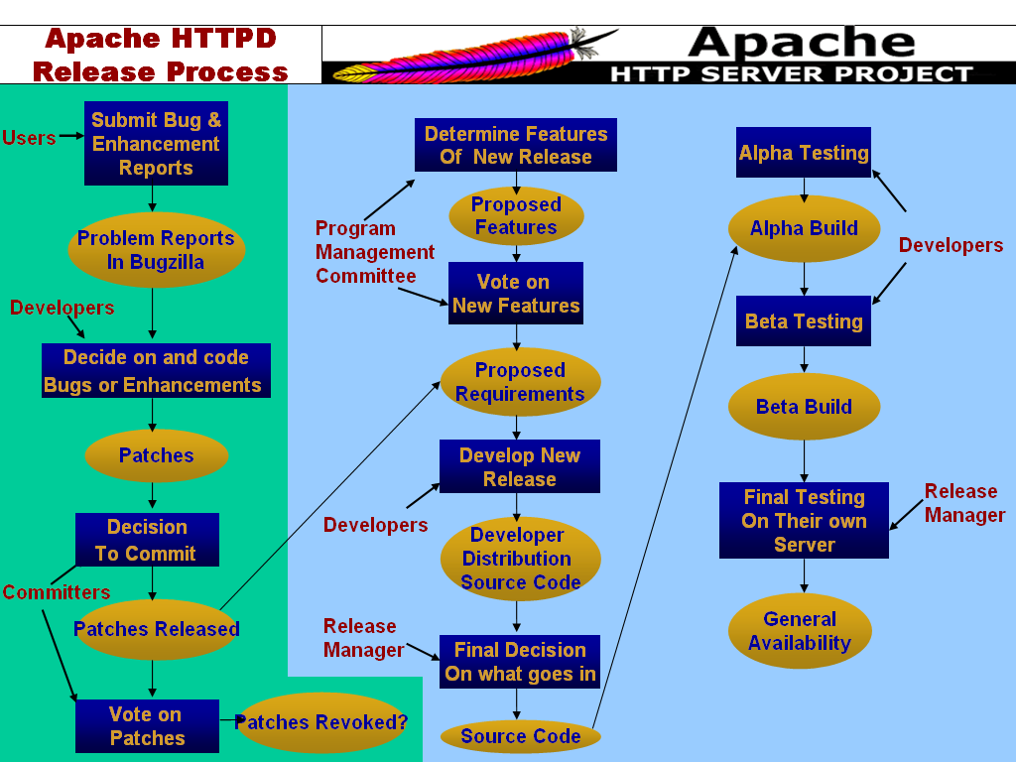
Figure 1: The overall Apache HTTPD release process. The green portion depicts the patch development process, while the blue portion depict the release process.
Apache works on a meritocracy so developers must prove their skills before any of their code is committed. All code is reviewed by many eyes. This follows Linus' Law [1] which basically states that the more eyes looking at the code the more likely it is that faults will be discovered and repaired. Committers have shown that they are competent developers with an understanding of how to write good code. Most committers have a good understanding of software process and best practices in developing software. Therefore it can be concluded that all the traditional training that these software engineers have been exposed through either formally or through experience is not disregarded while developing open source software, but has become a part of their work routine.

The Patch Development Process

Previously released patches can be new features as opposed to just bug fixes. They become part of a new release and understanding how those patches are developed is essential before delving into the release process.
Anybody in the community can submit a new feature request via Bugzilla by indicating the submission as an “enhancement”. Developers scan Bugzilla and decide which of these items they would like to implement. Once a developer has committed to coding the new enhancement, he/she interacts with the submitter to sort out any details. This is similar to discussing a requirement with a customer. The “customers” of Apache HTTPD are the users. The developer then posts the patch in the form of a diff-file to the mailing list dedicated to new patches (i.e. new-httpd), or by submitting the diff-file to the Bugzilla database. From there a committer decides whether or not to commit the patch into the CVS. In the past, committers follow a review-then-commit (RTC) policy. But due to the large amount of patches submitted currently, committers follow a commit-then-review (CTR) policy for patches. The CTR policy is subject to the lazy consensus rule. They commit the patch and then see if any other committers dispute the patch by sending in a –1 vote or a veto vote. Only one veto is needed to cause a patch to be revoked. This is different from a majority consensus rule. When there are at least three +1 votes and there are more +1 votes than the -1 votes, then a majority voting issue is passed. A veto cannot be cancelled, but can only be withdrawn by the originator of the veto. The status of the veto must be changed for the patch to be released. Developers may vote as well, but only the developer who authored the patch has a binding vote in the voting process.

The Release Process
Patches that have been committed and not revoked become a part of the proposed requirements for the new release. The release manager can also look at Bugzilla for other enhancement requests to determine the requirements for the new release. Communication with the Program Management Committee as well as coordination with the entire community is also a crucial step for the success of the release process.
Requirements are elicited in a variety of ways. First, as mentioned above, potential features can come from enhancement reports that are submitted to Bugzilla. Second, features can be in the form of patches already available (committed into the CVS already). Finally, features can be requested from the Program Management Committee. The Program Management Committee details a “ROADMAP” file, which is overall direction for the preliminary requirements of HTTPD. These requirements are then voted upon by the community. Each item on the “ROADMAP” file is then detailed out and the results of these votes are recorded, all together to be put into the “STATUS” file. The status file represents a history of the development effort for the release. Unlike patches, new features are not subject to veto. A majority vote means approval for new features. Developers and Committers both access and review the status file. From there they decide which features they want to implement. The new features are then submitted as patches (diff-files); the same applies to bug fixes (with respect to PR#). From there the Release Manager decides which of these patches and new features will be part of the new release. Despite what the Program Management Committee’s recommendation is, the final decision of what will be released is made by the release manager.
Once the final decision as to what goes into the release is determined, the code is then built into executable ready for Alpha testing. Developers and committers have access to the Alpha release distribution for testing purposes. This release is provided on the developers’ website and announced through the developers’ mailing list, where users do not have access to. As developers and committers find bugs they fix them and submit them as patches again. When the release manager as well as the community is satisfied with the Alpha testing, the code with all the fixes applied will then moves into Beta Testing. Again, only developers and committers have access to the Beta release. They test and fix bugs until the release manager decides that the code is finally ready to become a general availability (GA) release. Prior to doing this, it is recommended that the binary distribution is tested on the Apache Software Foundation website for at least 48 to 72 hours. This is only a suggested guideline and again the release manager has the ultimate control over when the new release is ready and will be available. After all these testing steps, the code finally is ready for GA and an announcement will be made to the public regarding of the new release.

Rich Picture for Apache HTTPD Project
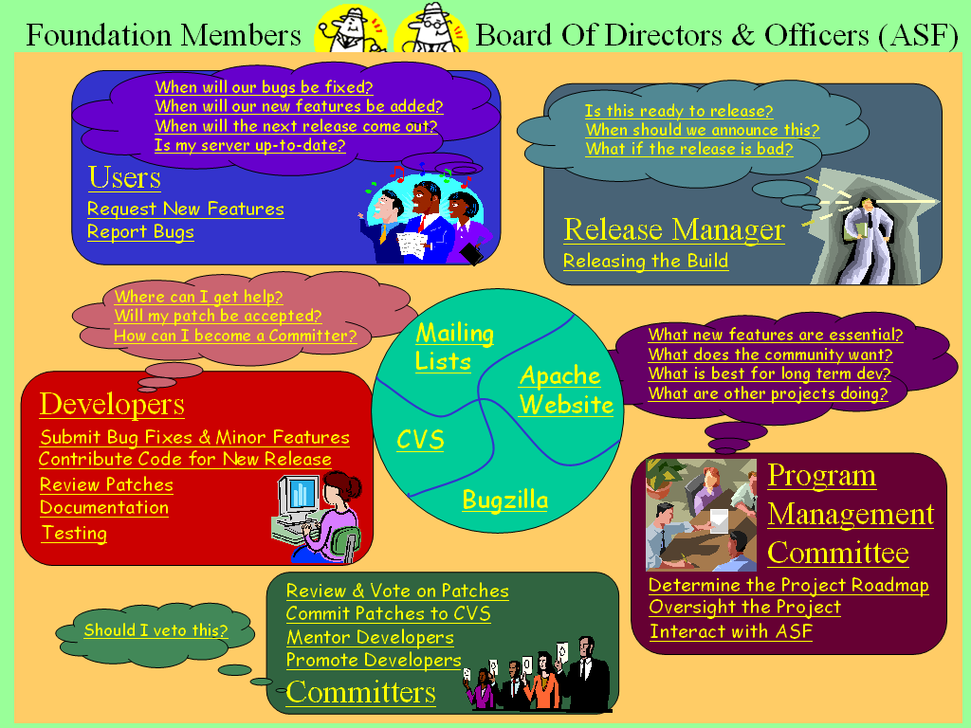
Figure 2: Rich picture for the Apache HTTPD project. The link to the entire document is here.

Use Cases for Apache HTTPD Project

Use case per Process (Relation)
UC provide process sequencing (control flow), tool invocation, resources input/output along the way, pre-conditions, post-conditions (goals/outcomes), and anticipated breakdown and recovery situations

Formal Model of Release Process Apache HTTPD Project

The graph of the model that the Protégé tool generates is a very large and complex graphic; it is best viewed by itself and is available here. However, a partial view from within the Protégé tool is presented here.

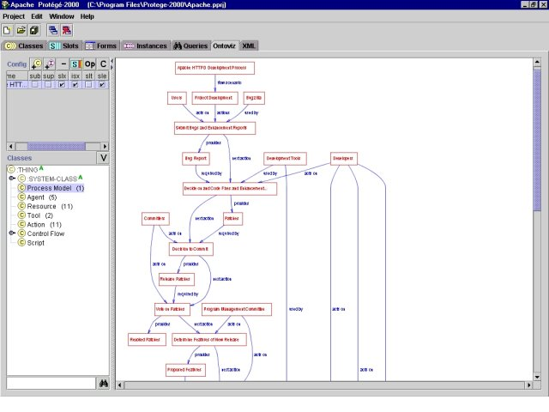
Figure 3 - Partial view of the Apache HTTPD development process

Jakarta Introduction and Overview

In order to have a more general understanding of Open Source development within the Apache group, we decided to analyze the Jakarta project, in addition to the httpd project. Jakarta is one of the largest projects in the Apache Software Foundation.

The purpose of the Jakarta project is to produce and maintain open source products created on the Java platform. This project is comprised of several server-side Java subprojects, categorized in the following three categories:

- Libraries, tools, and APIs. Includes build tools, repositories, Java and JSP libraries, APIs for file manipulation, regular expression packages, etc.

- Frameworks and Engines. Frameworks for unit testing and web application development, text search engines and template engines for source code generation.

- Server Applications. This includes Tomcat, the official Reference implementation of JSP technologies, WebDAV aware CM systems and email/news/messaging servers, amongst others.

We analyzed the software process followed in two of these subprojects, in order to gain insight on Jakarta software product lifecycles. The two subprojects selected, Tomcat and Lucene, belong to the Engines and Server Applications category, respectively. We chose these projects due to their success and visibility within the Jakarta project.

Tomcat is the servlet container used by the official reference implementation for Java Servlets (http://java.sun.com/products/servlet/index.html) and Java Server Pages (http://java.sun.com/products/jsp/). Tomcat is commonly used in combination with the httpd server, in order to support Java Server Pages development and usage. Tomcat is available for commercial use under the ASL license in both binary and source versions.

Lucene is a fully featured, Java-based text search engine, optimized for high performance. Lucene became part of the Jakarta project in September of 2001. This subproject features incremental and batch indexing searching, it allows having indexing control, stop-word processing, content tagging, stemming and querying. Lucene is available for commercial use under the ASL license.

Jakarta Problem Domain Characterization

The Jakarta project, especially the Tomcat subproject, has been very successful. Over the years the developers and committers on this project have learned valuable lessons from personal experience as well as from the older httpd project. This has allowed them to restructure their open source software development processes in a more efficient way. Lessons learned in the Jakarta project, have allowed team members to further refine the software process in order to enhance it and make it more efficient. An example of this is a problem that presented itself with the 3.0 release plan of Tomcat. At the time, a group of developers that happened to know each other would create the release plan offline, that is, without making the process public, until they came to a decision. This caused a great deal of complaints from other Tomcat contributors (see http://www.mail-archive.com/general@jakarta.apache.org/msg02778.html for details). This led PMC member, Ted Husted, to prohibit offline committer votes to occur.

These types of problems have allowed Jakarta to flourish into a great example of open source software development. Therefore, analyzing this project provides us with valuable open source techniques, which may allow us to form a general open source software development meta-model.

Jakarta Process Modeling and Visualization

Using the information we collected from the Jakarta, Tomcat, and Lucene websites and mailing lists, we have been able to abstract a general software life cycle process for a typical Jakarta subproject. Several agent roles have been identified and are discussed in the following section. Section 9.2 discusses the tools and network infrastructure used by typical Jakarta subprojects, followed by the Jakarta artifacts in section 9.3. The process description and hierarchy are then described in section 9.4.

Agent Roles

A subset of the httpd agent categories compose the members of the Jakarta project. These agents include the following:
- Users – See section 4.1.1
- Developers – See section 4.1.2
- Committers – See section 4.1.3
- PMC members – See section 4.1.4

Tools and Network Infrastructure
The tools and network infrastructure in the Jakarta project are the same as those in the HTTPD project. Please see section 4.2 for more information.

Artifacts
Artifacts of the Jakarta projects are the process inputs and outputs. For artifact descriptions please see the appropriate subsection in section 9.4.

Process Description and Hierarchy

The following subsections describe the software lifecycle process of a typical Jakarta project, which is depicted in figure 2. The subsections represent process enactments, which are represented as rectangular boxes in the diagram. Since open source software lifecycles are being examined here, the following subsections cover all three open source software development (OSSD) process layers. In particular, OSSD articulation processes are reflected during Jakarta voting procedures, which are discussed in section 9.4.4.1. OSSD community development is also portrayed by the extensive emphasis on communication, which is chiefly described in section 9.4.12. The bottom-most OSSD process layer, software development process, is encompassed by the entire process description.

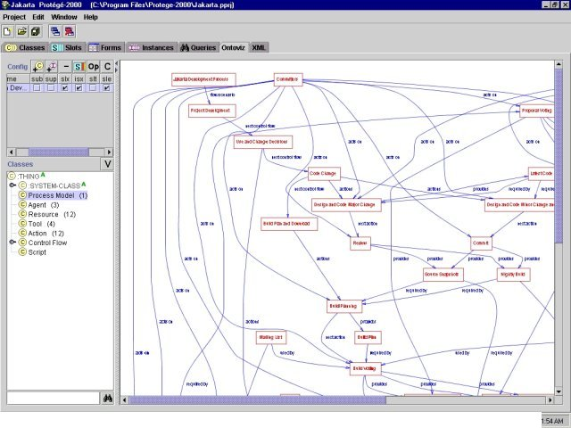
Figure 4 - Partial view of the Jakarta process life cycle model from within Protégé. For the full view see here.
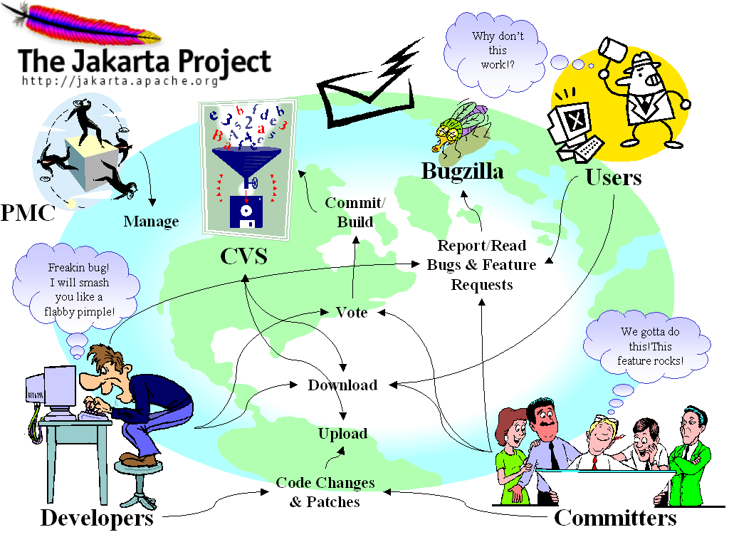
Figure 5 - Jakarta software development life cycle process rich picture. See here for the hyperlinked version.

Download

Input: Latest Build
Output: Latest Build
Agents: Users/Developers/Committers

As shown in the Jakarta process diagram (see figure 2), a specific starting point for the Jakarta software life cycle does not exist. Despite this we chose to begin our process description with the download procedure since it is at the root of all open source software development projects.

Downloading application source or binary code is the first step towards application usage or development. Therefore, as a prerequisite for the download procedure, source and binary code is made available via the Jakarta website. For example, Tomcat and Lucene binaries may be downloaded at http://jakarta.apache.org/site/binindex.html and source code is available at http://jakarta.apache.org/site/sourceindex.html.

Downloads are performed by all users interested in the Jakarta project. More specifically, many users are most likely to download the binaries of an application and use it as is without needing to make any modifications to it. These users have a choice amongst four types of binary builds:

- Release builds – See section 9.4.11
- Milestone builds – See section 9.4.11
- Nightly builds – See section 9.4.8
- Demo builds – See section 9.4.11

For more information regarding these builds, see http://jakarta.apache.org/site/binindex.html.

On the other hand, other users download the source code so that they can “hack” and integrate the Jakarta application into their software product. In this case, these users have a choice from three types of source code drops:

- Release source drops – This code is “as good as it gets” according to the Jakarta website and is intended for high quality products. These releases are reviewed to ensure Servlet and JavaServer Page compatibility.

- Milestone source drops – Milestone code is not intended for commercial products because although much of the functionality is acceptable, there still exist many bugs. The advantage of milestone source drops is that they allow their users to explore and use future feature of the product.

- Automated nightly snapshots – These code “snapshots” are automatically taken by CVS everyday. As a result, the code is very unstable. Despite this, Jakarta project developers may need this latest code.

More information regarding Jakarta source downloads can be found at http://jakarta.apache.org/site/sourceindex.html.

Application Usage

Input: Latest Build
Output: Bugs/Feature Requests
Agents: Users/Developers/Committers

Once application source or binary code has been acquired following the download process, users then begin to use the application. As described above, these users may either use the application as-is, or they may make modification to it and possibly integrate it into their own software product.

Over time, users will begin to notice and potentially be irritated by bugs and other problems in the software. As problems are encountered these users communicate primarily through the use of the user mailing list appropriate to the Jakarta product they are using (see http://jakarta.apache.org/site/mail2.html). They use this mailing list in order to resolve their problems by asking other, more experienced, users for assistance. Other resources, such as the Tomcat FAQs at www.jguru.com, as well as online books, articles, and even debuggers (see http://jakarta.apache.org/tomcat/resources.html).

Problems that are not resolved through the use of these resources are eventually perceived by the users as bugs or software deficiencies. This leads to the following section, which discusses the feature requests and bug reports that users can make when unsatisfied with some particular aspects of a Jakarta application.

Feature Requesting and Bug Reporting

Input: Bugs/Feature Requests
Output: Requirements
Agents: Users/Developers/Committers

As active users of the Jakarta project come across bugs in their Jakarta application they often report it using mailing lists, IRC chat, and primarily Bugzilla (http://nagoya.apache.org/bugzilla/enter_bug.cgi). In Bugzilla, users must first chose which application they are using before submitting their report.

Users of some of the Jakarta applications, such as Tomcat, are encouraged to follow bug-reporting guidelines. In particular, for Tomcat, users should include the following information (http://jakarta.apache.org/tomcat/bugreport.html):
- Tomcat version
- Tomcat component – the component which has the bug
- Hardware platform and operating system
- JVM and Web server version
- Configuration files
- Log files and stack traces
- Examples which demonstrate the problem
- Bug fix patch if available

Users may also use Bugzilla to request new features for a Jakarta application. This is performed by submitting a bug report as any other bug, and setting its severity to “enhancement” (http://jakarta.apache.org/site/bugs.html).

New Feature Proposal

Input: Requirements
Output: Proposal
Agents: Developers/Committers

From time to time, developers and committers, perhaps under the influence of feature requests, draft a new feature proposal (see http://www.mail-archive.com/tomcat-dev@jakarta.apache.org/msg26507.html for an example of such a proposal in the Tomcat project). If their idea actually came from a feature request then they assign themselves to that bug in Bugzilla, so that others will know who is doing work on that particular request. Next, they submit the new feature proposal to the developer mailing list for approval. Approval or denial of the proposal is dependent on developer and committer votes. Jakarta voting procedures are explained in the following section.

Voting

Input: Proposal
Output: Approved/Disapproved Proposal
Agents: Developer and Committers

Unlike other projects, Jakarta is not controlled by a single dictator. Instead, Jakarta projects are based on a “minimum threshold meritocracy” with project decisions being made by a particular group (http://jakarta.apache.org/site/decisions.html). This group includes contributors that have committer status in the project. The only exception to this rule occurs when the voting issue regards changing source code that was created by a developer. In such a case, the primary author of that code is allowed to make a binding vote. In addition, all other contributors are encouraged to express their opinions about a voting issue via the developer mailing list, despite the fact that their votes do not count.

Voting in a Jakarta project is performed primarily via the developer mailing list (see http://www.mail-archive.com/tomcat-dev@jakarta.apache.org/msg27296.html for an example vote). These votes are based on a three point system as described below:

+1 | “Yes” or “agree” or “the action should be performed.” For some issues this vote can only bind if the voter has already tested the action on their own system.
+/– 0 | “Abstain” or no “opinion.” Although these are neutral votes, too many could lead to negative results.
–1 | “No.” On issues that require voter consensus, this vote acts as a veto. All vetoes are expected to be accompanied with an explanation, otherwise they are deemed void.

Another type of vote, which is not included above, includes the non-binding and informal votes that occur in email and chat conversations.
The different types of votes described above are cast on different types of issues. These issues are categorized into six different categories, which are described as follows:

- Long-term plans – These plans are simple announcements made by developers working on a particular component of a Jakarta project. Binding votes are not made on these, but committers and developers are encouraged to express the opinions regarding these plans such that problems can be addressed as quickly as possible.
- Short-term plans – Short-term plans are also not directly voted upon. These are announcements that are intended to keep developers and committers updated on who is working on which part of the project.
- Release plans – See section 9.4.10
- Release testing – New releases must be tested before release to the general public. Release test require majority consensus for approval.
- Showstoppers – Showstoppers are issues that must be resolved before the next public build release. These issues are considered quite important and are kept in a unique file, named STATUS, which is packaged with the build. This is done in order to ensure that the problem is fixed before the release.
- Product changes – Project code and documentation changes are also voted upon. These changes are also kept in the STATUS file.

Checkout

Input: Approved Proposal/Requirements
Output: Latest Code
Agents: Developers/Committers

Once a developer has decided what to work on, whether it be a bug fix or a new feature, he or she then retrieves the latest version of the source code. This is performed using CVS, WinCVS, ViewCVS, CVSup, and Rsync (http://jakarta.apache.org/site/cvsindex.html). Using these tools developers and committers may access the data repository in two ways: anonymously or via login access.

All users are given permission to access the data repository anonymously. When logged in anonymously, users may only checkout source code. In order to attain full access, the user must actually be a committer with a login account on the Apache development server.

Design and Code Major Change

Input: Latest Code
Output: Latest Code
Agents: Developers/Committers

One central part of the process is the design and implementation of the product. Implementation is many times the route in which many developers get started. A person can propose a new piece of code, or a patch to be included into the code base. This person then becomes a developer. Developers often get involved in the project because they desire to include additional features for the product, and they volunteer to make the change or contribute to the implementation.

When developing the software, there are two kinds of code changes that developers and committers can make: major changes and minor changes. Minor changes encompass simple patches to fix bugs, or minor changes to the code that affect little part of the functionality. In the other hand, major changes are new features, large-scale changes that can affect the semantics of an existing API function, program size or data formats. In general, a major change is such that it can affect a major area of the program.

Design is largely done by the contributor of the code, when the feature is small or when just one person is developing a large feature to be submitted latter to the project. But when a major piece of functionality is to be developed, committers and developers will exchange ideas and comments on how to go about implementing a major feature. After a decision is made, developers can start working on the items that have been assigned to a particular release version of the product.

In the Jakarta project, developers and committers make code changes by using different tools (such as text editors, IDEs, etc). Each developer/committer will either contribute with a piece of code (such as a feature, for instance, Spanish support in Lucene), or will volunteer to fix a bug or help implementing a feature request made by somebody else.

All code changes should be successfully compiled and tested before being submitted for review/commit.

Each of the projects repositories contain a file called STATUS that keeps track of the agenda and plans corresponding to that repository. Committers use this file to inform others of the changes being made. When submitting patches/code changes to CVS, the person who checked in the patch should send a message to the person who contributed with the patch, as well as the mailing list, to specify that the patch has been submitted, and avoid source code/patch conflicts.

Developers and committers should follow project conventions when working with the source code (see http://jakarta.apache.org/site/source.html and Code Conventions for the Java Programming Language for more details).

After changes have been made, source code is submitted to CVS for storage. This is called the “latest code” and it can be used to produce nightly builds. Latest code at this point is very unstable since people other than the developer who contributed with the change haven’t tested it.

Design and Code Minor Change/Bug Fix

Input: Latest Code
Output: Latest Code
Agents: Developers/Committers

Simple fixes to bugs can be committed and then reviewed. With this kind of process, there is a high level of confidence in the change made by the Committer. This is an acceptable practice since minor changes shouldn’t affect major functionality of the product. Developers and committers implementing minor bug fixes follow the same rules as those implementing major code changes. Basically, after a minor change has been made, the code will eventually be reviewed and included into the main code base. The person implementing the change informs the developers’ list about the updated code.

Commit

Input: Latest Code
Output: Nightly Build and Source Snapshots
Agents: Committers

When committing code changes, committers should try to commit related changes as a group, or as close together as possible. It is very important that the current source code should be ready for compilation at all times. Thus, committers have to be careful when committing major changes and they must indicate any risks or expected problems when committing the code.

Committers can use the STATUS file in the repository, to summarize the code changes submitted since the last release.

Every night, a new build is created, that includes the latest code for the day. These nightly builds are very unstable, but they can be used for further testing. Nightly builds are meant for developers helping to develop the product.

Once committers have decided that a new build can be considered for final release, a committer will make the build and send a message to all committers, to indicate that no changes are to be made to the repository for a certain period of time (after this a build can be submitted as release candidate). This is known as “code freeze”.

Code freeze periods have to be short, otherwise, changes start being submitted again and the code freeze stops. This usually happens when changes are still being made to add new features. Another alternative could be to create a branch when a release is "feature complete" and then apply bug fixes in that branch until the release is ready. At this point, changes can be merged in the mainline. (This alternative was suggested for the Lucene project, but it seems that to this day, they are still using code freeze as the main alternative to this problem, see http://nagoya.apache.org/eyebrowse/ReadMsg?listName=lucene-dev@jakarta.apache.org&msgId=115310)

Review

Input: Latest Code
Output: Nightly Build and Source Snapshots
Agents: Committers

Once a developer or committer has submitted code changes, committers are informed of this through the mailing list. All major code changes have to go through a revision process. In this process, developers and committers communicate to verify that the code has been successfully updated to address the bug or to implement the feature request or area of functionality that has changed.

Sometimes the actual source code or documentation will be attached to the body of the message being sent, along with comments about the code. Another option is to review what has been submitted to CVS (for instance, when a committer makes a minor change to the code). After the code/documentation has been reviewed, the code can be committed, to be included in a nightly build.

It is important to note, that code has to be approved with no rejections on it, by any of the committers, in order to be approved as part of the code base.

Build Planning

Input: Nightly Build and Source Snapshots
Output: Build Plan
Agents: Committers

Committers develop release plans upon which they vote in order to determine what will be contained in a build release. Committers will gather information contained in the “status” and “to do” files for a particular project, and then plan what features will be included in a particular release of the product, and what builds can be considered as candidates for milestone or release builds.

Several methodologies have been proposed within the different Jakarta projects, in order to determine what should be the build planning process to be followed. An example of this can be found at http://nagoya.apache.org/eyebrowse/ReadMsg?listName=lucene-dev@jakarta.apache.org&msgId=115564

The proposed release staging process is as follows:

Stage 1 (Design) - determine and design new features for next release.
Stage 2 (Development) - Work on new features.
Stage 3 (alpha) - All new features exist, but there are bugs. May fail some unit testing. Feature Freeze (difficult in a open source environment).
Stage 4 (beta) - No show stopping bugs and all unit testing completed. Request outside developers to start working with release. Fix bugs.
Stage 5 (release candidate) - All know bugs have been fixed and the product is presumed stable. A wider audience tries the release. If not bugs are found in a 5-day period (suggested), the release goes final gold master. Source code freeze unless bugs found.
Stage 6 (Gold Master) - The release is final.

Build planning results in a build plan. A build plan can include:

- Schedule for release candidates.
- Schedule for release, considering other product schedules. (For instance, Tomcat and Apache)
- Frequency of release candidates.
- Milestone Builds.
- Naming conventions for releases.
- Features to be included with a release.
- Platforms to be supported.
- Documentation (FAQs, Installation guides, Release notes, etc).

Build Voting

Input: Build Plan
Output: Release Build and Source
Milestone Build and Source
Demo Build
Agents: Committers

The voting process is fairly similar across the different Jakarta projects. As outlined previously (see section 9.4.4.1), committers will vote on what builds can be considered a final release. There are few different kinds of builds that can be decided upon. The categories for builds (other than nightly) are:

Release Build. Release Builds are the top quality builds. These are considered to be the "final" builds. A build is not considered good for release, unless a considerable amount of testing has been performed on it. Users, developers and committers will use it for some time after it was originally released, and if no problems are found, then committers will vote to make it a final release.

Milestone Build. These are somewhat stable, but not as good as a release build. They are buggy, however they can be used as a patch for users who want to take advantage of new features. As for developers and committers, these milestone build can be used to track the progress of the project.

Demo Builds. These are done to show demonstrations of the products.

Announcement

Agents: Developers/Committers

In addition to the sub-processes described above, announcement is a background process that continuously occurs in parallel with any other process. This communication occurs primarily on the mailing lists. Jakarta contributors have a choice amongst of four types of lists (http://jakarta.apache.org/site/communication.html):
- Announcement lists – This type of list is quite low in mail traffic, and is intended for announcing very important information, such as final release builds, to all people involved in the Jakarta project.
- User lists – This type of list is intended for Jakarta software users to discuss with one another configuration and operating questions. These mailing often lists contain high mailing traffic.
- Developer lists – Developer lists are intended for developers and committers to discuss development issues. Some announcement that occur here, which may not be found in the other mailing lists, include project proposals (see http://www.mail-archive.com/tomcat-dev@jakarta.apache.org/msg26507.html for an example).
- Commit Lists – These lists receive all of the automatic CVS code commit messages of their respective project. Committers are required to be subscribed to the commit list of their Jakarta subproject so that they can remain aware of the changes that are made to the repository.

When announcements are made to these lists they must follow certain conventions. For example, when a new patch is developed an email is sent by the patch’s author to the developer and/or user mailing lists. The subject headline of such an email is labeled “[PATCH].” Likewise, proposal and general announcement emails are labeled “[PROPOSAL]” and “[ANNOUNCEMENT]” respectively.

Announcements are not only performed via email. They are also communicated via IRC chats, website forums and FAQs (for examples, see http://jakarta.apache.org/site/faqs.html).

Open Source Software Process Modeling with Protégé

Introduction

Software development is a challenging task, not only because of the complexity of the software artifacts being developed but also because of the complexity of the process that defines the activities needed to produce these artifacts. This process is a very complex task that involves many different artifacts being produced, various users involved in the process, a variety of tools that are used to support software development and communication, and constraints on these entities imposed for various purposes. In software engineering research, there have been many attempts to capture the necessary information in effective abstractions in order to make the development of software an easier task. Software lifecycle models such as the traditional waterfall model or more recent technique such as extreme programming are attempts to create some sort of order in the chaos of the software development process. Some technologies make these attempts in a general and highly abstracted manner, such as the waterfall model [Roy70], or in the ad hoc and flexible manner of the extreme programming model [Bec99]. Others, like process programming, attempt to formalize the process so that they can be manipulated using the advanced programming techniques familiar to software developers from the realm of source code creation and management [Ost87]. One of the most important challenges involved in these attempts is striking a balance between expressiveness and succinctness. Processes must be defined precisely enough to be useful, but need to be sufficiently abstracted so as to promote understanding. Formal approaches to software process descriptions have several advantages such as the enabling of automated analyses on software process models, easy interchange of process descriptions due to the common format, and multiple visualization generation from a single formal description. To leverage these advantages, process formalization using the Protégé system is described.

Formal Approaches

Formal approaches to the problem of process definition have both advantages and disadvantages. One of the most important disadvantages is the fact that it is an intellectually challenging task to understand a formal process description. Being able to understand formalisms by looking past the unintelligible collection of the formal syntax requires a significant familiarity with formal techniques. As a result, these techniques are not accessible to a large number of users. Additionally, defining any activity or artifact in a formal way requires a greater degree of effort mainly dedicated to adhering to the rigorousness of the model guiding the formalism; formal methods are not well-suited to casual use for a non-challenging software development activity.

Nevertheless, formal approaches are not without significant advantages. A formally defined model is uniquely suited to analytical scrutiny. Automated tools can be created that examine the formal description of a software development process searching for any number of possible inconsistencies such as problematic activity steps. Additionally, automated efficiency improvements can be applied to such models, as places in the process model where these are possible can be algorithmically located. Also, a formal description that adheres to an accepted and well-defined set of constraints is one that is organization and developer independent. The interchange of formal descriptions and the use of tools created by third parties become an easy task; the lack of ambiguity and the common format enable easy information exchange. Finally, multiple visualization capabilities can be leveraged once a formal description exists. It is an easy task to conceive of different ways to visualize the same model emphasizing different aspects. A formal description that can be used as an input to a particular visualization generator reduces the effort to create these multiple visualizations significantly. Therefore, a formal model of software development processes can be a powerful artifact that can enable many different activities and analyses that are impossible with in informal description of the same model.

Protégé

Protégé is a tool developed at Stanford University that allows for the creation and manipulation of ontologies [Pro02]. Ontologies are specifications of conceptualizations encoding knowledge about the structure of a specific domain. An easily accessible example for the domain of software development is that of a class hierarchy from object-oriented programming techniques. This class definition encompasses the knowledge about the domain the software system operates within; this definition is precise and unambiguous. The Protégé tool allows for the creation of the ontology model, the general structure that all knowledge bases dealing with the ontology's domain must adhere to. Additionally, the tool allows for the instantiation of specific occurrences of the ontology to capture information about a particular situation. For example, an ontology can be created capturing the information essential to a vineyard such as the different types of wine that are available and the quantities of each. In the ontology, the structure for this information is created in an abstract way with no instance-specific information. In the instantiation of this ontology, information is precisely defined according to the ontology's model; for example, specific wines with precise quantities would be defined. Using the object-oriented programming example, instances of classes can be defined.

The capabilities of Protégé can be used for the definition of process models. An ontology can be created that defines a process meta-model, encapsulating the general structure of the actions involved in the software generation software, the users that perform these actions, the artifacts that are produced by these actions, and the tools that make the operation of the process possible. The meta-model would be an abstract entity that contains the general information that underlies all software development process descriptions; the ontology defines the commonalties between processes.

The Protégé system was designed to be extensible and in line with the open source development methodology allows its users to develop extensions to the main tool. To fully leverage the advantages of a formal process description, there are certain available extensions that must be used.

The Ontoviz plug-in is an extension to the Protégé tool that implements automated graph layout capabilities. The extension uses the Graphviz package developed at AT&T to automatically graph the entities defined in the main Protégé ontology both for the abstract ontology as well as any instantiations. Because the graph layout is done automatically, process designers can focus on the creation of the process model rather than its visualization. A variety of options for graph customizations are provided by the Ontoviz extension, further emphasizing the multiple visualization advantage of formalization. For example, the tool allows for the expansion of certain aspects of the process model and the suppression of others in the final graph.

In addition to Ontoviz, the XML Tab extension is one that is very useful in the processing of open source software development processes. This plug-in allows for the importing and exporting of both ontologies and instantiations in XML format. These capabilities support the formalization advantage of interchange by saving process models in a non-proprietary format. Sharing of models could be done easily, with only a single XML file representing processes. Additionally, the XML format is well supported in a variety of other tools; therefore, third party tools could be modified to perform various analyses on the software development process models in addition to a host of other tasks intrinsic to the XML file format.

Meta-Model Definition

The meta-model is the driving entity of any software development process model; the foundations for all models are contained within the meta-model. The first step toward using Protégé for formal software development process descriptions is the definition of a meta-model that can be used to instantiate specific instances. This paper defines a meta-model that can be used to represent software development processes, both those having to do with open source as well as traditionally developed software. The overall design has been heavily influenced by the Process Markup Language (PML) presented in [NS01]. The application domain of the Protégé tool with the limitations that the graphical options available impose on the model, and the desire to decentralize some of the information contained within individual action constructs prompted some changes that are presented in the following discussion of the meta-model. For example, the notion of a next field has been used to indicate the proper sequence of actions.

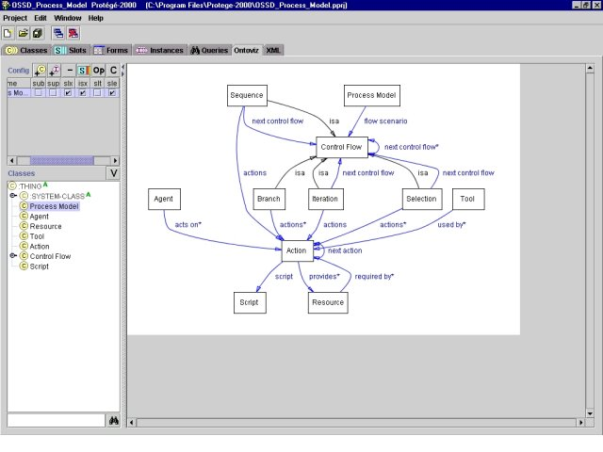
Figure 6 - Meta-model view from within the Protégé tool

The basic design of the software development process meta-model that is presented here consists of certain high-level elements that are abstractions of the basic entities of the software development as well as some constructs meant to illustrate the different types of the logical control flow that the process can follow. Each of these elements is composed of a number of attributes that specify the values that distinguish one element of the same type from another. A listing and discussion of each of these high-level elements follows.

Process Model
- name (required)
- url
- flow scenario (required)

The Process Model element is the top-level element that represents the overall process construct. The name field defines the name of the entire process, while the url field is a possible link to documentation. The flow scenario field is a link to an instantiation of a Control Flow construct, and represents the main logical flow of the process. Both the name and the flow scenario fields are required; values must be entered for these fields.

Agent
- name (required)
- url
- acts on (required)

The Agent element is an abstraction of the actors that participate in the execution of a certain process step. The name field defines the name of the actor being represented, and the url field is a hyperlink to possible documentation. The acts on field is a link to an instantiation of an Action element, which defines the action that the particular agent participates in. Motivation for the design decision of including the acts on field within the Agent construct was twofold. First, there is a set of display limitations imposed by the Ontoviz plug-in; by establishing the relationship between actors and actions in such a manner, the graph generated by Ontoviz was easily understandable without significant display customization. Second, and perhaps more importantly, there was a desire to distribute some of the information encapsulated in the Action construct to other element types in order to make the Action construct more compact.

Resource
- name (required)
- url
- required by

The Resource construct is an element that defines a particular resource that is either produced or required by a certain action. The name field defines the name of the resource being defined, while the url field defines a possible link to further documentation. The required by field is a link to an instantiation of an Action element and establishes that the resource being represented is required by the defined action. Similar to the case of the Agent acts on field, the required by field was included in this construct for both graphical understandability and information distribution.

Tool
- name (required)
- url
- command
- used by (required)

The Tool element describes a particular tool that is used by actors in accomplishing a task. These tools are most usually in the form of executable tools, though they can also be collaboration support applications such as chat programs. The name field defines the name of the element, the url field defines a link to possible additional documentation, and the command field may define the command to begin the tool's execution. This command field will be especially useful when applying a process prototype generation system on the formal description of the software development process being modeled. The used by field defines which actions these tools are used in. The decision to associate tools with actions was made to promote readability of the graph by minimizing the number of connecting lines in the case when the same tool was used by more than one actor in a single action; by associating the tool with the action, only one line needs to be drawn to connect the action with the tool. If tools were associated with agents, there would need to be as many lines as there are tool users.

Script
- name (required)
- url
- code (required)

The Script construct is an abstraction of an automated script that performs an action without the manual contribution of an agent. The name field defines the name of the script, the url defines a possible link to further documentation, and the code field defines the actual code that the script executes; this code may be one of many different types of an executable program ranging from a script to a full-fledged program.

Action
- name (required)
- url
- type (required)
- script
- provides
- next action

The Action element is the abstraction of a primitive process step that represents a particular action; the action that this construct represents will be the smallest granularity action that the process designer desires for the model being built and should carefully balance the prescriptive and advisory features of the process definition. The name field is the name of the action being represented, the url field is possible hyperlinked documentation, the script field may define which Script construct presents the executable of this action, and the provides field defines what resources are produced by the action. The type field defines whether the action is a "manual" one or an "executable" one; if it is an executable action, the script field should be defined. Finally, the next action field is a logical link to the next action that composes the overall sequence the action being defined belongs in; this field was added partly to ensure that during XML interchange of models the order of their execution remained unambiguous, and partly to take advantage of the graphical capabilities of Ontoviz.

Control Flow
- name (required)
- url
- next control flow

Constructs that belong to the Control Flow element type specify the logical order in which actions should be performed. The name field defines the name of the construct, and the url field is a link to possible hyperlinked documentation. The next control flow field is a link to an instantiation of a Control Flow element and defines the logical flow construct that follows the one being defined, and is similar to the next action field that was defined in the Action element type. The existence of this next control flow field allows for the nesting of Control Flow constructs to allow for the construction of logically complex processes. This element as four sub-categories that provide more details about the logical flow.

Sequence
- actions

The Sequence sub-construct defines a set of actions that are to be performed sequentially, and is the most common type of control flow encountered. The actions field defines the first of these actions.

Selection
- actions

The Selection sub-construct defines a set of actions, only one of which is to be performed. The actions field defines what these actions are.

Branch
- actions

The Branch sub-construct defines a set of actions or control flows that can be performed concurrently. The flow of the process only moves on if all of these actions are completed. The actions field defines the set of actions to be performed.

Iteration
- actions
- condition

The Iteration sub-construct defines an iteration over the specified actions or control flows. The actions field defines the first action of the sequence to be iterated, while the condition field defines when iteration ends. This condition field is currently defined as a string that can take the form of a natural language statement; this was considered to be the most versatile way to implement a conditional check that would accommodate everything from a formal condition to a completely informal and developer-dependent one.

Using Protégé for Process Descriptions
Using the Protégé system is not a difficult task, once the meta-model has been established; instantiations of each entity that comprise the process are easy to create. The most difficult part of using the tool is the identification and proper use of the different types of logical control flows. Simple sequences are less common as the software development process scales up; once the process begins to glow, more and more constructs such as branches and iterations begin to appear. It seems, then, that the most important element of an effective and understandable formalization of a software development process is the proper decomposition of the overall process into smaller sub-processes, which the Control Flow constructs are meant to define. It is on this task that the majority of time should be spent when formalizing a process so that the maximum gains from the formal description can be had.

Discussion

In the following subsection we compare our findings on the Jakarta and HTTPD software process lifecycle models. Then we discuss the differences observed between traditional software lifecycle models and open source software development at the Apache Software Foundation.

Jakarta versus HTTPD

As shown above, Jakarta and HTTPD follow relatively similar software lifecycle process models. Due to the fact that Jakarta is a more recent Apache project, its process is more clearly reflected in its website. This is because Jakarta contributors had already learned from the mistakes which occurred in the Apache project, resulting in more organized software development process guidelines.

Traditional Software Lifecycle Models versus Apache
Clearly, open source software development processes are quite different from traditional software development models.

Based in our findings on the Apache projects analyzed, it appears that the most significant differences are found in the following areas:

Management. While traditional software enterprises maintain a tight management to control software development projects, open source development projects are controlled by individuals who volunteer their time and skills to the community.

Licensing and Usage. Open source development licenses (i.e. http://www.apache.org/licenses/LICENSE) are created to maintain the open source status of a project as it is distributed, reused, and modified by different users. This means that the source code is required to remain openly available to the public. On the other hand, traditional software source code is protected from public distribution by special types of licenses, such as copyrights, in order to ensure that it is kept proprietary to its manufacturer.

Requirements Elicitation. Requirements in OSSD are obtained from user and developer requests, whereas in traditional models, software requirements are drawn from a particular department, like marketing from instance.

Design and Development. Design does happen in OSSD, mainly for major changes to the base code. Development is also different since developers volunteer to work on certain part of the project they are interested on.

Testing. Since all members of the community have access to the product at any time, testing becomes everybody’s task. The more people download and test the software, the more problems will be discovered and eventually fixed. This differs from the traditional approach, where only a handful of people will test the software, under controlled circumstances.

Frequency of builds and product releases: Traditional software processes only release when a build is stable enough (called either “alpha” or “beta”, depending on the quality of the build). In comparison, OSSD builds happen nightly. They follow the rule of releasing early and often.

Team communication: Communication in OSSD happens asynchronously, as team members are located in different places, and work under different schedules. Most of the time, team members do not know each other and the only interaction between them happens through email exchange.

Conclusions

As demonstrated in this paper, open source software development processes blatantly defy the rules and methodologies that have been so carefully laid out by proponents of traditional software development processes. Despite this, some of the most successful software in the world, such as those developed at the Apache Software Foundation, has been developed following open source ideologies. This would seem to indicate that software development efforts can be successful even without following the traditional models. However, there is method to the open source community’s madness. The processes that govern their software development efforts exist, even though they may not match those generally accepted by monolithic software development organizations. However, without a dedicated effort to precisely identify and model these processes, the questions of why these processes are successful and how they may be improved cannot be answered. This paper has been an attempt to study in detail the software development efforts of the Apache Foundation and the very closely related Jakarta project. The examination of the process that these two entities follow in developing their software yields valuable results both in providing insight into a successful open-source development methodology as well as in uncovering potential areas of improvement where the existing process can be streamlined. Perhaps the clearest contribution is the identification of the model itself; processes in the open-source community are well hidden within vast mailing list archives and personal communications. Formalization of these processes provides further added value to the models developed, as the realm of easy interchange of process models and automated analyses becomes available to the open-source community.

Acknowledgements

- Justin Erenkrantz <jerenkrantz@apache.org> provides information that is not documented in the HTTPD project website. More information about Justin can be found at his personal website at http://www.erenkrantz.com/.
- Jason Robbins <mailto:jrobboins@collab.net> provide information regarding the Tigris project. More information regarding the Tigris project can be found at http://www.tigris.org/.
- Walt Scacchi wscacchi@ics.uci.edu provided much guidance and inspiration for studying the OSSD community and the processes they follow.

References

- E. S. Raymond, The Cathedral and the Bazaar, First Monday, 3(3), 1998.
- SourceForge, http://www.sourceforge.net
- Netcraft Web Server Survey, http://www.netcraft.com/survey/
- B. Behlendorf, The Apache Story, Linux Magazine, June 1999
- R. Fielding and G. Kaiser, The Apache HTTP Server Project, IEEE Internet Computing, 1(4):88-90, July/Aug. 1997.
- D. Cubranic and K.S. Booth, Coordination in open-source software development, Proc. 8th IEEE International Workshops on Enabling Technologies: Infrastructure for Collaborative Enterprises, 1999.
- D. Wheeler, Why Open Source Software / Free Software (OSS/FS)? Look at the Numbers!, June 2002
- M Kasichainula, Presentation: IBM and Apache plan their first date, ApacheCon 2000, March, 2000
- New version of Apache released – again, http://www.news.com/, April 8, 2002
- Apache 2.0 to debut Monday – partway, http://www.news.com/, November 9, 2001
- Delayed Apache software nears release, http://www.news.com/, April 5, 2001
- Apache Web software on verge of major revision, http://www.news.com/, August 8th, 2000
- W. Scacchi, Understanding the Requirements for Developing Open Source Software Systems, to appear in IEEE Proceedings--Software, 2002.
- C.R. Reis and R.P.M. Fortes, An Overview of the Software Engineering Process and Tools in the Mozilla Project, Proc. Workshop on Open Source Software Development, Newcastle, UK, February 2002.
- A. Mockus and J. Herbsleb, Why not improve coordination in distributed software development by stealing good ideas from Open Source?, Proc. 2nd Workshop on Open Source Software Engineering, Orlando, FL, May 2002.
- T. Halloran and W. Scherlis, High Quality and Open Source Software Practices, Proc. 2nd Workshop on Open Source Software Engineering, Orlando, FL, May 2002.
- A. Brown and G. Booch, Reusing Open Source Software and Practices: The Impact of Open Source on Commercial Vendors, Proc. 7th International Conference on Software Reuse, 123-136, Austin, TX, USA, April 15-19, 2002. Appears in, C. Gacek (Ed.), Software Reuse: Methods, Techniques, and Tools, LNCS 2319, Spring-Verlag, May 2002
- A. Monk and S. Howard, The Rich Picture: A Tool for Reasoning about Work Context, Interactions , March-April 1998.
- S. Bendifallah and W. Scacchi, Work Structures and Shifts: An Empirical Analysis of Software Specification Teamwork, Proc. 11th. Intern. Conf. Software Engineering, IEEE Computer Society Press, Pittsburgh, PA. 260-270, May 1989.
- P. Mi and W. Scacchi, A Knowledge-Based Environment for Modeling and Simulating Software Engineering Processes, IEEE Trans. Data and Knowledge Engineering, 2(3):283-294, September 1990. Reprinted in Nikkei Artificial Intelligence, 20(1):176-191, January 1991, (in Japanese). Reprinted in Process-Centered Software Engineering Environments, P.K. Garg and M. Jazayeri (eds.), IEEE Computer Society, 119-130, 1996.
- P. Mi, M.J. Lee, and W. Scacchi, Knowledge-Based Software Process Library for Process-Driven Software Development , Proc. 7th. Knowledge-Based Software Engineering Conf., Washington, DC, IEEE Computer Society, 122-131, September 1992.
- P. Mi and W. Scacchi, Articulation: An Integrated Approach to the Diagnosis, Replanning, and Rescheduling of Software Process Failures, Proc. 8th. Knowledge-Based Software Engineering Conference, Chicago, IL, IEEE Computer Society, 77-85, 1993.
- W. Scacchi and P. Mi, Process Life Cycle Engineering, Intern. J. Intelligent Systems in Accounting, Finance, and Management, 6(1):83-107, 1997.
- J. Noll and W. Scacchi, Supporting Software Development in Virtual Enterprises, Journal of Digital Information, 1(4), February 1999.
- W. Scacchi, Understanding Software Process Redesign using Modeling, Analysis and Simulation, Software Process--Improvement and Practice, 5(2/3):183-195, 2000.
- J. Noll and W. Scacchi, Specifying Process-Oriented Hypertext for Organizational Computing, J. Network and Computer Applications, 24(1):39-61, 2001.
- W. Scacchi, Process Models in Software Engineering, in J. Marciniak (ed.), Encyclopedia of Software Engineering (Second Edition), 993-1005, Wiley, New York, 2002.
- [Roy87] Royce, W. W., Managing the Development of Large Software Systems, Proc. 9th. Intern. Conf. Software Engineering,IEEE Computer Society, 1987, 328-338.
- [Bec99] Beck, K. Embracing Change with Extreme Programming. IEEE Computer. 32(10), p. 70-77, 1999.
- [Ost87] Leon J. Osterweil. Software Processes Are Software Too. In Proceedings of the 9th International Conference on Software Engineering, pp. 2-13, Monterey, CA, March 1987.
- [Pro02] Protégé Project. Stanford University. 9 June 2002. http://protege.stanford.edu/
- [Geo02] Software development process using Protégé. University of California, Irvine. 9 June, 2002. http://www.ics.uci.edu/~jgeorgas/ics225/index.htm

Appendix

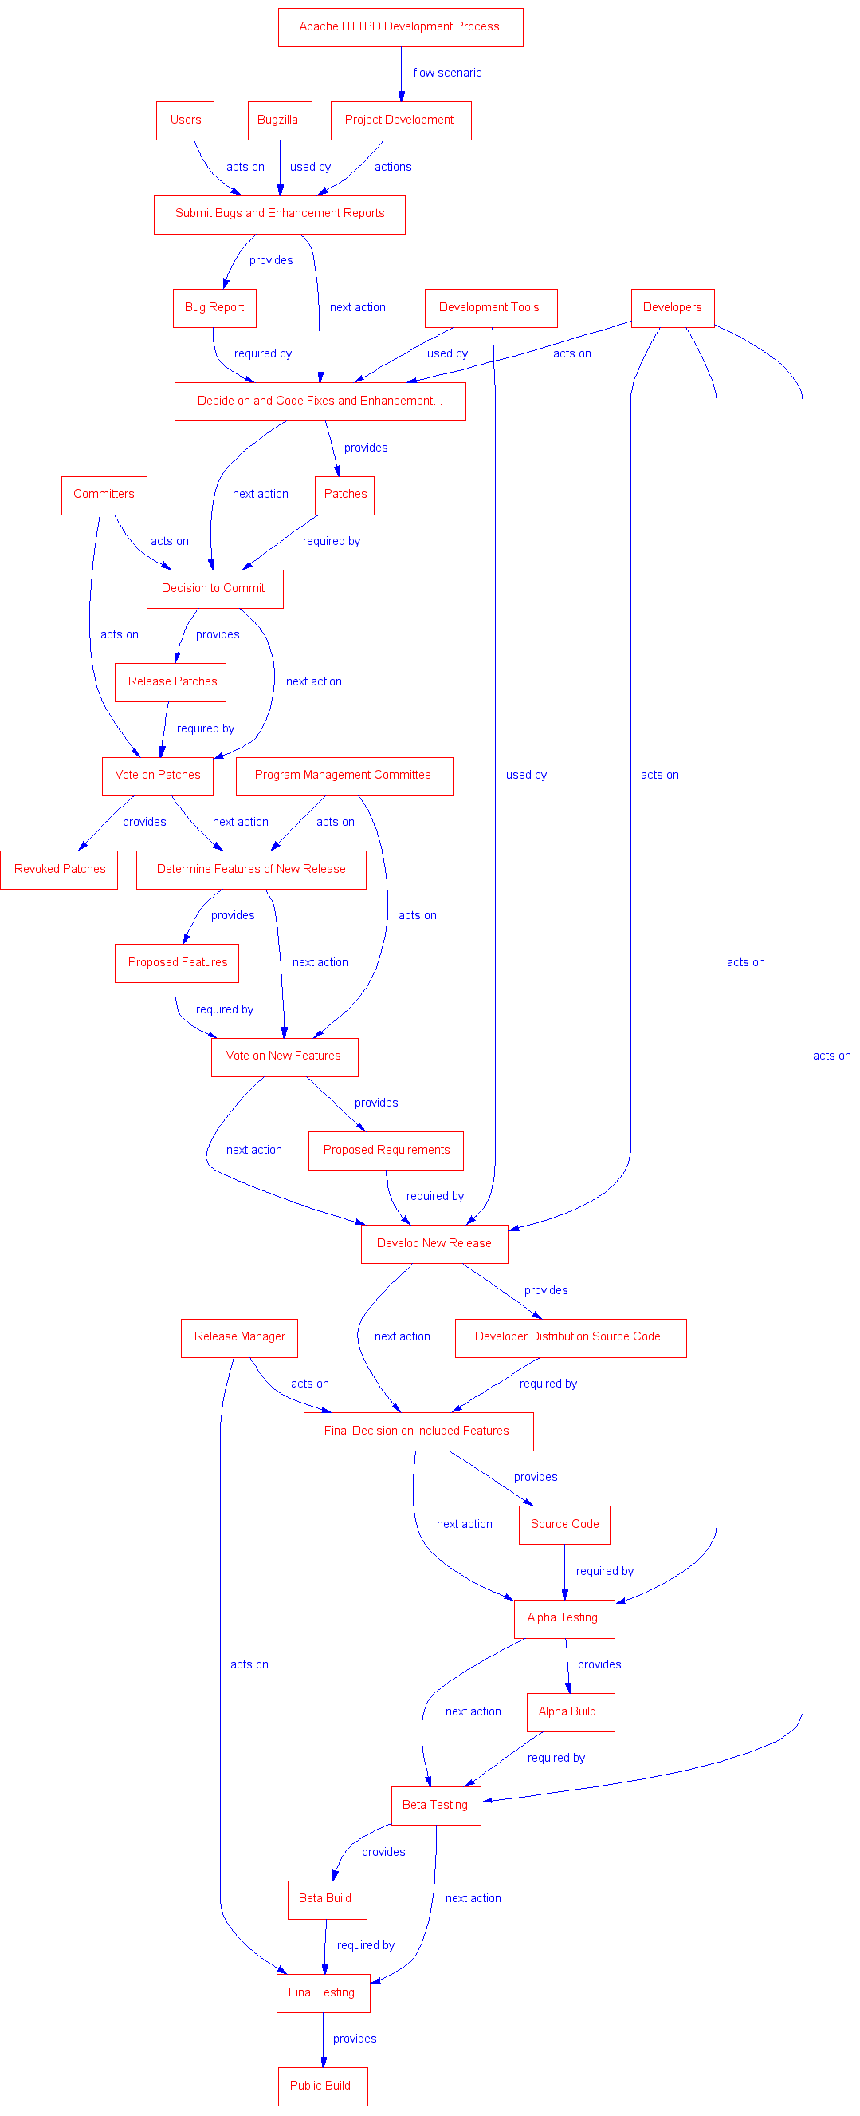
Figure 7: Formal graph of Apache

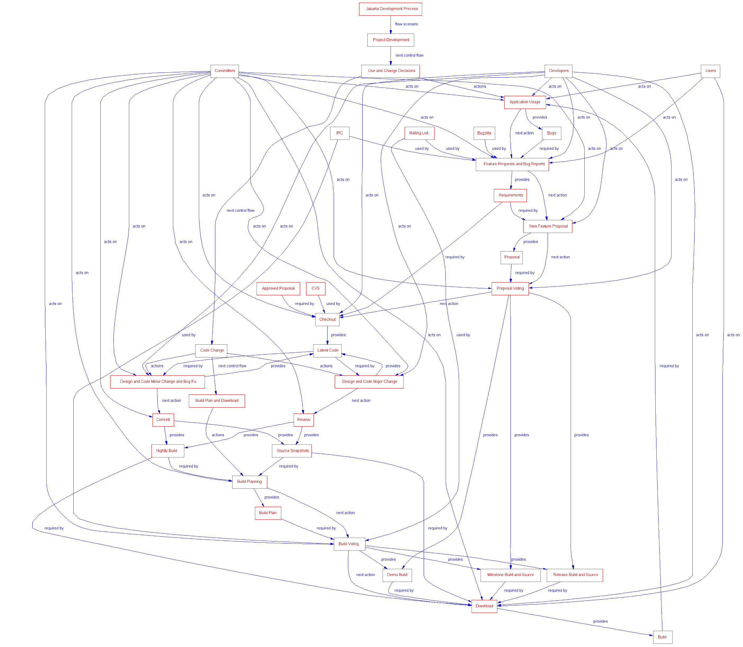
Figure 8: Formal graph of Jakarta

<?xml version="1.0" encoding="UTF-8" ?>
- <ontology>
<Process_Model name="Process Model" sl1="flow scenario" vt1="Instance(Control Flow)" sl2="name" vt2="String" sl3="url" vt3="String">The top level definition of the overall process model.</Process_Model>
<Agent sl1="name" vt1="String" sl2="acts on" vt2="Instance(Action)*" sl3="url" vt3="String">An actor that participates in a part of the process.</Agent>
<Resource sl1="name" vt1="String" sl2="url" vt2="String" sl3="required by" vt3="Instance(Action)*">A resource item that is required or produced by actions.</Resource>
<Tool sl1="command" vt1="String" sl2="used by" vt2="Instance(Action)*" sl3="name" vt3="String" sl4="url" vt4="String">A tool that is used by an agent as part of an action.</Tool>
<Action sl1="script" vt1="Instance(Script)" sl2="next action" vt2="Instance(Action)" sl3="type" vt3="String" sl4="name" vt4="String" sl5="provides" vt5="Instance(Resource)*" sl6="url" vt6="String">A primitive step in a process.</Action>
- <Control_Flow name="Control Flow" sl1="next control flow" vt1="Instance(Control Flow)*" sl2="name" vt2="String" sl3="url" vt3="String">
A construct specifying the order in which actions should be performed.
<Sequence sl1="actions" vt1="Instance(Action)">A set of actions to be performed in order.</Sequence>
<Selection sl1="actions" vt1="Instance(Action)*">A set of actions, only one of which should be performed.</Selection>
<Branch sl1="actions" vt1="Instance(Action)*">A set of actions that can be performed concurrently, in any order.</Branch>
<Iteration sl1="condition" vt1="String" sl2="actions" vt2="Instance(Action)">An iteration over the specified sequence of actions.</Iteration>
</Control_Flow>
<Script sl1="code" vt1="String" sl2="name" vt2="String" sl3="url" vt3="String">An automated script that can be executed.</Script>
</ontology>
Figure 9: The XML representation of the process meta-model.

